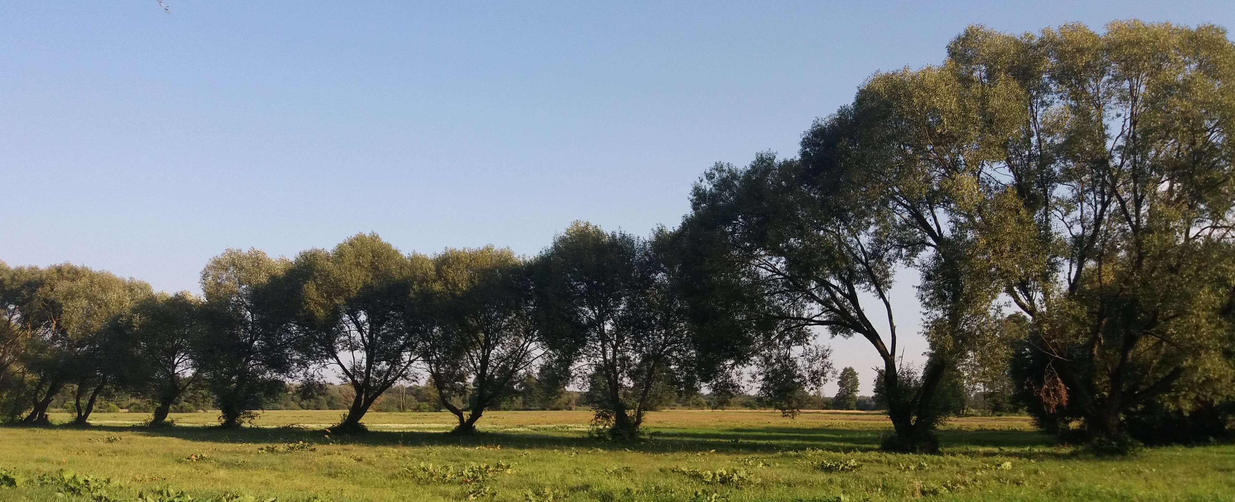  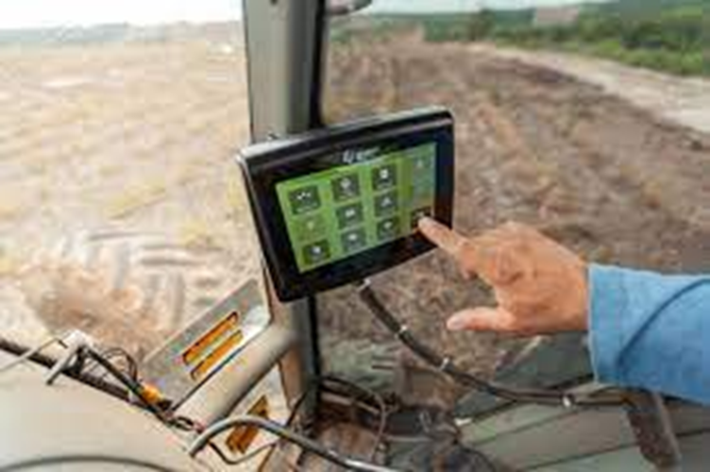  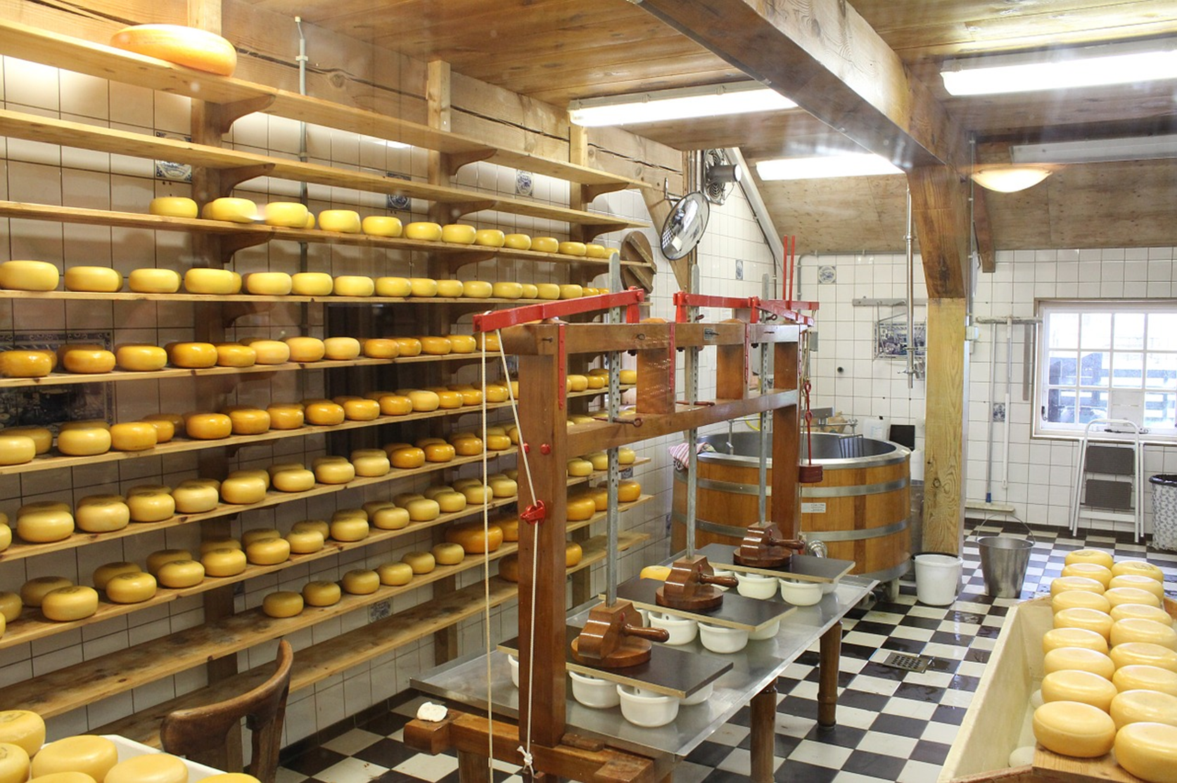  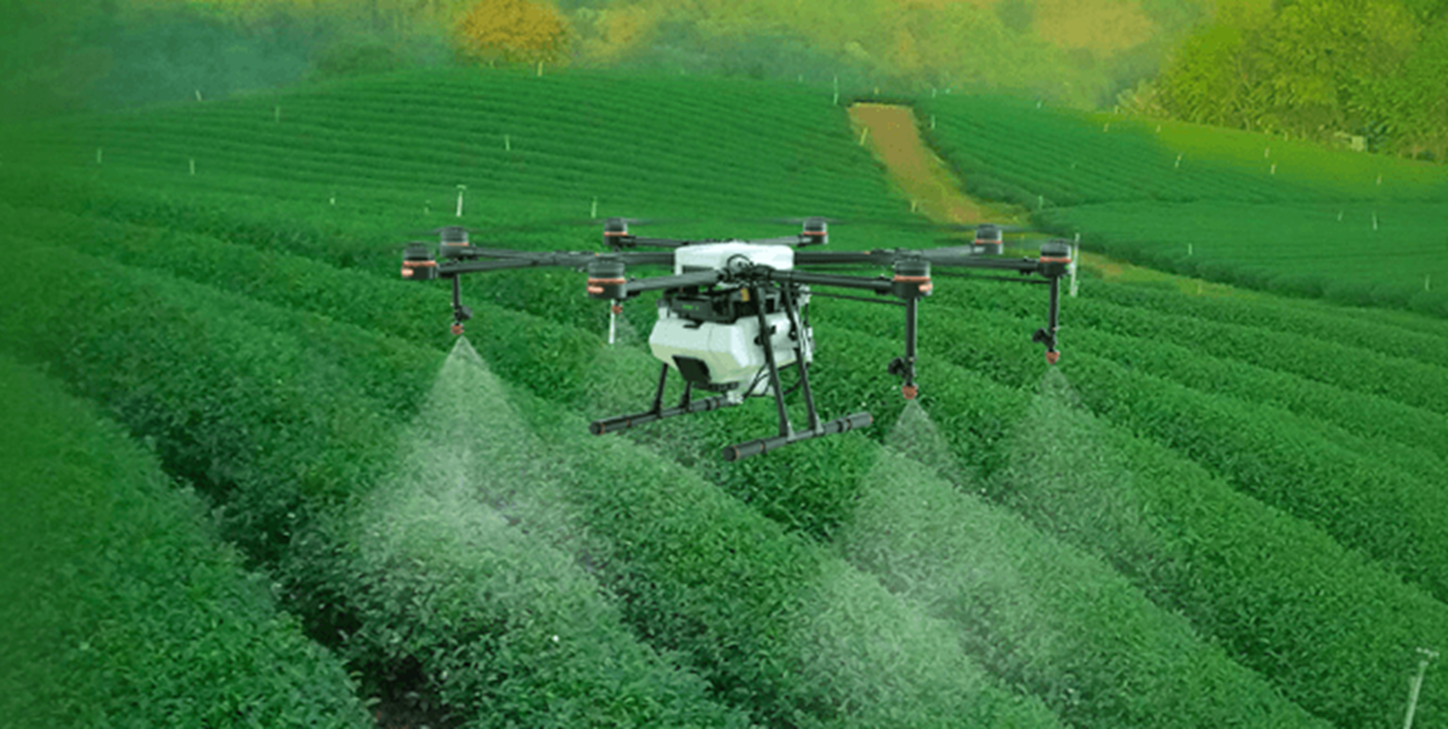  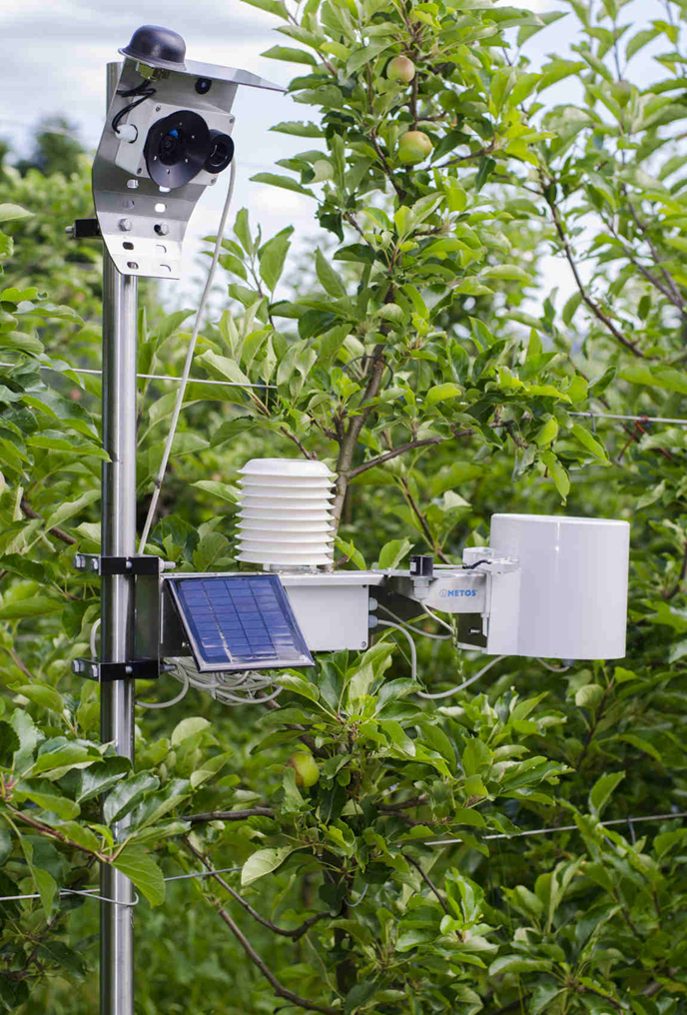  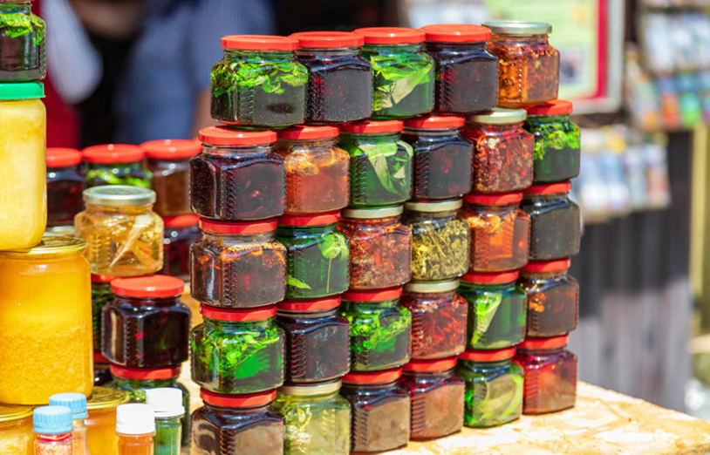  national pathway  - FOR FOOD SYSTEMS TRANSFORMATION IN SUPPORT OF THE 2030 AGENDA  National pathway in preparation  for the Food Systems Summit 2021  Evaluation of current food systems  Poland is a country with a large agricultural production potential, ensuring the nation’s food self-sufficiency. The ongoing streamlining of agricultural structures, professionalisation of farms and commercialisation of agricultural production is of an evolutionary and dynamic nature, enabling an increase in agricultural productivity while complying with the principles of sustainable development.  The agri-food sector is also very important for the labour market. The share of those working in the agricultural sector is more than double the EU and OECD average. Since 2004, Poland has seen one of the largest declines in the number of people working in agriculture in the EU. There is still a surplus of labour force (among other things due to the insufficient number of non-agricultural jobs available for those working on farms) and, on the other hand, an increasing lack of people willing to do seasonal work in agriculture.  Poland is characterised by a high production potential both in quantitative terms (land resources, number of farms and amount of labour resources in agriculture, high share of young and educated farmers) and in qualitative terms (domestic breeds of farm animals, varieties of arable crops, high quality food products). However, factors of production (e.g. suitability of soils for agricultural production, agrarian structure) are strongly regionally differentiated.  A significant proportion of the agricultural land is owned by micro or small farms that operate exclusively or mainly for subsistence or as a hobby. For this reason, small farms still predominate in Poland, although their number is clearly decreasing. The role of family farms in the country’s global food production is also declining.  Concentration of agricultural production occurs in commercial farms producing on an "industrial" scale.  The agricultural area on farms without animals is increasing, with a simultaneous increase in the number of animals and a tendency to simplify the structure of crop production on large farms.  The results of the 2020 General Agricultural Census indicate dynamic changes in Polish agriculture. We observe an increasing specialisation of farms and an ongoing concentration of agricultural production. The dominant trend observed for at least the last two decades has been a reduction in the number of agricultural farms, with the area of agricultural land remaining at a similar level.  With the specialisation of farms, modernisation is also progressing. Changes in agriculture result from adaptation to the economic environment, consumer demand for a certain quality of agricultural products or adaptation to climatic and environmental changes. The implementation of the EU’s Common Agricultural Policy is also of major importance, as it stimulates structural changes in agriculture [2020 General Agricultural Census preliminary data].  Climate change (including increased frequency and severity of extreme events), as well as more frequent sanitary and phytosanitary crises are key sources of production risk. There is also a systematic increase in economic risk, including high price volatility and pressure on incomes (among other things due to the increasing openness of the EU agri-food market and deregulation under successive CAP reforms).  The high fragmentation of wholesale trade means that many smaller operators do not have the purchasing power to obtain competitive terms from global food producers. Moreover, the wholesale market in Poland is heavily involved in the development of franchise stores, among other things because of the decline in the number of independent stores subject to intense pressure from large retail chains.  There is a risk that the Polish agri-food sector will not participate sufficiently in creating its development, but will only imitate foreign solutions. Poland is mainly an importer of modern technology solutions dedicated to the agricultural sector because a strong national brand of innovative machinery, equipment and services in agriculture has not been developed.  Poland belongs to the group of countries with the lowest malnutrition rates. At the same time, problems associated with poor nutrition – adverse changes in dietary patterns – are on the increase. On the other hand, new patterns of consumer demand are emerging, with some consumers returning to healthy dietary patterns and looking for functional, low-processed products or products for particular nutritional uses.  The high quality of Polish food is also determined by the rich tradition of production and agri-food processing. Family-run businesses and producers of regional or traditional foods in particular can benefit from the culinary heritage.  The most important tasks for Poland in relation to the sustainable development goals  The analysis shows that the most important issues for Poland in relation to the sustainable development goals are poverty reduction and ensuring sustainable development of cities and communities. Equally important is ensuring good quality education, equality between men and women, and reducing development inequalities in Poland. It also remains important to promote a peaceful and inclusive society by ensuring all people’s access to justice and building effective and accountable inclusive institutions at all levels.  Measures related to providing access to clean water and ensuring adequate sanitation, climate action and the protection of oceans, seas and marine resources will be important for achieving the ambitious vision of Agenda 2030 in Poland.  No less important will be the measures and feedbacks that occur between economic growth and decent work and between responsible consumption and production. Ensuring food security, investing in the protection of biodiversity, which affects health and improves quality of life, sustainable urban development and climate should also be considered crucial.  Increased outlays flowing from public policies in the mentioned areas should bring the desired effect and constitute a lever for effective implementation of sustainable development goals in Poland. [Implementation of Sustainable Development Goals in Poland. Report 2018, p. 85]  Indication of the links between the "pathway" and other strategic documents, including current policies and the budget  The sustainable development goals, based on development that also addresses social, economic and environmental aspects, are strongly reflected in the Polish development policy. They are also included in the vision of development formulated in the Strategy for Responsible Development adopted by the Council of Ministers in February 2017 and the vision of rural areas outlined in the Strategy for Sustainable Development of Rural Areas, Agriculture and Fisheries 2030 (SSDRAAF 2030) adopted by the Council of Ministers in February 2018.  SSDRAAF 2030 is the main strategy under which Goal 2 of Agenda 2030 End hunger, achieve food security and improved nutrition and promote sustainable agriculture will be implemented. In addition, due to its cross-cutting nature, the SSDRAAF 2030 contributes (to varying degrees) to the tasks of the other Sustainable Development Goals, including in particular Goals 6, 8, 12 and 17.  Lines of intervention under the 2030 Strategy for Sustainable Development of Rural Areas, Agriculture and Fisheries (SSDRAAF 2030) Related sustainable development goals from Agenda 2030  - New models for the organisation of markets, short market chains and fair competition Goal 2, Goal 8  - Food quality and safety Goal 2, Goal 12  - Development of innovation, digitalisation and Industry 4.0. in the agri-food sector Goal 2, Goal 9  - Risk management in the agri-food sector Goal 2  - Expansion and development of markets for agri-food sector products and raw materials (including bio-economy) Goal 2, Goal 9  - Development of technical infrastructure in rural areas Goal 6, Goal 7, Goal 9  - Development of high-quality public services Goal 3, Goal 4  - Revitalisation of villages and small towns Goal 11  - Sustainable management and protection of environmental resources Goal 6, Goal 12, Goal 15  - Adaptation of agriculture and fisheries to climate change and their contribution to counteracting it Goal 2, Goal 13  - Counteracting negative demographic changes (and their consequences) in rural areas Goal 4, Goal 8  - Development of entrepreneurship and creation of new jobs in rural areas Goal 8  - Increase of skills and competences of the inhabitants of rural areas Goal 4  - Development of bottom-up initiatives for the creation of social capital Goal 10, Goal 11  - Development of economics and social solidarity in rural areas Goal 1, Goal 8, Goal 10  Cross-cutting area: Efficient management of the development of the agri-food sector and rural areas Goal 2, Goal 16  Cross-cutting area: Stable financing for agricultural and rural development Goal 2  Cross-cutting area: Modern system for creation and transfer of knowledge and innovations – science, consultancy and agricultural education addressing the challenges of rural development Goal 2, Goal 4, Goal 9  Indication of the changes and decisions that need to be taken in the next 3 years in order to achieve the goals within 10 years  In order to increase the effectiveness of achieving sustainable development goals in the next years, the following seems to be particularly important for Poland in the context of food systems transformation:  - Selective intervention – selective choice of areas for support by national funds and funds from the new EU financial perspective (2021-2027) and the construction of a portfolio of strategic projects in the agri-food sector, with objectives like, inter alia, reducing marginal energy consumption by rural households, agri-food processing plants and farms; increasing the use of RES (Renewable Energy Sources) in the agri-food sector; increasing spending on R&D infrastructure and increasing the effectiveness of agricultural research; increasing organic farming.  - Education for sustainable development – implementation of education and information projects raising awareness of the principles of sustainable development in agriculture and agri-food processing.  - Effective monitoring and coherence of development policies and programmes – developing and implementing a monitoring system for sustainable development of rural areas and the agri-food sector in Poland. A mechanism for verifying the impact of policies on rural development should also be put in place to ensure coherence, compliance and complementarity among policies for rural areas and communities.  - Increase in spending for sustainable development of agriculture and rural areas – inter alia by targeting the goals of national programmes implementing EU funds (not only CAP) to the needs and challenges of sustainable development of rural areas and agriculture.  - Efficient organisational structure and co-operation – taking measures to strengthen the organisational structure within the co-ordination, management and monitoring of the implementation of the goals of sustainable rural development in Poland. This includes establishing co-operation with the EC Observatory of Rural Areas, which will serve to further improve the collection and analysis of rural data. The Observatory will also provide information for policy-making related to rural development, while supporting the overall implementation of the Rural Action Plan.  Identification of "milestones" in the implementation of the strategy  The milestones for the implementation of the strategy are closely linked to the 4 key changes and decisions that need to be made over the next 3 years in order to achieve the targets within 10 years. These include:  - Elaboration of the Polish Deal for rural areas and agriculture  - Elaboration of the national Strategic Plan for the CAP 2023-2027  - Preparation of the Partnership Agreement and programmes implementing it  - Adoption of the National Recovery and Resilience Plan  Identification of ways in which stakeholders can work together  In June 2017, the Partnership for the Sustainable Development Goals was launched in Poland, which is a platform that brings together representatives of different communities in pursuit of the goals. The aim of this Partnership is, among other things, to develop multi-sectoral co-operation, transfer knowledge, identify good practices and programme better activities and initiatives through joint development planning.  On 27 June 2018, the Agenda 2030 National Stakeholder Forum was established at the Ministry of Entrepreneurship and Technology, which is a national conference event aimed at a wide audience representing various circles. During the Agenda 2030 National Stakeholder Forum, the Partnership for the Implementation of the Sustainable Development Goals was ceremonially signed. The 3rd edition of the Agenda 2030 National Stakeholder Forum took place on 8 October 2020. The 4th edition of the Agenda 2030 National Stakeholder Forum was held as part of the V4+ Agenda 2030 Forum on 2 June 2021 as an official event during the Polish Presidency of the Visegrad Group. The Forum adopted a final document that addresses important issues for the countries participating in this meeting.  PL EN  MINISTERSTWO ROLNICTWA I ROZWOJU WSI MINISTRY OF AGRICULTURE AND RURAL DEVELOPMENT | Poland's development priorities centred on the "5 Ps" of the 2030 Agenda (People, Planet, Prosperity, Partnership, Peace)¹⁾  People – enhancing the role of human and social capital. Reduction of social exclusion, poverty, social inequalities of all kinds, improvement of the quality of life, access to knowledge and education, improvement of competences, decent work, improvement in health care.  Planet – improving the state of the environment and sustainable resource management, increasing available water resources and achieving high water quality, rational management of natural and geological resources and efficient waste management, improving air quality, protecting soils from degradation and reducing the impact of noise and electromagnetic fields on society.  Prosperity – building a strong industry, support for entrepreneurship in all sectors, coherent and comprehensive investments, especially in innovation, expansion of Polish business abroad, making the most of the digital revolution, dynamic development of information technologies; further development of transport and energy infrastructure; inclusion in the development processes of all areas, including agglomerations, small towns and rural areas.  Partnership – strengthening the system of strategic management of development processes, better coordination among different branches of administration, moving away from the administration system towards co-management in co-operation with stakeholders, development of partnership and social dialogue.  Peace – increasing the efficiency of the functioning of public institutions, their accessibility and openness for citizens and entrepreneurs; simplifying the law; ensuring better conditions for economic activity and the fulfilment of citizens' needs, as well as using the opportunities offered by available digital technologies on an economic scale.  ¹⁾ Implementation of Sustainable Development Goals in Poland. Report 2018, p. 21  over 1.3 million farms in Poland  over 14.6 million ha of farm-owned agricultural land  52.5% of farms are those with up to 5 ha of agricultural land  The number of agricultural farms has decreased by approx. 190,000 in Poland i.e. nearly 13% in relation to 2010.  over 3 million people work in agriculture and the share of those employed in the agricultural sector is 9.5% in total  8.8% of farms produce about 63% of the total agricultural production in Poland.  More than 13% of Polish exports are agri-food products.  25.6% is the adult obesity rate  9.1% is obesity rate for children and adolescents between the ages of 5 and 19  Food systems will support the implementation of the SDGs over the next 10 years by:  - ensuring sustainable agricultural development in order to safeguard health, improve quality of life and protect the environment and climate. In order to reconcile the meeting of global food demand with the direction of sustainable agriculture, it is crucial to carry out the green and digital transformation of the entire agri-food sector as well as the diversification and shortening of supply chains;  - reducing urban-rural development disproportions, with particular emphasis on areas at risk of permanent marginalisation, and inclusion in the development processes of all areas, including small towns and rural areas;  - implementing the principles of responsible consumption and production also in the agri-food sector, inter alia through investments in the green or digital transformation of farms and processing plants and investments to shorten the food supply chain  Transformation of food systems towards meeting the Agenda 2030 goals is highlighted in the national priorities adopted for Goals 2, 6, 8, 12 and 17 of the 2030 Agenda  [Agenda 2030 in Poland, National Priorities – Joint Actions. 2019.]  NATIONAL PRIORITIES for ASG 2030 Goal 2 [End Hunger]  - support for structural transformation ensuring an increase in the competitiveness of agriculture, including an increase in the competitiveness of agricultural farms and agri-food producers;  - ensuring food quality and safety and national food security, subject to environmental requirements;  - an increase in the diversification of income sources of inhabitants of rural areas;  - increasing the share of products of the agri-food sector (including high-quality food) in Polish exports;  - development of rural infrastructure;  - respect for biodiversity by enhancing it or at least not deteriorating it;  - promotion of a healthy lifestyle among adults and children.  SELECTED NATIONAL PRIORITIES for Goal 6 [Clean water and sanitation]  - increasing the available water resources, improving their ecological status and chemical quality;  - establishment of legal and financial mechanisms favouring rational use of water resources and implementation of water-saving technologies, as well as construction and modernisation of sewage treatment plants.  NATIONAL PRIORITIES for Goal 8 [Economic growth and decent work]  - seeking new competitive advantages based on the technological advancement in production, the quality and innovation of products on offer, as well as mechanisms for the internationalisation of businesses  - improving the flow of unused labour resources from agriculture to other sectors.  [Agenda 2030 in Poland, National Priorities – Joint Actions. 2019.]  NATIONAL PRIORITIES for Goal 12 [Responsible Consumption and Production]  - increasing resource use efficiency and changing resource attitudes away from linear resource management and changing consumption patterns (development of a circular economy, reducing food loss and food waste);  - developing organic farming.  SELECTED NATIONAL PRIORITIES for Goal 17 [Partnerships for goals]  - The priorities of Polish development assistance for 2016-2020 include 6 main thematic areas of development assistance, including but not limited to: sustainable agriculture and rural development, and environmental protection  [Agenda 2030 in Poland, National Priorities – Joint Actions. 2019.]

