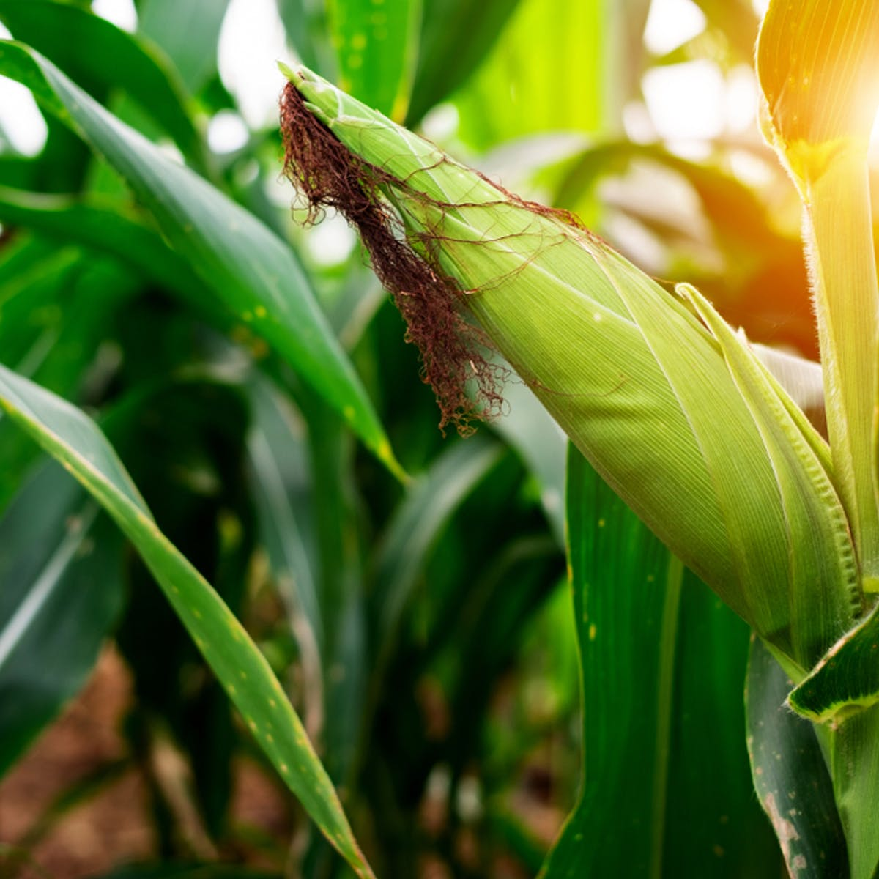

July 2021

**Prepared by:**

Masia Johane (Team Leader), Professor Philip Makama, Professor Oluremi, Ehsan Rizvi, Dr. Fedelis Asanjor, and Dr. P. Nkhabutlane

Context. Challenges. Opportunities

Lesotho Food Systems

###### Contents

Review Process and Methodology 1

1. Executive Summary 6

2. Introduction 8

2.1. Global Context (The World) 8

2.2. Regional Context (Africa) 10

2.3. Local Context (Lesotho) 13

2.4. Progress towards SDG 2 in Lesotho: 15

3. Food Production System in Lesotho 16

3.1. Climate in Lesotho 16

3.2. Annual and Seasonal Climate Trends 17

3.3. Climate change impacts on production 17

3.4. Climate change vulnerabilities 18

3.5. Climate change effects on crop physiology 18

3.6. Cereal Crops in Lesotho 20

3.7. Horticulture in Lesotho 22

3.8. Impact of COVID-19 22

4. Seed System in Lesotho 24

5. Food Supply Chain System in Lesotho 25

5.1. Fresh Fruits and Vegetables (FFV) Value Chain in Lesotho 25

5.1.1. Local Production of FFVs 27

5.1.2. Finance 27

5.1.3. Extension and Training 27

5.1.4. Retail 28

5.1.5. Wholesale 29

5.1.6. Marketing 29

5.1.7. Consumers 29

6. Nutrition 31

6.1. Nutrition Governance Situation 31

6.2. Infant and young child feeding practices and state of nutrition 32

6.2.1. Birthweight 32

6.2.2. Infants (0-6 months) – Breast feeding 32

6.2.3. Children (6-23months) – Complementary feeding 32

6.2.4. Stunting 33

6.3. Adult Nutritional Status (Overweight and Obesity) 34

6.4. Women of childbearing age (15-49 years) 34

6.5. The Burden of Malnutrition 35

6.5.1. Diseases and poor health care 35

6.5.2. Chronic food insecurity 35

6.5.3. Low levels of education 35

6.5.4. Household poverty 36

6.6. Nutrition Specific Interventions 36

7. Food Consumption and Utilization 39

7.1. Consumption of Fruit and Vegetables 40

7.2. Consumption of Traditional Foods 40

7.3. Consumption of Processed Foods 41

7.4. Geographical variations (Food Environment) 41

8. Food Waste Management 43

8.1. Post-Harvest Handling and Storage 43

8.2. The role of food processing in diet quality 44

9. Major Policies Defining Food Systems in Lesotho 45

9.1. National Strategic Development Plan (NSDP) II 2018/19 – 2022/23 45

9.2. Lesotho Food Security Policy 2005 45

9.3. National Action Plan for Food Security Policy (NAPFS) 2007 – 2017 46

9.4. Agriculture Sector Strategy 2003 46

9.5. Lesotho National Climate Change Policy 2017 – 2027 46

9.6. Lesotho Food and Nutrition Policy 2016 – 2025 47

9.7. National Seed Policy 2016 47

9.8. Subsidies in the Agriculture Sector: Policy Statement and Implementation Framework – 2003 48

10. Lesotho Food System Challenges and Opportunities 50

11. National Interventions Specific to Food Systems in Lesotho 55

11.1. Malabo Declaration 55

11.2. Comprehensive Africa Agriculture Development Programme (CAADP) 55

11.3. Sustainable Development Goals (SDG’s) 56

11.4. Cost of Hunger in Africa (COHA) Study 57

11.5. Zero Hunger Strategic Review 57

11.6. Food and Nutrition Strategy and Action Plan 58

12. Recommendations & Way Forward 59

13. References 66

###### List of Figures

Figure 1: Prevalence of Undernutrition in Africa 13

Figure 2: Prevalence of Undernourishment 14

Figure 3: Household Nutrient Requirement Cost (Maloti) 15

Figure 4: Prevalence of Stunting 16

Figure 5: Yield, area harvested & production of cereal crops in Lesotho 21

Figure 6: Distribution patter of acreage of major crops grown in Lesotho (BOS) 22

Figure 7: Maize production in Lesotho (FAOSTAT) 23

Figure 8: Cereal total production in Lesotho (FAOSTAT) 23

Figure 9: Vegetable production in Lesotho (FAOSTAT) 24

Figure 10: Lesotho horticulture value chain (FAO) 28

Figure 11: Production and Yield of Vegetable in Lesotho 29

Figure 12: Market Share of Vegetables 30

Figure 13: Vegetable import in Lesotho (source: UNCOMTRADE) 31

Figure 14: Per capita consumption of vegetables in Lesotho (FAOSTAT) 32

Figure 15: Major constraints for sourcing vegetable produce locally 33

###### Abbreviates

ACPF African Child Policy Forum

ARC Agricultural Resource Centers

BOS Bureau of Statistics

CAADP Comprehensive Africa Agriculture Development Program

COVID-19 2019 Novel Coronavirus

EIF Enhanced Integrated Framework

FAO Food and Agriculture Organization of the United Nations

FFV Fresh Food and Vegetables

GDP Gross Domestic Product

GOL Government of Lesotho

HIV/AIDS Human immunodeficiency virus infection / acquired immunodeficiency syndrome

IFAD International Fund for Agricultural Development

LDHS Lesotho Demographic and Health Survey

LENAFU Lesotho National Farmers Union

LHWP Lesotho Highlands Water Project

LNDC Lesotho National Development Corporation

MAFS Ministry of Agriculture and Food Security

MOET Ministry of Education and Training

MTICM Ministry of Trade, Industry, Cooperatives and Marketing

NAIP National Agriculture Investment Plan

NAPFS National Action Plan for Food Security Policy

NCD Non-Communicable Diseases

NGO Non-Governmental Organization

NSDP National Strategic Development Plan

NSDP II National Strategic Development Plan 2018/19 – 2022/23

OPV Open Pollinated Variety of seeds

PoU Prevalence of Undernutrition

RSA Republic of South Africa

SADP Smallholders Agricultural Development Program

SDG[1] Sustainable Development Goals

UNDP United Nations Development Program

UNICEF United Nations Children's Fund

WFP United Nations World Food Programme

WHO World Health Organization

WTO World Trade Organization

# Review Process and Methodology

Lesotho situation analysis carried-out using desk-top study. The situation analysis prepared through collection, review and analysis of existing information and institutions.

Review of current literature such as fill nutrition gap analysis, food security policy (2005), Nutrition and home economic strategy. Six experts were engaged handling different thematic areas which made a cursory observation to ensure that national situation analysis is aligned to five international tracks, namely ensuring access to safe and nutritious food for all, boosting nature-positive production at sufficient scale, shifting to sustainable consumption patterns, advancing equitable livelihoods and value distribution, and building resilience to vulnerabilities to shock and stress.

The team of expert’s explored five thematic areas for the country known as climate change impact on food systems, production and post-harvest losses, Food consumption and utilization, marketing and distribution and, governance support system in an attempt that un national food systems summit reflects national ambitions and that national efforts benefit the whole country.

It will ensure that it further explores experience options for action and combine efforts in order to encourage emergence of sustainable food system. The situation analysis is also an attempt to guide national dialogue that emerging challenges be linked to stakeholders within agricultural systems. Discussing how supporters, participants and champions of the food systems can built pathways to change their situation.

Workshop held in Molengoane between 11 – 13, June 2021 prepared a roadmap for Lesotho food system situation analysis.

Table below outlines the outcome of the workshop:

|  |  |  |  |
| --- | --- | --- | --- |
|  | Activities | Outcomes | Panelist questions |
|  | Extraction of recommendations from thematic areas: | Consolidated set of pathways that could potentially be adapted to direct the national food systems  (see annex 1) | e.g. explain how climate change has impacted on our food systems, and what pathways should we follow to mitigate the impact and ensure inclusivity and sustainability of the food systems. |
|  | Climate change and food systems |  | * Controlled running water downstream into the rivers by building stone bridges on the slopes. * Ensure best farming practices that conserver and protect vegetative cover * Re-vegetate as soon as work is completed to reduce run off * Ensure best farming practices that preserve and restore soil health and nutrients |
| Policies, Production and Post-Harvest Loses | Policies |  | - to what extend do our agricultural  policies (formal and informal)  promote increased productivity?  - to what extend do the promote  production and commercialization of agriculture and food security?  - to what extent do they take into  cognizance of climate changes?   * To what extend do they promote food value chain? * To what extend do they promote agricultural marketing? |
|  | Production |  | * Are there food and agricultural projects that are targeted at improving agricultural productivity (horticulture, crops, livestock) in the post covid-19 recovery? * What pathways should be followed to obtain maximum yield out of these projects? * How do you tackle non and under-performing projects that are meant to promote productivity (how to remove bottle necks in the post covid-19 recovery period)? * Is there a possibility for agricultural recapitalization? |
|  | Post-harvest losses |  | * What tools should be put in place to measure post-harvest losses? * How should we manage post-harvest losses in the post covid-19? |
| Food Consumption, Utilization and Processing | Food Consumption and Utilization |  | . How has covid-19 disrupted our consumption and utilization patterns in both rural and urban area?  . How should society cope with emerging food and nutrition disruptions caused by shocks such as covid-19? |
|  | Food Waste Management |  | . What causes food waste?  . How should society deal with food waste? |
|  | * Sustainable agricultural practices |  | * What can we showcase of the success stories of sustainable agricultural practices? * What good practices can we revive for sustainable agricultural practices? |
|  | * Agricultural food value chain |  | * What makes our agricultural food value chain remain under-developed? (potato seed, piggery, poultry, red meat, beans, horticulture and crops) * Ministry of Agriculture must promote value chain through incentives and instruments |
|  | * Marketing and distribution |  | * Itemize agricultural facilities that would enable us, rural and urban residents, to become productive in agriculture. |

Following thematic areas were chosen:

1. Production and post-harvest loses

* Sustainability of agricultural practices
* Diversity in production and value adding
* Post-harvest loses
* Performance of agricultural projects

1. Food consumption and utilization

* Food waste management
* Dietary diversity and bio-diversity
* Food availability and accessibility
* Overweight and obesity

1. Marketing and Distribution

* Processing
* Use of information and communication technology in marketing
* Organized markets

1. Impact of climate change on food production

* Coping mechanisms

1. GOVERNANCE support system

* How do you restructure the economy into circular economy not extractive economy?
* What kind of leadership is required to drive this transformation?

**Who are true critical mass in the food systems?**

* Communications
* Farmers, farmers’ associations
* Emerging Agri-businesses
* Agric business enterprises e.g. livestock feed suppliers, input suppliers,
* Subject matter specialists – agricultural extension workers, veterinarians, nutritionists,
* Catering, retail, wholesale, transporter, waste management, storage, packaging,
* Non-Governmental Organizations
* Civil Society Organizations including Faith Based Organizations
* Financial Institutions (banking and insurance)
* Development Partners
* District Administrators and District Council Secretaries
* Youth and disabled people
* Women representatives
* Elderly
* Herders (culling and exchange programme)
* Bo-’Maphepo
* Academicians
* Projects implementation units related to food systems
* Consumer organizations

# Executive Summary

Food systems (FS) encompass the entire range of actors and their interlinked value-adding activities involved in the production, aggregation, processing, distribution, consumption, and disposal of food products that originate from agriculture, forestry or fisheries, and parts of the broader economic, societal, and natural environments in which they are embedded[2].

The food system is composed of sub-systems (e.g., farming system, waste management system, input supply system, etc.) and interacts with other key systems (e.g., energy system, trade system, health system, etc.). Therefore, a structural change in the food system might originate from a change in another system; for example, a policy promoting more biofuel in the energy system will have a significant impact on the food system.

A range of pressures including rapid population growth, urbanization, growing wealth and consequent changes in consumption patterns, are challenging our food systems’ ability to provide nutritious food, and to contribute to enhanced livelihood opportunities in an environmentally sustainable way. Our food systems are contributing to, and affected by, extreme weather events as associated with climate change, land degradation and biodiversity loss. Responding to these challenges requires a systems-based approach that addresses the range and complexities in a holistic and sustainable manner.

Low adaptation to high-yielding technologies and poor adaption to climate change have also affected the sector. As a result, Lesotho is faced with chronic food insecurity and malnutrition, primarily affecting women, children, and vulnerable groups from poor households. This also undermines overall population productivity. National Strategic Development Plan 2018/19 – 2022/23 (NSDP II) outlines that in 2017/18, an estimated 15% of the population was food insecure, of which 78% resides in rural areas. This is despite implementation of agricultural support programs, including input subsidy and sharing cropping initiatives by the Government of Lesotho. The commercialization of agriculture requires a functioning agri-food system. Farmers are not well organized and lack support services and coordinated information sharing. They are unable to supply markets because they are not aggregated into producer organizations and common value chains, and value addition is limited.

Agriculture is one of the four priority sectors under the NSDP II. NSDP II outlines the development of agriculture and food systems in Lesotho through it two main objectives:

* To ensure sustainable commercial agriculture while remaining cognizant of climate change impacts, environmental degradation, other natural disasters, as well as harmful cultural practices that have rendered the economy vulnerable,
* To increase agriculture production and its commercialization. The country will address issues related to management of range, water sheds, protection of the environment and biodiversity, and reversing alarming environmental degradation that has aggravated the food insecurity situation.

As outlined in the NSDP II, the remaining arable land can still provide Lesotho with enough food to satisfy the population and export market if commercial large scale farming along with irrigation are introduced into the farming culture of Lesotho.

Lesotho also has potential to expand the horticulture, meat, poultry and dairy industries, which are currently dominated by imports from South Africa. The Government of Lesotho has declared the dairy industry as a priority for food security, and several initiatives are underway to stimulate dairy development. Crop production is dominated by maize, sorghum, and wheat production, which occupy about 60%, 20%, and 10% of agricultural land, respectively (NSDP II, 2018). In recent years, Lesotho has shown significant potential in horticulture (fruits and vegetables). Lesotho has further demonstrated potential in aquaculture, particularly the production of trout, which takes place in the Highlands.

# Introduction

## Global Context (The World)

Traditional food security programs tend to adopt a production-focused approach, which seeks to directly influence food security through increasing the supply of food. In a few regions of the world, particularly Sub-Saharan Africa, inadequate food production is still the major cause of food and nutrition insecurity. However, the dramatic pace of food system changes over the past decades has brought about complex interactions and feedback loops that impact food and nutrition security in many ways. The focus on food production leads to the neglect of other areas in which the root causes of the food system underperformance, as well as the leverage points to bring about the biggest impacts can often be found. Furthermore, the interwoven interactions and feedbacks in the food system mean that direct interventions in one area risk creating or exacerbating problems in another[3].

Currently the world is producing enough food to feed its entire population; however, more than 1.5 billion people cannot afford a diet that meets the required levels of essential nutrients and over 3 billion people cannot even afford the cheapest healthy diet. People without access to healthy diets live in all regions of the world[4]; thus, we are facing a global problem that affects us all.

Five years after the world committed to end hunger, food insecurity and all forms of malnutrition, we are still off track to achieve this objective by 2030. The world is not on track to achieve the global nutrition targets, including those on child stunting, wasting and overweight by 2030. Data tell us that the world is progressing neither towards SDG target 2.1, of ensuring access to safe, nutritious, and sufficient food for all people all year round, nor towards target 2.2, of eradicating all forms of malnutrition[5].

The number of people going hungry and suffering from food insecurity had been gradually rising since 2014. It is estimated that nearly 690 million people in the world were hungry in 2019, or 8.9% of the world population – up by nearly 60 million in five years[6]. About 2 billion people worldwide did not have regular access to safe, nutritious, and sufficient food in 2019[7], an increase from 22.4% in 2015. The fastest rise was in Latin America and the Caribbean, although the highest levels were found in sub-Saharan Africa. About 795 million people face hunger on a daily basis and more than two billion people lack vital micronutrients (e.g., iron, zinc, vitamin A)[8], affecting their health and life expectancy. After steadily declining for a decade, world hunger is on the rise, affecting 8.9 percent of people globally. From 2018 to 2019, the number of undernourished people grew by 10 million, and there are nearly 60 million more undernourished people now than in 2014[9].

Trends in food insecurity contribute to increasing the risk of child malnutrition, as food insecurity affects diet quality, including the quality of children’s and women’s diets, and people’s health in different ways. In 2019, 21.3 percent (144.0 million) of children under 5-years of age were estimated to be stunted, 6.9 percent (47.0 million) wasted and 5.6 percent (38.3 million) overweight, while at least 340 million children suffered from micronutrient deficiencies[10]. Even though global prevalence of child stunting declined by one-third between 2000 and 2019, the world is not on track to achieve the global nutrition targets, including those on child stunting, wasting and overweight by 2030.

In women, anemia increases the risk of adverse maternal and neonatal outcomes. In 2019, global anemia prevalence was 29.9% in women of reproductive age, 29.6% in non-pregnant women, and 36.5% in pregnant women. Prevalence was higher in Central Asia and Southern Asia (47.5% in women of reproductive age)[11].

The COVID-19 pandemic has intensified the vulnerabilities and inadequacies of global food systems, which could add hundreds of million more people to the chronically undernourished, making the goal of ending hunger a more distant reach. The COVID-19 pandemic might have pushed an additional 83-132 million into chronic hunger in 2020[12]. In addition, countries around the world continue to struggle with multiple forms of malnutrition.

There are many threats to progress. The 2017 and 2018 editions of this report showed that conflict and climate variability and extremes undermine efforts to end hunger, food insecurity and malnutrition. In 2019, the report showed that economic slowdowns and downturns also undercut these efforts. In 2020, the COVID-19 pandemic, as well as unprecedented Desert Locust outbreaks in Eastern Africa, are obscuring economic prospects in ways no one could have anticipated, and the situation may only get worse if we do not act urgently and take unprecedented action.

We face the challenge of transforming food systems to ensure that no one is constrained by the high prices of nutritious foods or the lack of income to afford a healthy diet, while we ensure that food production and consumption contribute to environmental sustainability. However, there is no one-size-fits-all solution for countries, and policymakers will need to assess the context-specific barriers, manage trade-offs and maximize synergies – such as potential environment gains – to achieve the required transformations.

The complexity of food systems requires a more holistic and coordinated approach. Many food security and nutrition challenges are complex problems whose solutions are contested, and which transcend disciplinary, divisional, and institutional boundaries. In increasingly globalized food systems, these challenges result from interactions across different scales and levels. They require integrated actions taken by all stakeholders at local, national, regional, and global levels, by both public and private actors, and across multiple fronts- not only in agriculture, but also in trade, policy, health, environment, gender norms, education, transport, and infrastructure, and so on. It requires a synergetic merging rather than a destructive clashing of the ideas emerging from these various angles. Identifying critical research areas where investment can lead to the transformation of the global food system is vital.

We can still succeed, but only by ensuring all people’s access not only to food, but to nutritious foods that make up a healthy diet. As the world population continues to grow, much more effort and innovation will be urgently needed in order to sustainably increase agricultural production, improve the global supply chain, decrease food losses and waste, and ensure that all who are suffering from hunger and malnutrition have access to nutritious food.

## Regional Context (Africa)

As a region, Africa is unique and carries a heavy burden of food insecurity and malnutrition.

Hunger is one of the most pressing political, economic, moral and existential conundrums facing Africa today. About 59 million children are stunted and 14 million are wasted in Africa indicating the huge magnitude and severity of child hunger on the continent[13].

The Prevalence of undernutrition (PoU) in Africa was 19.1 percent of the population in 2019, or more than 250 million undernourished people, up from 17.6 percent in 2014. This prevalence is more than twice the world average (8.9 percent) and is the highest among all regions[14]. Access to food is primarily the result of poverty and inequalities in income. The proportion of people in extreme poverty in sub-Saharan Africa was estimated at 41% in 2015. Poverty is especially serious amongst children. The proportion of children in extreme poverty in sub-Saharan Africa was estimated to be 49% in 2013[15].

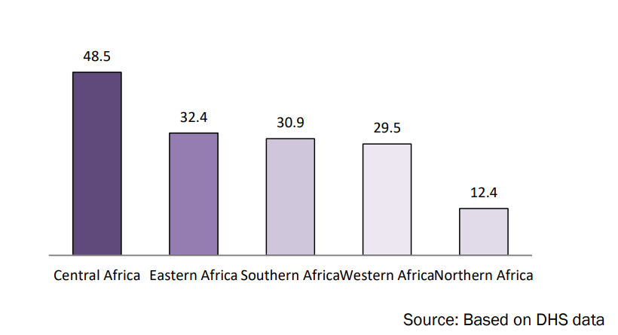

Figure 1: Prevalence of Undernutrition in Africa

In terms of the outlook for 2030, Africa is significantly off track to achieve the Zero Hunger target in 2030. If recent rates of increase persist, its PoU will rise from 19.1 to 25.7 percent. By 2030 Africa would overtake Asia to become the region with the highest number of undernourished people (433 million), accounting for 51.5 percent of the total[16]. Africa’s population is expected to reach 2.5 billion people in 2050, and its child and youth population will hit the one billion mark[17]. If current trends continue and corrective measures are not taken, Africa could have one billion undernourished, malnourished, hungry children and young people by the middle of the century.

In 2003, Africa adopted the Comprehensive Africa Agriculture Development Program (CAADP) as a continental policy framework for agricultural transformation aimed at increasing food security and nutrition and reducing poverty. It was reinforced in 2014 under the CAADP Malabo declaration on agricultural growth and transformation with an expanded set of goals and targets to be achieved by 2025. However, only ten countries met their commitment under CAADP to allocate at least 10% of their annual public expenditure to agriculture. Thirty-four countries are off course to meet the target of reducing childhood wasting to less than five per cent by 2025. And only 9 countries are on course to meet the target of reducing stunting by 40% by 2025[18].

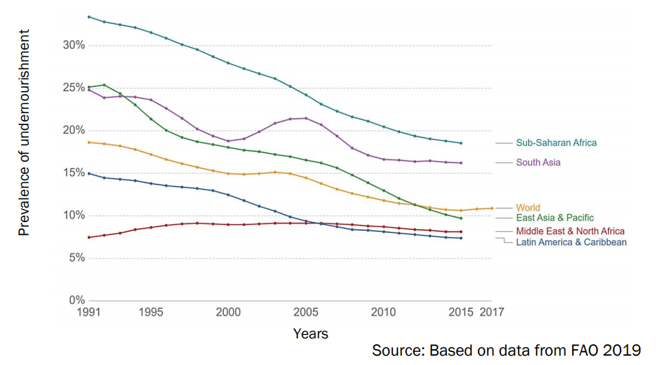

Figure 2: Prevalence of Undernourishment

The vision for the 10 years of the CAADP Malabo declaration is to position agriculture at the centre of driving inclusive growth and economic development to ensure wealth creation, food and nutrition security; economic opportunities for poverty alleviation and prosperity as well as ensuring resilience and sustainability. Through the CAADP agenda, African leaders envisioned a food systems approach to attain agricultural-led economic transformation for its Member States.

## Local Context (Lesotho)



Figure 3: Household Nutrient Requirement Cost (Maloti)

Lesotho is mostly food deficit, and the country is not self-sufficient in the production of cereals, meat, or vegetables; the country depends on South Africa to supply their internal market. In good harvest years, Lesotho is only able to meet roughly 30 percent of its annual cereal requirements. Overall, a large part of the population remains exposed to situations of chronic food and nutrition insecurity, especially the rural population, which is heavily dependent on subsistence farming and other rural non-farm activities.

Ninety percent of broiler meat and 80 percent of vegetables sold in the Basotho formal market are imported from South Africa (UNTRADE, 2018). Lesotho’s production is focused on cereals, primarily maize. Average yields remain comparatively low (cereal yields of 987 kg per hectare in 2017 and 468 kg per hectare in 2016) and are vulnerable to climate shocks.

Although 78 percent of all productive land area is agricultural (meaning that it is used for crop, horticulture or livestock) and 38 percent of the economically active population engages in agriculture, it contributes to a mere 5 percent of GDP. Lesotho relies heavily on imports from South Africa for almost all commodities, with only 30 percent of all foods consumed being produced in Lesotho. The majority (91 percent) of fields for crop production is run by smallholder farmers for own consumption. These farmers often struggle to reach a subsistence level and, in most cases, need to supplement their own production with purchased commodities, resulting in an overall deficit at the household level. This suggests that currently many smallholders are not able to sustain their livelihoods by agricultural activities[19].

This trend is likely to continue, partly due to external factors such as climate change that causes increasingly long and intense spells of drought, but also due to sub-optimal agricultural practices. Agricultural inputs such as fertilizer and improved seeds are not widely used, and government input subsidy programmes do not effectively reach those households with small landholdings. As a result, few smallholders make use of agricultural inputs to boost their productivity.

Meeting nutrient requirements costs a household an estimated LSL 71 per day, almost four times as much as meeting energy requirements (LSL 18). While energy requirements can be met by consuming very few food groups, a nutritious diet in Lesotho requires up to 8 food groups, including dairy, green leafy vegetables, fruit, eggs, meat, fish and pulses. The price distribution within the country differs, with the lowlands and foothills having relatively low prices and the mountainous regions being the most expensive. Likewise, the rural regions are 10 percent or more expensive compared to the urban parts.

Malnutrition is widespread across Lesotho. There has been little progress in addressing undernutrition, and overnutrition has emerged as a serious concern. This growing double burden hinders the country’s potential for social and economic development and is estimated to cost the country $200 million annually in GDP[20]. Thirty three percent of children under the age of 5 years are stunted and unlikely to reach their full mental and physical potential. Although economic growth and overall improvements in the health sector resulted in a reduction of stunting by 10 percentage points (to 33 percent) from 2000 to 2014, the overall prevalence is still classified as very high according to World Health Organization (WHO) standards. In addition, overweight and obesity rates of adults have increased sharply over the last two decades (from 39 percent in 1999 to 54 percent in 2016) among women aged 18 or older, contributing significantly to public health problems.



Figure 4: Prevalence of Stunting

The nutrition situation in Lesotho is characterized by high stunting rates above the World Health Organization (WHO) public health threshold of 29 percent for moderate prevalence in children under the age of five years, wide-spread micronutrient deficiencies in children, adolescents and adults, overweight and obesity in some segments of the population and the growing incidence of diet related non-communicable diseases (NCDs) which are costing lives and imposing a burden on the health budget, Lesotho Demographic and Health Survey (LDHS, 2014).

Malnutrition results in an annual loss of USD 200m to the economy of Lesotho, equivalent to more than 7% of its GDP (COHA 2016). Over half of the population in Lesotho cannot afford a healthy, nutritious diet. Almost one in ten households cannot even afford meeting energy requirements.

## Progress towards SDG 2 in Lesotho:

***Ensure access to adequate and nutritious food all year (Sustainable Development Goal [SDG] target 2.1)*:**Lesotho has a Global Hunger Index score of 24.1, which indicates a precarious food security situation. The 2018 Integrated Food Security Phase Classification analysis indicates that 18 percent of the rural population (257,283 people) and 9.2 percent of the urban population (51,683 people) will require food assistance between September 2018 and February 2019[21]. In addition, the prevalence of undernourishment increased from 11.7 percent of the population in 2004–2006 to 14.5 percent in 2014–2016[22]. Most woman-headed households are food-insecure and have higher dependency ratios than man-headed households, fewer employment opportunities and assets, and more people affected by HIV and AIDS, including children, particularly orphans.

***End all forms of malnutrition (SDG target 2.2)***: While the national average rate of stunting declined from 39.2 percent in 2009 to 33.2 percent in 2014, stunting remains a serious development challenge[23]. It is more prevalent in rural areas (35 percent) than urban areas (27 percent), and among boys (39 percent)[24] than girls (28 percent). Three percent of children under 5 years of age suffer from wasting. There is an alarming increase in the prevalence of overweight and obesity, with 7 percent of children under 5 overweight and 45 percent of women and 12 percent of men aged 15–49 years overweight or obese. Other challenges affecting nutrition outcomes include low intake of vitamins and micronutrients such as vitamin A, folic acid and iron. more than half of all children aged 6–59 months suffer from anemia.

# Food Production System in Lesotho

## Climate in Lesotho

The climate of Lesotho is primarily influenced by the country’s location in the Karoo basin, and its altitude and latitudinal positions. It is therefore under the influence of the sub-tropical high-pressure. It is classified as continental temperate with the altitude giving it some alpine characteristics that distinguish it from the rest of the sub-continent. Winters are dry and cold with winter precipitation mainly in the form of snow, which occurs annually in the Highlands, and occasionally in the Lowlands. Heaviest snowfalls occur either at the beginning or the end of the winter season. Summers are hot and humid. The average annual precipitation for Lesotho is about 720 mm, 85 percent of which falls during the rainy season between October and April (the peak rainfall period is from December to February) when most parts of the country record over 100mm per month with a standard deviation of rainfall of about 130 mm, resulting in a coefficient of variation of approximately 20 percent. Precipitation is highly variable both temporally and spatially (see Figure 2.4). Annual precipitation ranges from below 500 mm in the Senqu River Valley area to as high as 1,200 mm in a few localities in the northern and eastern escarpments, which form the border with the Republic of South Africa and are part of the Highlands region. Precipitation totals show considerable variation from year to year. The lowest rainfall occurs during July period when the monthly totals of less than 15mm are recorded at most stations.

Total monthly evaporation ranges from 60mm to 70 mm during June – July period, to between 175 mm and 225 mm during December – January period while annual mean evaporation for the whole country ranges from between 1,400 mm in the Highlands to 1,600 mm in the Lowlands. Evaporation is greater than rainfall, with the deficit greatest in summer. In general, Lesotho experiences relatively low humidity, and exceptionally clean air. The country enjoys annual average sunshine hours of around 3,211, over 300 days of sunshine. The annual total solar radiation over the country is estimated to be between 5,700 (Mega Joules per square metre) MJ/m2 and 7,700 MJ/m2.

Temperatures are highly variable, on diurnal, monthly and annual time scales, and are generally lower than those of other inland regions of similar latitudes in larger landmasses of both northern and southern hemispheres. This is due to the tapering of the African sub-continent and overall altitude of the country. Mean annual temperature ranges from 15.2°C in the lowlands to 7°C in the Highlands. January records the highest mean maximum temperatures throughout the country, ranging from 20°C in Highlands to 32°C in the Lowlands. On the other hand, minimum temperatures of below 0°C are frequent in July, the coldest month, with the Lowlands recording the monthly mean temperatures ranging from -3°C to -1°C and -8.5°C to -6°C in the Highlands. Daily minimum temperature can drop as low as -21°C in winter, and highest daily temperature can reach 36 °C (Figure 2.5) in summer.

On average, the first and last days of frost occurrence in the lowlands are the of the 18th of May and the 6th of September, respectively, while those for the mountains are the 16th February and the 19th November respectively.

## Annual and Seasonal Climate Trends

There is generally warming trend of temperatures countrywide during the historical period (1951-2005). Most of the studies show the increasing trend in the annual hottest day in the Mountains, extending to the lower Senqu River Valley and almost all of Lowlands as statistically significant. The increase in temperature is evident in all temperature indices that are based on the daily maximum temperatures such as the hottest day, warm days and coldest day indices as well as the minimum temperature indices and coldest night indices. The increasing trend in maximum temperature indices combined with decreasing trend in minimum temperature indices reflects plausible warming of daytime and night-time temperatures.

Most of the historical trends for daily minimum temperature-based indices are statistically significant. The exceptions are the cold spell duration index and coldest night index. In the case of the statistical significance reflected by the ensemble members is variable across the agro-ecological zones hence, rendering the signal for change. In conclusion, reports reflect both night-time and day-time temperatures getting warmer with an increasing frequency of both warm days and nights.

The majority of the ensemble members portray the Mountains as predominantly wet relative to the rest of the agro-ecological zones. The Lowlands and Senqu River Valley are the least wet during the baseline period with the Foothills having precipitation conditions that are spatially variable similar to those seen in the Lowlands and the Mountains sub-regions. Contrary to the striking agreement in the spatial pattern of most of the indices among the ensemble members, when it comes to the trend, there is notable intermodal variability in sign/direction as well as in the magnitude of change. In fact, during the historical period, most places have an almost zero trend. In cases where there is a strong trend, multi-model disagreements in the sign of the trend is often the case. The above information suggests that there is relatively some change in the Lesotho weather patterns which has affected both the temperatures and precipitation.

## Climate change impacts on production

Climate change is a phenomenon that affects almost all nations globally, and Lesotho like many other countries is experiencing these adverse impacts. Most of the rural population in Lesotho is vulnerable to climate change due to its heavy dependence on rain-fed agriculture and other climate-sensitive resources, widespread poverty, and limited coping capacity. Extreme weather events notably drought, heavy rains, and hailstorms, also threaten development gains across agricultural related sectors. Agriculture’s sensitivity to climate-induced water stress is likely to intensify the existing problems of decreasing agricultural outputs, declining economic productivity, poverty, and food insecurity, with smallholder farmers in Lesotho particularly affected. The spatial and temporal changes in the frequency of temperature and precipitation may be linked to a decline in crop production.

The projected temperature increases amplify societal concern that more frequent and intense climate extreme events could occur in the 21st century. Without strong and focused adaptation strategies, climate change could generally be detrimental to cropping systems in agriculture. The most important cereal crops (maize, sorghum, and wheat) have been decreasing in production, the area planted and yield in the last few years due to recurring droughts.

## Climate change vulnerabilities

From early spring to Autumn (September to April) in the near-term (2011-2040), precipitation is likely to decline under both scenarios relative to the baseline for all Livelihood Zones. However, in the long-term (2071-2100), models project drought conditions under the worst-case scenario, thus there is a likelihood of a significant shift in planting dates or crop failure if commensurate adaptation measures are not adopted. During Autumn (March, April, May), the near-future projections indicate dry conditions along the Foothills, Senqu River Valley and Highlands although the signal of change for the Lowlands is inconclusive, this could hinder the crop’s maturity as most of Lesotho’s staple crops are at critical stages at this time (pollination to grain-filling) which has high rates of water requirements thus being at high risk or reduced yield. Dry conditions in Autumn also delay the onset of winter cropping with detrimental consequences on food security.

## Climate change effects on crop physiology

The crop modelling exercise deployed in this chapter showed that climate change is likely to affect the yields of common crops, such as Sorghum, beans, as follows:

* The increased temperatures will reduce the growing period of most crops (one week in the period 2011-2040, two weeks in the period 2041-2070 and three to four weeks in the period 2071-2100) by accelerating their physiological maturity.
* Because of dominant yield reduction over the evapotranspiration reduction, water use efficiency (WUE) will decrease for both the grains and legumes and biomass yields for maize, wheat, and beans.
* Overall, mean yield reductions are projected for maize, beans, and wheat, while the yields of sorghum are projected to increase by up to nine percent (9%). The most significant yield reduction projected within the 21st century is for wheat (50%), and to a much lower yield reductions for other cereals, e.g., maize (11%) and beans (9%). For all three crop types with yield reductions, decrease in yield is higher in all conducted studies. The Kingdom of Lesotho’s third National Communication on climate change reveals the negative impacts of increased temperature and changes in precipitation on crop yield as illustrated in (Table 4.4, and Appendix 4D for spatial variations of climate change-induced changes in crop yields in the 2011-2040, 2041-2070 and 2071-2100 periods relative to the baseline period of 1971 - 2000 for both the RCP4.5 and RCP8.5 scenarios). The yield increases in sorghum may be attributed to predicted increases in temperature. Climate change affects the physiology of most crops, mainly through hastening plant development due to increased temperature.28,29

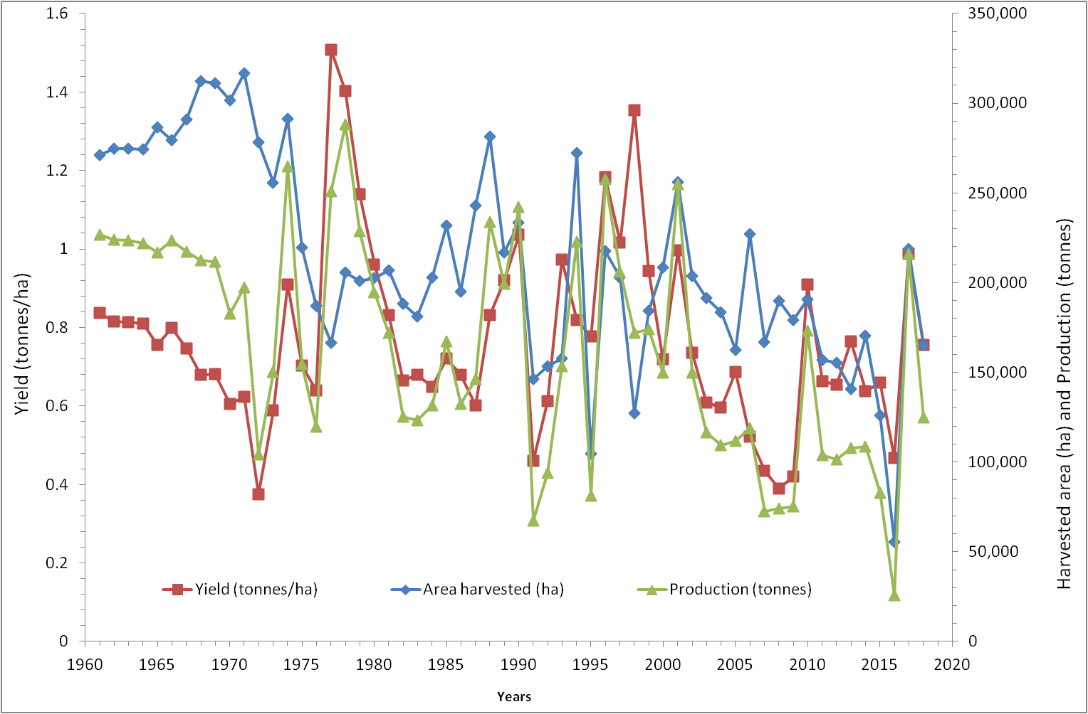

Figure 5: Yield, area harvested & production of cereal crops in Lesotho

The projected annual maximum temperature changes in the near future (2011-2040) for the Highlands, Foothills, Lowlands and Senqu River Valley respectively include a temperature mean increase by at least (1.95, 1.83, 1.66 and 1.95 times) under the medium emission scenario (RCP4.5). Under the high emission scenarios (RCP8.5), the mean increases relative to the global average increase by a factor of (1.92, 1.86, 1.73 and 2.00) for the respective ago-ecological zones. During the mid (2041-2070) and far-future (2071-2100) projection periods, the maximum temperature for the respective zones are projected to increase by (3.26, 3.18, 2.96, and 3.30 times) and (3.72, 3.72, 3.75 and 3.81 times)

The projected temperature increases amplify societal concern that more frequent and intense climate extreme events could occur in the 21st century. Without strong and focused adaptation strategies, climate change could generally be detrimental to cropping systems in agriculture. The most important cereal crops (maize, sorghum, and wheat) have been decreasing in production, the area planted and yield in the last few years due to recurring droughts.

## Cereal Crops in Lesotho

Cereal crop farming is mostly based on traditional low-input, low-output rain-fed production system. The main crops—maize, sorghum, and wheat—are planted on more than 85 percent of the cultivated area (World Bank 2017). Maize is a major staple cereal crop in Lesotho ranking first followed by sorghum and wheat respectively as evidenced by production level and area under which it is grown (Bureau of Statistics, 2013/2014). Maize, sorghum, wheat, beans, and peas occupy about 70%, 12%, 7%, 10%, and 1% of the total area, respectively. Yields vary significantly, depending on the amount of rainfall, but are generally low, contributing to widespread poverty in rural areas.

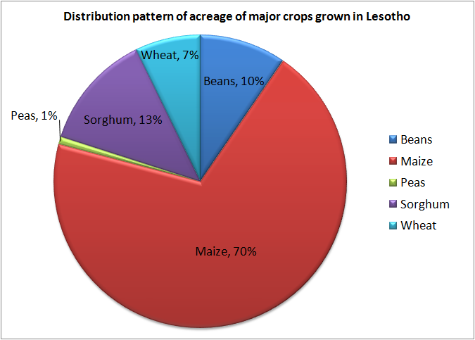

Figure 6: Distribution patter of acreage of major crops grown in Lesotho (BOS)

Lesotho does not have a competitive advantage in cultivating cereals due to its mountainous terrain, challenging agro-climatic conditions, and poor soils, as well as the large economies of scale and high levels of mechanization required for commercial grain cultivation.

Furthermore, cereal crop production, area harvested, and yield have declined across all the major crops in Lesotho. See the picture below. Area harvested of cereal crop has declined from 271,059 ha in 1961 to 56,475 ha in 2017, while yield has plummeted from 8,362 hg/ha to 6,873 hg/ha and production from 226,648 tons to 38,818 tons during the same time period.

Graph above shows that Lesotho’s maize production has fluctuated in past 6 decades and has plummeted from 130,000 tons in 1961 to 70,000 tons in 2020. Production is inadequate to meet the country’s requirement necessitating importation of supplementary maize grain from other countries like South Africa.

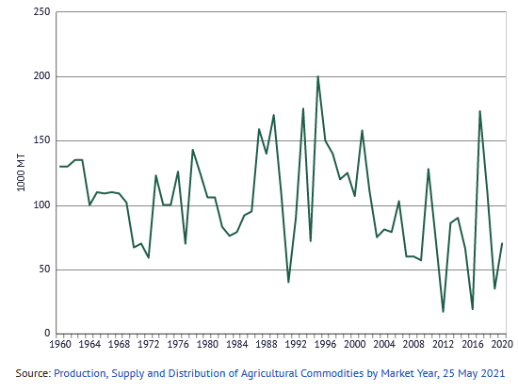

Figure 7: Maize production in Lesotho (FAOSTAT)

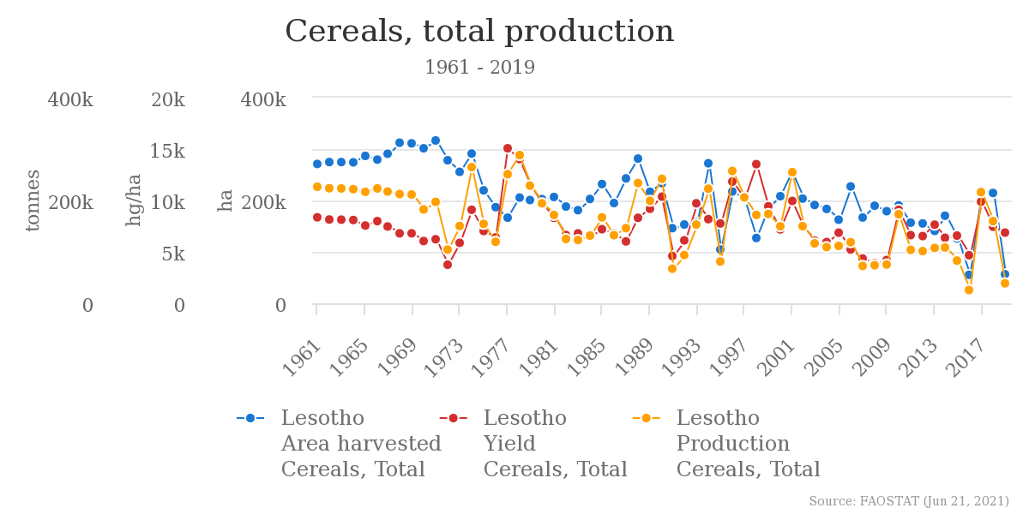

Figure 8: Cereal total production in Lesotho (FAOSTAT)

## Horticulture in Lesotho

Lesotho’s climate conditions are favorable to produce many vegetables and deciduous fruit. A crop suitability map identified 5,500 square kilometers (550,000 hectares) of micro-climate areas favorable for fruit cultivation and an even larger area is deemed to be suitable for vegetable production in Lesotho.

Lesotho’s vegetables production was at level of 32,342 tons in 2019, up from 32,216 tons previous year, this is a change of 0.39%. The graph below shows that vegetable production has risen significantly in past 6 decades from 12,000 tons in 1961 to 32,342 tons in 2019.

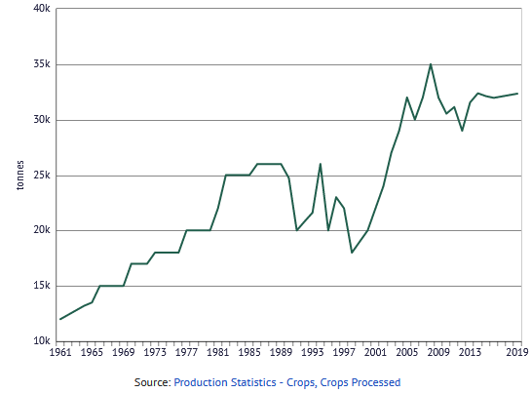

Figure 9: Vegetable production in Lesotho (FAOSTAT)

But this increase has not met with the rising vegetable consumption in the country, which has risen from mere 15,000 tons in 1961 to 59,000 tons in 2018. The main reason for the lag of domestic supply with demand is increasing population, high cost of domestically produced vegetable compared to imported vegetables, lack of consistent quality and increasing consumption shift towards healthy and nutritious food, i.e., vegetables and fruits.

## Impact of COVID-19

These challenges have been exacerbated by the COVID-19 pandemic and subsequent restrictions on movement of people and goods, which has had devastating socio-economic impacts on the country, including sharp increases in unemployment, vulnerability, and poverty. A rapid assessment conducted by the Lesotho National Farmers Union (LENAFU) found that the lockdown, put in place by the government in March 2020, negatively impacted agriculture value chains by limiting access to inputs, extension services, and markets.5 Producers and smallholder farmers lost the maize marketing window because lockdowns coincided with the maize harvesting period, and vegetable production suffered because produce could not be sold and was damaged on farms. Similar impacts were recorded in other value chains, including wool and mohair, milk, manufacturing, tourism, retail, and livestock.

The production chains have been adversely affected. Specifically, green maize has lost marketing window because the harvest period coincided with the lockdown period. Bean production also decreased due to spoilage in the field as at first declaration of national lockdown, farmers were not allowed to access their fields. Winter cropping was also negatively affected as it converged with delayed summer crop harvesting. The production vegetables was good, however the produce spoiled due to closed markets and attack by weeds, pests and diseases.

# Seed System in Lesotho

The seed system in Lesotho consists of both formal and informal sectors. The informal sector dominates as 80 percent of farmers use this subsector. The formal seed subsector is dominated by the Government input subsidy program. The majority of agro-input dealers sell inputs through the subsidy program. The Government input subsidy program has negatively affected the private sector participation in seed marketing in the country. There are efforts aimed at increasing local seed production but face challenges.

Farmers in Lesotho depend on both formal and informal seed systems. In the formal seed system, most seed are imported from neighboring South Africa, sold by local traders, and account for more than 70 percent of seeds bought in the country. The local formal seed producer system is not yet developed to required standards. Few farmers produce certified seed on small scale. Smallholder farmers usually select seed from their previous harvest.

A well-functioning seed system is one that uses the appropriate combination of formal and informal channels to efficiently meet farmers’ demands for quality seeds of suitable crop varieties. The seed sub sector in Lesotho is not well developed, and reliability on imports has made seed accessibility more difficult as costs are usually very high. The local private sector participation is very minimal, so far only one private seed company is being registered to produce seed in the country. Other than that, seed production is mostly done by individual farmers (approximately 70 smallholder farmers). These individual farmers focus on maize and bean crops, not giving other important crops like sorghum and peas the same attention. Few farmers in Maseru district are involved in seed potato production.

As per FAO (2016), sorghum and wheat seed were affordable while maize and bean prices were expensive to most of the households in Lesotho. Although there is the Government input subsidy scheme most farmers do not participate in the programme as they are poor. Most farmers use traditional seeds which have been used from generation to generation and this results in lower productivity. Within the formal seed system, there are limited quantities of crop and varieties. With regards to germination a good percentage of households report that bean seed germination was good and this may be attributed to most bean seed being sourced from the formal market sources. Significant proportions of the farming households claim that the germination of seeds of all the crops to be poor (FAO, 2016). The seed from seed aid have good germination rates and are clean. The seed from formal seed sector was reported to be clean by most households. A significant proportion of the households consider own saved seed and seed from neighbors as clean. Government input subsidy program has limited varieties from which farmers to choose from.

# Food Supply Chain System in Lesotho

A value chain (VC) is a set of connected activities that work together to add value to a product while linking buyers, sellers, and markets. It can also be defined as the goods, services, and processes involved in an agricultural product moving from the farm to the final customer or consumer. Picture below is a typical representation of agriculture value chain.

Value chain actors refer to the individuals, farmers, companies, organizations, and associations with a market chain or value chain that are involved in regulating, producing, buying, selling, and providing services that enable products to move from farmers to markets where they are purchased by consumers. Depending on their position within the chain, or association with the chain, all the actors are seeking to capture market share, deliver maximum value and increase profit margins.

In Lesotho, agriculture markets range from small local markets, where farmers sell directly to local consumers, up to globally integrated modern markets, where thousands of farmers sell millions of tons of produce into mass consumer markets, e.g., wool and mohair. Markets can be categorized as informal market, farm gate market, informal assembly market, informal wholesale markets, informal retail market, formal markets including more regulated and selling more defined products such as Pick n Pay, Shoprite etc.

Based on overall analysis of agricultural value chain analysis, it has been observed that currently agricultural value chain is totally fragmented and disjointed in the country as all of them are working in silos. Primary reasons for weak agricultural value chain in Lesotho are limited access to agro-inputs/livestock materials, extreme weather volatility, too much dependence on rainfall, less irrigation water, lack of knowledge about high value products, limited exposure to high productivity practices, weak market linkages, and inefficient supply chain.

## Fresh Fruits and Vegetables (FFV) Value Chain in Lesotho

For the Lesotho horticulture value chain, about three-quarters of all horticulture (including potatoes) are grown domestically – domestic as opposed to imports, and home-grown as opposed to store-bought. However, since most domestic horticulture does not come to any market, it is the import trade that dominates the commercial horticulture value chain.

The schematic representation of the Lesotho horticulture value chain below indicates the major players and processes currently active in bringing fruits and vegetables to the consumer. In the current Lesotho value chain, imports and import sellers dominate the system. They supply the street vendors, small retailers, institutions, and the supermarkets. The local production of horticultural produce is geared to subsistence farmers and urban gardeners – not commercial production.



Figure 10: Lesotho horticulture value chain (FAO)



### Local Production of FFVs

Although vegetable production has reportedly increased, emerging commercial farmers often suffer from low productivity and challenges in accessing formal markets. Lack of data on vegetable production volumes, yields, and farm revenues complicates analysis of the industry and policy efforts to support the sector. The first pilot commercial horticulture survey identified 198 “commercial vegetable farmers,” defined as those who produced primarily for the market and used irrigation (Bureau of Statistics 2016). The survey covered a limited number of variables, including area planted to different crops and the educational attainment and age of farmers. There are no data on yields or farm turnover. The results suggest that a little more than 600 ha were planted to vegetables by the surveyed farmers. The most common crops were spinach, spaile (traditional green leaf vegetable), and pumpkins.

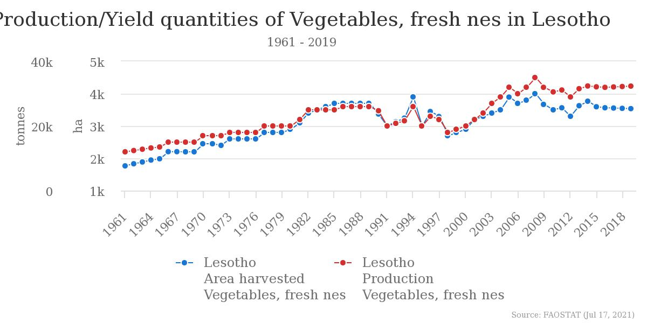

Figure 11: Production and Yield of Vegetable in Lesotho

### Finance

Since the collapse of the Lesotho Agricultural Development Bank, with its rural branch networks, micro-lenders such as cooperative societies and other non-formal financial entities, have assumed the role of providing financial services to the low-income households in the rural and peri-urban areas.

Farmer credit remains a problematic issue for Lesotho agriculture. A number of initiatives are underway to address rural finance issues. IFAD’s Rural Financial Intermediation Programme is assisting the Lesotho Postal Bank to serve farmers and support member-based financial institutions, financial cooperatives and savings and credit groups. NGO programs are promoting savings and credit groups in rural areas.

### Extension and Training

MAFS operates an extension service in all of the districts. The focus remains on cereal and livestock production, but horticulture is increasingly being addressed. The major element of extension and training support are the sixty-seven Agricultural Resource Centers (ARC) across Lesotho. These centers provide technical support and access for farmers to route their problems to experts. Other platforms include irregular farm visits and annual agricultural shows.

MTICM provides weekly market information, but since price data relates essentially to imported vegetables, it may be misleading for commercial producers and irrelevant for subsistence farmers. Recently, MTICM and MAFS have been promoting business skill training for farmers. FAO is active in providing international guidance and training for government officials and extension staff in capacity building programs. The effects of these business “trainings for trainers” have yet to percolate down to the active farmers.

### Retail

The retail level in Lesotho is varied and seems to be changing rapidly. Until a decade ago, street vendors and small stores were the primary retail outlets. Street vendors continue to dominate the retail landscape throughout the country. Fresh produce stalls are intermingled with clothing stalls, electric goods, grooming products, building supply, dry foods, barber shops, etc. Nowhere in Lesotho did we see a market area with stalls dedicated specifically to FFV – nor specifically to foodstuff.

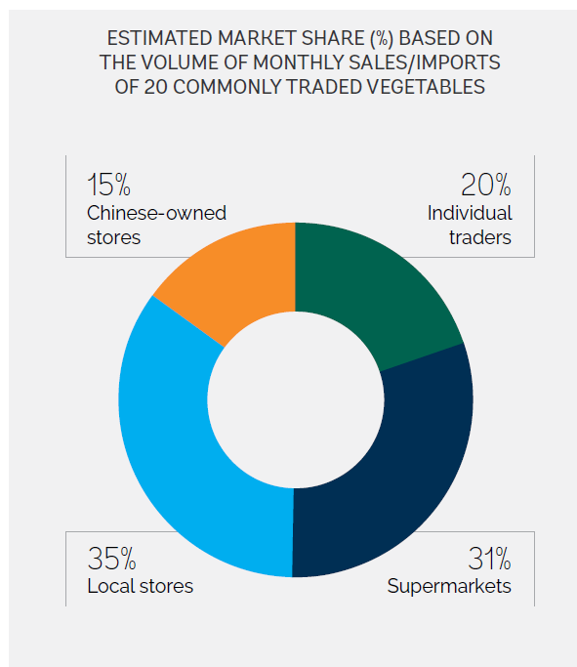

Figure 12: Market Share of Vegetables

The relatively new player in the retail sector in Lesotho, as in much of Africa, is the growing presence of larger supermarkets. The South African ShopRite chain opened its first retail outlet in Lesotho in 2001 and now has six modern supermarkets, with more units planned. In 2009 Pick n’ Pay opened a 2,000 m2 franchise outlet in Maseru. Fruit and Veg City, also a South African firm, has a wholesale operation and retail store in Maseru which in many aspects’ functions like a supermarket – although its selection of dry food products is limited.

### Wholesale

The horticultural wholesale trade in Lesotho – that is, the market link that provides products for retailers to sell - is dominated by importers. Produce is primarily imported from RSA. In the commercial marketplace, it appears that imports are 80% or more of the value of horticulture product[25]. Much of the imported produce probably could not be grown commercially in Lesotho (e.g., citrus), and includes tropical products imported through South Africa from other countries (e.g., bananas.) The largest import item is cabbage – which also is produced on a large scale in Lesotho.

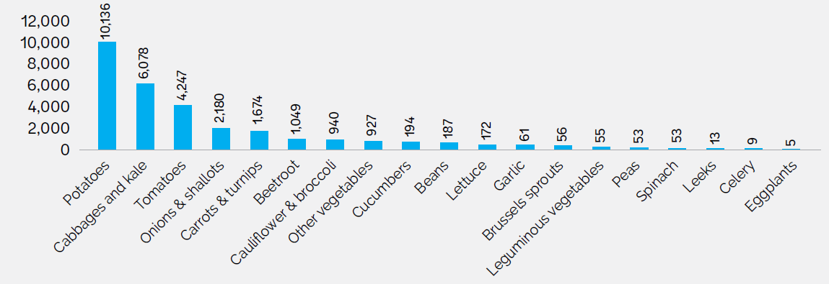

Figure 13: Vegetable import in Lesotho (source: UNCOMTRADE)

There are at least three types of wholesale importers in the country, and they are supermarket chain distributors, e.g., ShopRite and Pick n’ Pay, FFV specialists, such as Fruit and Veg City in Maseru and a handful of additional specialists in Leribe, Berea, Mafeteng and elsewhere, and traders that send semitrailers or smaller tucks to RSA to buy produce and resell cartons and large bags to street venders and to all comers.

### Marketing

Many FFV farmers sell their produce to street vendors and in informal community markets rather than to formal buyers that offer better prices. There are no packing houses, aggregators, or agro-processors in any of the crop value chains in Lesotho (except Lesotho Flour Mills, which imports most of the raw material from South Africa).

### Consumers

The consumers are represented as rural households, urban households, and institutional buyers. Rural households number about 300,000, representing 1.45 million residents of all ages. Urban households total about 120,000 with 428,000 people.13 The institutional sector includes schools, police, and army which are major purchasers of fruit and vegetables. Since they require relatively larger quantities, and try to maintain reasonable sanitation and quality standards, they tend to purchase from larger dealers or from traders with whom they have longstanding agreements of trust. (Some schools, and the Agricultural Faculty, maintain their own fresh vegetable gardens to teach and to feed their students.)

The urban household and institutional markets are the primary focus of the horticulture trade. They have disposable income, and while urban households do have vegetable gardens, they do not rely year-round on their own home garden. Rural households have less disposable income, and greater need and ability to store some vegetables, particularly root crops.

Vegetable consumption in Lesotho is calculated at close to 20 kg. per capita per year, with fruit consumption at about 18 kg. Comparison with neighbors is shown below:

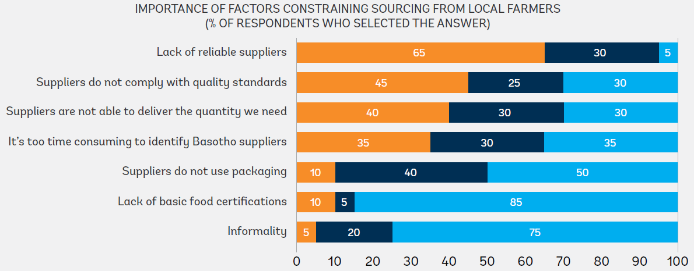

Figure 15: Major constraints for sourcing vegetable produce locally

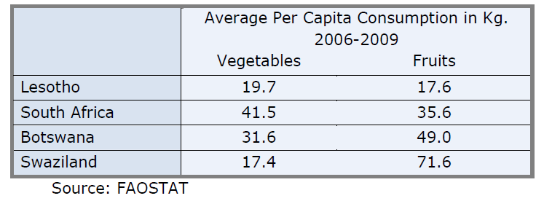

Figure 14: Per capita consumption of vegetables in Lesotho (FAOSTAT)

# Nutrition

## Nutrition Governance Situation

The Kingdom of Lesotho has made a commitment to scale up nutrition in 2014 when Lesotho joined the Scaling-up Nutrition Movement. His Majesty King Letsie III is the African Union Champion for Nutrition and FAO Special Ambassador for Nutrition, and these roles have increased the coverage of and attention to nutrition issues in the country. The launch of the National Nutrition Policy in 2016 marked a significant milestone as it will provide guidance to sectors on the comprehensive approach to address malnutrition using evidence-based strategies to maximize impact.

Nutrition programmes are located across several ministries that have food and/or nutrition security mandates. The key ministries with nutrition departments of units are: Ministry of Health (MOH), Ministry of Agriculture and Food Security (MAFS), Ministry of Education and Training (MOET). The FNCO which is located in the Cabinet Office is responsible for providing strategic leadership and coordination to the sector. The MoH Nutrition Unit, which is located in the Family Health Division, has a policy on Infant and Young Child Feeding, which informs their work. The MoH implements nutrition-specific programmes through the clinics and at community level through village health workers. The MoAFS Nutrition Division, in the Department of Field Services is responsible for implementing nutrition-sensitive actions implemented at community level. This happens with the support of Nutrition Subject Matter Specialists and Agriculture Assistants at community level. The work of the Nutrition Division is guided by the MoAFS Food Security Policy. MoET has an Early Childhood Care and Development (ECCD) Policy, which has informed activities in the care of children under five years through the ECCD network of schools at community level. With the support of REACH and UNICEF, FNCO has been able to undertake several studies in nutrition and governance which will guide and inform the work of multi-sectoral nutrition in order to achieve the scaling up activities in Lesotho.

With the support of REACH and UN Network (FAO, UNICEF, WFP and WHO), FNCO has been able to undertake several studies in nutrition and governance which will inform the work of multi-sectoral nutrition in order to achieve the scaling-up of core nutrition activities in Lesotho.

The main findings on the nutrition governance situation point to the existence of weak legal and policy frameworks in the country which do not adequately provide an enabling environment for multi-sectoral nutrition. They also emphasize the need for nutrition to be mainstreamed in all policies, frameworks and strategies and the importance of strengthening the nutrition coordination mechanisms. The Food and Nutrition Commission was established in 1998 through a Cabinet Memorandum and had a Cabinet Sub-committee chaired by the Prime Minister. This structure has not been functioning for a number of years due to inadequate expertise, lack of knowledge about nutrition and its impact on the population and economy, therefore rendering nutrition a low priority in Lesotho. For scaling-up nutrition efforts to be successful support and leadership at the highest levels of government is required.

The structure of the FNCO lacks experienced senior managers with functional skills and lacks technical capacity at national and district levels to guide and direct staff and all key stakeholders in the sector. Financial resources, equipment and infrastructure are severely lacking. The FNCO capacity must be strengthened in all these areas if it is expected to lead implementation of the Food and Nutrition Policy and Strategy. The collaboration mechanisms are also weak and cannot facilitate effective multi-sectoral collaboration. The nutrition units within key ministries are severely inadequate to inadequate nutritionist at national and district levels, the structures are also weak due to their low locations in the ministries and lack decision making power and other resources to effectively implement sectoral nutrition policies and strategies.

## Infant and young child feeding practices and state of nutrition



### Birthweight

Although the prevalence of underweight children has marginally improved, low birth weight remains steady at 9.4 percent.

### Infants (0-6 months) – Breast feeding

Colostrum is contained in the mother’s first milk, just after birth, and it contributes to the prevention of infections and is extremely rich in nutrients. Early initiation to breastfeeding promotes good lactation; it also presents a series of benefits for post-partum mothers (reduces breast and ovarian cancers) (LDHS, 2014). In Lesotho, 65% of newly born children are initiated to breastfeeding within the first hour of birth and 66.9% of children aged between 0 to 6 months are exclusively breastfed (LDHS, 2014).

### Children (6-23months) – Complementary feeding

Complementary feeding behaviors are poor. Complementary foods are often introduced too early or too late and are insufficiently diversified. Only 11.3% of children 6-23 months are fed according to appropriate complementary feeding practices. This indicator suggests that poor complementary feeding contributes to under nutrition because infants are not able to get enough calories and nutrients from breast milk alone after about 6 months. With a high anemia prevalence among children under five years of 51% (2014, LDHS), fewer than half of all children 6-23 months (40.5%) consuming iron rich foods and only 60.5% of children 6-23 months consuming vitamin A rich food, micronutrient malnutrition remains a serious concern for Lesotho. These inadequate infant and young child feeding practices coupled with food insecurity of households, the HIV/AIDS pandemic and low access to health services are among the major causes of chronic malnutrition in young children. In light of this, deworming also remains a priority if micronutrient malnutrition is to be reduced.

### Stunting

At least one in three children under the age of five years is stunted (33.2 percent according to the Lesotho Demographic Health Survey of 2014). Whilst both chronic and acute malnutrition in this age group of children has decreased since 2004, stunting remains high and above the WHO public health threshold of 29 percent for moderate prevalence. Chronic malnutrition is high across all districts, especially in Butha-Buthe (40.3 percent), and the mountain districts of Mokhotlong (47.7 percent) and Thaba-Tseka (40 percent). The population density varies by districts with the largest number of children chronically malnourished in the higher population districts of Maseru, Leribe and Mohale’s Hoek. Two of the districts with the highest stunting rates (Mokhotlong and in Thaba-Tseka) have extreme concentrations of poverty. The majority of the population in these districts is in the lowest wealth quintile (53% and 55%, respectively). About 45 percent of the adult population in Lesotho is stunted (COHA Lesotho, 2016). Wasting is experienced across all districts, although the prevalence of wasting remains low (under 5%). The districts with the largest number of children under five with acute malnutrition are Maseru, Leribe and Berea.

|  |  |  |  |
| --- | --- | --- | --- |
| **Indicator** | **WHA Targets 2025** | **Lesotho Current Status 2016 (from 2009** | **2025 target for Lesotho** |
| Stunting | 40% reduction in children Under 5 years of age | 33% (from 39%) | 23.4 % |
| Anemia | 50% reduction in women of childbearing age | 27% (from 26% | 13.5% |
| Low birth weight | 30% reduction | 10.4% (from 9.3%) | 7.3% |
| Childhood overweight | No increase | 7% (from 7.2%) | <7% |
| Exclusive breast feeding | 50% increase in children under 6 months | 67% (from 54%) | 100% |
| Wasting | Reduced & maintained at <5% | 2.8% (from 3.8% | <5% |

Source: WHO Ambition and Action Strategy, 2016-2025.

## Adult Nutritional Status (Overweight and Obesity)

Adult nutritional status is measured by Body Mass Index (BMI), which is an index of weight-forheight. International classifications of BMI rates have been established for adult underweight, overweight, and obesity. However, it has been recognized that BMI may not correspond to the same degree of fatness in different populations due, in part, to different body proportions. The health risks associated with increasing BMI are continuous and the interpretation of BMI grading in relation to risk may differ for different populations. Unfortunately, trend data on adult BMI is limited but overweight and obesity is believed to be rising rapidly in Lesotho. Forty-five (45%) percent of women and 13 percent of men aged 15–49 was overweight or obese. Overweight and obesity correlates with wealth and age: 55 percent of women in the richest socio-economic strata are overweight or obese compared to 25 percent in the poorest. Eighteen percent of women aged 15–19 is overweight or obese, while 67 percent of women aged 40–49 are overweight or obese.

Overweight and Obesity are defined as excessive fat accumulation that presents a risk to health. Overweight and obesity are major risk factors for a number of chronic diseases including diabetes, cardiovascular diseases and cancers. According to Lesotho STEPS Survey 2012, 41.5% of adults (24.8% males and 58.2% females) are overweight, and 19.9% are obese (7.9% males, 31.9% females). While is shown that there is a high level of overweight among women (45% urban and 42% rural), the rate of overweight is lower for men with 12% (LDHS, 2014).

## Women of childbearing age (15-49 years)

In Lesotho childbearing starts as 15-19 years with 19% already having a first child. Children born to adolescents are more likely to have low birth weight and to become stunted or wasted. In addition to ensuring that mothers are well nourished before and during pregnancy, delaying the age of first pregnancy is key to reducing malnutrition during the first 1000 days. The rates of stunting is more than 2 times higher among children whose mothers have only attained primary education compared to children whose mothers have attained higher levels of education. Therefore, keeping girls longer in school delays the age at which a woman will give birth to her first child and will therefore help to prevent malnutrition. Over a third of women have begun childbearing by age of 19 (LDHS, 2014)

Inadequate intra-uterine nutrition is proven to result in low-birth weight (small for gestational age) and poor development of central nervous system in infants (Zimmet et al, 2014). The rate of malnutrition among pregnant women remains unknown, but low-birth weight (new-borns weighing < 2.5kg), which serves as a proxy for maternal nutrition status currently stands at 10.4% (LDHS, 2014). According to the LDHS, 2014, the prevalence of low birth weight is higher in adolescent mothers which increased from 8.9% (2009) to 13.8%. This is coupled with high rates of anaemia (haemoglobin < 11g/dL in pregnant women) among women of childbearing age 46.5% (LDHS, 2014). While over a quarter of women in the country have some form of anaemia.

## The Burden of Malnutrition



### Diseases and poor health care

A major causal factor for high malnutrition rates in Lesotho is the high prevalence of infectious diseases such as diarrhoea, HIV and TB and poor health care. The report on the Cost of Hunger Study in Africa (COHA) Lesotho 2016, states that less than half (42%) of the 33.2% of stunted children under the age of 5 years in Lesotho, receive proper health attention, and most of the health costs associated with undernutrition occur before the child turns 1 year old.

Poor access to improved water sources and sanitation facilities and hygiene practices. Prevalence of diarrhoea, associated with compromised WASH practices is a major contributor to stunting, and the use of zinc supplements to manage diarrhoea is hardly practiced, as less than 1% of the 12% of children who suffer from diarrhoea receive zinc supplements (LDHS, 2014). Yet zinc supplementation can decrease the number and duration of diarrheal episodes. A combination of contaminated water, poor hygiene and inadequate sanitation practices is the main cause of diarrhoea. About 22.8 percent of rural people do not have access to an improved water source and a majority of them do not treat their drinking water. Nationally, only 11.8 percent of households use an appropriate water treatment method before drinking (LDHS 2014).

### Chronic food insecurity

Inadequate food intake (meal frequency), limited diversity of diets and the low intake of micronutrients, in particular, are major drivers of chronic malnutrition and micronutrient deficiencies in Lesotho. Nine out of ten children in the age-group 6-23 months does not have an adequate diet. Intake of micro-nutrients is in particular very low. About 39.2 percent of children 6- 23 months of age are not fed the recommended minimum number of times per day according to their age (LDHS 2014). Food insecurity (market scarcity, high cost and low household income to purchase) is a major factor affecting the ability of households to secure adequate food to meet their needs.

### Low levels of education

Low educational level of the mother, partly attributed to school dropouts associated with early marriages and teenage pregnancies and orphan hood is also a major contributor. In Lesotho, available research evidence shows that children of mothers with secondary education are 50% less likely to be stunted (LDHS, 2014). Better educated mothers and caregivers of children have more information sources and mental capacity to comprehend nutrition messages, have more income and exercise better nutrition purchasing choices. They are more likely to feed themselves and their children better (balanced diet and more frequently).

### Household poverty

Low household incomes lock households in a vicious circle of poverty, low investment and underdevelopment, which is contributing to low food self-sufficiency, inability to pay for education, inadequate purchasing power to interact with food markets and secure their food needs, failure to improve their access to health services, improved water sources and sanitation. Poor households are less likely to afford soap much needed for good hygiene practices and prevention of diarrhoea. In 2014, the LDHS observed that children under the age of 5 years who came from households in the lowest wealth quintile were 3.5 times more likely to be stunted than those in the wealthiest quintile. The former were also 5 times more likely to suffer from acute malnutrition than those from the wealthiest households, but malnutrition was also found in some of the wealthiest households thus showing that wealth alone is not a sufficient condition for eradication of malnutrition.

## Nutrition Specific Interventions

1. Lesotho is rich with dedicated past and on-going efforts to address nutrition and there is success since malnutrition (especially chronic) is declining. Infant and Young Child Feeding has been included in the Health Sector Strategic Plan 2012/13-2016/17. Interventions have focused on training of health personnel utilizing the IYCF Guidelines adapted from WHO 2010 and 2016 versions; exclusive breastfeeding for the first 6 months and assisting the HIV-positive mother to make informed choices on duration of breastfeeding, adequate and safe infant and young child feeding including supporting the mother or caregiver of an HIV exposed infant to carry out a feasible feeding option based on their situation.
2. The then Ministry of Health and Social Welfare in 2012 implemented a pilot programme on comprehensive care of pregnant women from the community to the health centre level, linking key primary care services to ANC and facility-based delivery in the Mountains Region.
3. Voluntary industrial fortification of food is being practised by 2 food producers. Lesotho benefits from the universal salt iodisation on its imported salt and has since late 1990s actively educated the population on the benefits and use of iodised salt and introduced the salt iodisation regulation in 1999.
4. Studies on the level of salt iodisation are outdated, but have shown that the level varies and very low levels of iodine were generally found in the salt. (Sebotsa ML, Adjei R. 2002). The Demographic Health Survey of 2014 also confirmed that 7% of households do not use iodised/iodated salt. Lesotho imports all its salt but the monitoring of the salt is however weak and recent observations are that the prevalence of goitre is again rising.
5. Vitamin A routine supplementation is done through public health facilities (the Ministry of Health and CHAL) and mop-up campaigns during Child Health Days.
6. The Ministry of Agriculture and Food Security has embarked on efforts to strengthen the food value chain towards achieving sustainable diversification and commercialism with an emphasis on developing integrated value chains10. This entails building effective agricultural support institutions, improving risk management in the sector and reducing stock theft. The livestock subsector – in particular wool and mohair – has been singled out as one of the country’s most important value chains and possesses considerable potential to contribute to economic growth and poverty reduction (FAO, Lesotho Website, 2017).
7. Government together with the World Bank and International Fund for Agriculture Development (IFAD) has been implementing from 2012 to-date a Smallholder Agricultural Development Programme (SADP) to support smallholder farmers in exploiting opportunities and increasing productivity, as well as diversifying into market-oriented agriculture. The programme focuses on four selected districts with high agricultural potential (Botha-Bothe, Leribe, Berea and Mafeteng), where projects are underway in irrigated vegetable production, wool and mohair, dairy, piggery and poultry hatcheries, among others.
8. In response to the food insecurity crisis in Lesotho, the MAFS with support from FAO, have been implementing a three-year programme to assist vulnerable households with agricultural inputs and know-how on agricultural technologies, helping communities to adapt to climate change and build their resilience to better withstand future shocks. The Emergency and Resilience Programme (ERP) provided input support and capacity development on conservation agriculture, home gardening and nutrition, targeting communities, lead farmers and extension services.
9. Government has continued to commit itself to subsidizing agriculture and irrigation revitalization until local farmers are adequately developed and local food reserves stocked with ample grain crops. Lesotho seeks to reduce its reliance on imports which satisfy more than 91 percent of its annual demand for sorghum and wheat.
10. Block farming and conservation agriculture have been promoted to intensify production and simplify management, on one hand, and conserve soil structure, fertility and water on the other, leading to higher yields, of high-quality crops that can be sold commercially.
11. Significant efforts have been invested in improving breeds of various stock (especially small stock), addressing stock theft, improving animal nutrition, controlling outbreaks of animal diseases and providing infrastructure to prevent and control the transmission of disease, with special focus being placed on production of wool and mohair, poultry, piggery, dairy and beef (Joint Agri-Business and Department of Agriculture Forum for Africa.
12. The Government of Lesotho developed a National Social Protection Strategy in 2014 and rolled out a package that includes a universal infant grant per infant under 2 years, child grant to all extremely poor households with children, national seasonal employment guarantee scheme to offer public works to the poor of working age, universal old-age pension to those 68 years and above, disability grant to all those with severe disabilities with transfer value indexed to inflation, and a discretionary public assistance grant to all requiring short-term reactive temporary support.
13. The Government has been implementing a National Sanitation Programme for decades and has introduced a system of constructing latrines.
14. Several capacity building initiatives have also been implemented on nutrition governance and implementation by the Ministry of Health with financial and technical support from UN and other development partners. The target groups varied by type of training, with health workers, FNCO staff, Ministry of Education and Training officers, and Ministry of Agriculture staff, being reached by different combinations of the above training courses.
15. Lesotho has also undertaken a series of water sector reforms and reorganization to strengthen regulatory, service provision, coordination and decentralization. It revised the national water policy in 2007 and the water act in 2008 as part of efforts to accelerate efforts to achieve universal access to water access by 2020. In addition, with support from the AfDB, the Government has been implementing a four-year Rural Water Supply and Sanitation Project for the Lowlands (December 2013 – December 2017). The project promoted the use of existing water resources to increase the coverage and extend the benefit to the rural population. It also promoted donor coordination in the water sector.
16. WFP has been supporting the Government of Lesotho to implement the school feeding program and provides technical support to the Ministry of Education and Training (MOET). The outcome focuses on ensuring that the Government has the right capacity in place to effectively manage a school feeding program that allows children in food insecure areas to have regular access to nutritious foods.

# Food Consumption and Utilization

Lesotho is considered a consumer country due to its heavy reliance on other regions to meet its food needs, from maize, vegetables and fruits to eggs, meat, chicken and fish. Lesotho relies on neighboring countries for virtually all the food that is consumed in the country. This exposes the city and the whole country to vulnerability in food insecurity especially during economic and political crises where the country is faced with severe food scarcity and high food prices or when transport systems are disrupted as was the case with the pandemic of covid 19. Low-income earners and the poor especially the rural population struggle to meet their minimum daily requirements for food intake as they can only access poor quality foods with low micronutrient content.

The diet is mainly based on cereals - predominantly maize, and, to a much lesser extent, wheat and sorghum. Rice is gaining importance in the diet of the urban middle-income group. The staples are complemented by starchy roots (potatoes) and fruit and vegetables. Cereals provide more than three-quarters of the dietary energy supply. The importance of maize in the diet, the decline in the production of this staple and the heavy dependency on cereal imports make the country very vulnerable to economic and climatic shocks for its food supply. The dietary energy supply meets population energy requirements, but the share of lipids in the supply is lower than recommendations and that of protein is at the lower limit. Prevalence of undernourishment has remained stagnant over the last decade (15% in 2003-2005). The decline in cereal production, low income and rising staple food prices contribute to worsening the situation.

Food consumption is at borderline and acceptable levels. Based on the recent LVAC, eight percent urban households had poor food consumption compared to 15 percent of rural households. Rural areas of Mokhotlong, Mohale’s Hoek and Berea had more households (22- 31%) with poor food consumption than rural areas in other districts. Mokhotlong and Berea urban also recorded the highest proportion of households with poor food consumption (15% and 17% respectively) compared to other urban.

Consumption of Vitamin A rich foods is higher than consumption of iron rich foods in most households across the country in the case of urban and rural areas. The highly consumed vitamin A rich foods in the rural areas is green leafy vegetables and this was evidenced in the LVAC report which indicated that 30-60 percent of rural households consumed vitamin A rich foods on daily basis. Additionally, the LVAC 2017 report showed that iron rich foods were the least consumed foods, with 43-71% households recording no consumption of this food group at all, while 27-53% recorded consumption of protein rich foods ‘sometimes’ (1-6 days). According to the LVAC report 2017, consumption of iron rich foods remained low even in urban areas. However, urban households of Mafeteng presented a different picture as 96% consumed vitamin A rich food daily, 87% consumed protein rich foods and 61% consumed iron rich foods. In more than half of all households the estimated intake of calcium, fat, iron, riboflavin, vitamin B12, vitamin C and zinc is inadequate.

The results of post distribution monitoring showed improved food consumption for both male- and female-headed households, with more than half the households recording acceptable food consumption. More than 90 percent of households in the Quthing an Mohales’ Hoek districts consumed vitamin A rich foods every day, while more than 80 percent consumed protein rich foods at least once a week. Female-headed households showed improved consumption - a positive achievement towards the targets. However, the proportion of households reverting to negative coping strategies increased, while consumption-based coping strategy index (rCSI) stabilized in Quthing and deteriorated in Mohale’s Hoek. This was attributed to the heavy rains, flash floods and hailstorms experienced in the two districts, that resulted in damaged infrastructure, loss of lives and livelihoods leading to many households diverting their incomes from buying food to meeting other needs. The Minimum Dietary Diversity for women (MDD-W) was not measured due to inadequate resources.

## Consumption of Fruit and Vegetables

Consumption of fruit and vegetables is low. Lesotho remains far below the WHO recommended intake of 400 g of fruit and vegetables per day. The 2018 Global Nutrition Report (GNR) estimated that only 68 g of fruit and vegetables are consumed on average on a daily basis, with only 128 g per person/day available throughout the country. Similarly, Lesotho misses the mark on dietary energy from non-staples, which stands at a low 20 percent, meaning that 80 percent of all dietary energy comes from energy dense foods such as cereals, starchy roots and oil. While these dietary patterns might be influenced by behavioural factors such as choices, the data indicates that production – and subsequently availability, are also an issue. The availability of vegetables, fruit and meat (as measured by trade balance) has remained unchanged. WFP, 2019 – Fill the Nutrient Gap Lesotho- Summary Report

Behavior changes around vegetable consumption: consumer motives and accessibility in almost all parts of the world, current consumption of fruits and vegetables is below WHO recommended levels. Fresh fruits and vegetables are challenging to produce and distribute. They are susceptible to temperature extremes during production and are highly perishable and so need to be brought to market in an unbroken cold chain or processed (dried, canned, pickled etc.) rapidly. Technological innovation should consider potential to improve fruit and vegetable availability by increasing consumption of fruit and vegetables in low-income groups in Lesotho through food systems innovation.

## Consumption of Traditional Foods

Lesotho traditional food system supports a wide variety of foods produced from the different agro-ecological zones. Traditional foods are foods produced locally which form part of the food culture inherent in the locality. The local climate enables the cultivation of such crops either for subsistence or for cash or both. Lesotho traditional foods can assure nutrition security even in all segments of the society including the under-fives and school age children. It is however sad that a large segment of the population is not consuming traditional foods as they should due to a number of reasons which include dislike of taste, texture, appearance and associations with poverty. They are shifting to less nutritious high energy urbanized diets leading to emergence of overweight and obesity occurring side by side undernutrition.

## Consumption of Processed Foods

Lesotho like other low-middle income countries is undergoing social and economic changes, which are resulting in increased urbanization with a potentially negative impact on health-related behaviors. This increasing urbanization is exposing Basotho to a more sedentary lifestyles and highly processed and unhealthy foods, which are high in refined carbohydrates, saturated and trans-fats, salt and sugars. Evidence from different studies has implicated a role of early-life exposures, maternal diet during pregnancy, post-natal growth, and childhood diet to chronic diseases. Hence improved maternal, infant and young child nutrition lay a foundation for NCDs prevention in a number of different ways (WHO, Nutrition Strategy, 2016-2025).

## Geographical variations (Food Environment)

In rural areas, diets are composed of staple crops (maize, wheat, and sorghum) and leafy vegetables. In cities and higher income groups, the share of (animal) proteins and fats is higher. Lesotho faces several barriers to increasing vegetable consumption in urban areas of Lesotho. Limited year-round availability, affordability, need for convenience, food safety issues and the attraction to the modern or Western lifestyles are constraints for healthy food choices by urban middle-class consumers. Next, cultural beliefs and taboos as well as religious beliefs are also found to influence the food choices of consumers. The vegetable availability is region- and season-dependent, and products are mostly eaten fresh since storage possibilities are few and substantial losses occur due to inadequate preservation and transport.

Also at the national level, the availability of vegetables is insufficient to meet the recommended levels of intake. For lower Social Economic Classes, the affordability of vegetables is problematic due to low purchasing power of households, and the necessity to priorities energy-dense foods, which are generally cheaper. Across all urban consumers, including the lower SEC, constraints in the time available for shopping and preparation of food appears to drive consumers towards increased consumption outside the home. Convenient foods are typically high in fat and carbohydrates, and low in vegetables and other nutrient-dense foods. Those seeking to shift to healthier, but convenient alternatives, such as, fresh fruits and vegetables, are faced with the increasingly expensive costs of nutritious foods relative to the fast-food alternatives.

The large distances in Lesotho between rural and urban areas, bad infrastructure, lack of good transportation means, and lack of storage are all serious challenges for the food supply meeting the demand. The difficulties in supply of perishable goods in combination with different lifestyles leads to changes in urban consumption preferences.

# Food Waste Management

Food loss and waste pose a myriad of challenges and lost opportunities for farmers, consumers, and societies as a whole.

## Post-Harvest Handling and Storage

A major contribution to food loss, especially in developing regions, is the lack of adequate handling of and storage facilities for fresh products such as fruits, vegetables, meat, and fish. In developing countries, 19% of fruit and vegetable loss occurs during handling and storage (FAO 2011). These food items can quickly spoil in hot climates and thus require proper cool storage after catch, slaughter, or harvesting (Rolle 2006; Stuart 2009). Additionally, failure to store cereal or pulse crops in airtight conditions allows moisture and pests to enter, potentially causing mold, toxin, or pest contamination of the crop (Lipinski et al. 2013). This often means that farmers must sell off their entire crop soon after harvest, which can mean receiving lower prices as supply will be high at this time (Kimenju et al. 2009). Thus, introducing and investing in technologies which allow for the proper handling and storage of fresh produce and grains in low-income countries could help reduce food loss.

Proper handling of fresh fruits and vegetables after harvest and during transport is critical, as these items can easily be bruised or blemished, becoming unmarketable (Kennad, 20, 19). Sacks and bags are often used in developing countries to transport produce, but these provide little protection (Kennad, 2019). One option is to use plastic crates, which provide more crop protection, are reusable for up to five years, and can often ease manual labour due to manageable size and presence of handles (Lipinski et al. 2013). One study conducted in Sri Lanka found that plastic crates reduced vegetable losses by weight from 30% to 5%, compared with previous handling strategies (Fernando 2006). However, plastic crates can be difficult for some farmers to secure, either due to availability or price (Kennad, 2019). Thus, there is research needed to identify better handling and transport containers using locally sourced and environmentally friendly materials. Increasing investment in infrastructure (i.e., building reliable roads) and introducing refrigeration to store food would reduce food losses and allow fresh food to arrive at the market more quickly, preventing spoilage (Lipinski et al. 2013). If electric refrigeration is not an option, evaporative coolers could be used to extend shelf life of food and reduce spoilage (Lipinski et al. 2013). Evaporative coolers do not require electricity and keep food at lower-than-room temperatures by utilising the evaporation of water in an outer vessel to create a cooling effect on the inner vessel, where the food is stored. Damage from pests is an additional source of post-harvest food losses. Innovative packaging strategies can help reduce food loss.

Food safety risks also occur throughout the food supply subsystem As with food loss and waste, food safety risks begin with production, particularly for livestock systems where animal parasites, pathogens and toxins affecting consumer health enter the system.

## The role of food processing in diet quality

While there are no official international guidelines available to date on the recommended amount of foods with differing degrees of processing. Processed foods typically contain little or no wholefoods, are ready-to-consume or heat up and are fatty, salty or sugary and depleted in dietary fibre, protein, various micronutrients and other bioactive compounds. Examples include: sweet, fatty or salty packaged snack products, ice cream, sugar-sweetened beverages, chocolates, confectionery, French fries, burgers and hot dogs, and poultry and fish nuggets. This is because these foods have very high energy densities, are high in free sugars, unhealthy fats and salt and are low in dietary fibre, all of which increase the risk of obesity and other diet-related diseases. On the other hand, some forms of processing can be beneficial for diet quality. Processed foods such as pasteurized milk, bread made through fermentation, canning and freezing vegetables and flours made from legumes, all provide important opportunities for preserving foods, converting inedible into edible foods and converting difficult-to-prepare foods into nutritious and convenient forms. These processing methods can help to increase food availability, extend seasonality through the ‘hunger gap’ and importantly, make food safer to eat (Food Systems Diet Quality, 2016).

# Major Policies Defining Food Systems in Lesotho

Lesotho has several important policy instruments in place for the development of food systems in the country. Some of the important policies guiding the food systems development are:

1. National Strategic Development Plan (NSDP) II 2018/19 – 2022/23
2. Lesotho Food Security Policy 2005
3. National Action Plan for Food Security Policy 2007 - 2017
4. Agriculture Sector Strategy 2003
5. Lesotho National Climate Change Policy 2017 – 2027
6. Lesotho Food and Nutrition Policy 2016 – 2025
7. National Seed Policy 2016
8. Subsidies in the Agriculture Sector: Policy Statement and Implementation Framework 2003

## National Strategic Development Plan (NSDP) II 2018/19 – 2022/23

NSDP II is the backbone of the rural economy where 65.8% of the population lives, as it proposes that agriculture remains a critical sector for food security and employment creation.

NSDP II outlines two key objectives for agriculture development, and they are:

* To ensure sustainable commercial agriculture while remaining cognizant of climate change impacts, environmental degradation, other natural disasters, as well as harmful cultural practices that have rendered the economy vulnerable,
* To increase agriculture production and its commercialization. The country will address issues related to management of range, water sheds, protection of the environment and biodiversity, and reversing alarming environmental degradation that has aggravated the food insecurity situation.

## Lesotho Food Security Policy 2005

The policy adopted the definition of food security from The World Food Summit 1996 as a situation when all people, at all times, have physical, social and economic access to sufficient safe and nutritious food to meet their dietary needs and food preferences for an active and healthy life. The widely accepted definition of food security implies that several conditions are to be fulfilled at the same time in order to achieve a state of food security, namely:

* Availability: Food supplies must be enough to feed the population,
* Access: All people must have physical, social and economic access to sufficient food,
* Stability: Access and availability must always be ensured,
* Effective utilization: The food consumed must be safe and nutritious.

Food insecurity exists when at least one of these conditions is not fulfilled.

It is mentioned in the policy that nutrition security is also crucial when addressing food security. Nutrition security is defined as a situation where all people at all times are able to utilise sufficient nutrients to live an active and healthy life. Food security is a necessary but not sufficient condition for nutrition security. This is because other factors, like individual health, the level of hygiene in the environment and the quality of care can interfere with the translation of food security into nutrition security.

The Lesotho Food Security policy has defined a number of areas including promotion of rural and urban employment, SMME development in formal and informal sectors and migrant labor opportunities, promotion of input supplies, promotion of conservation farming, promotion of block farming, and promotion of livestock production and improvements in range management for development to strengthen food security in the country.

## National Action Plan for Food Security Policy (NAPFS) 2007 – 2017

The National Action Plan for Food Security Policy was developed with the purpose of implementing the Lesotho Food Security Policy. The action planned was meant to run for ten years; 2007 - 2017. It contains five (5) programs: commercial and household food security, natural resource management, safety nets and social protection, food supply stability and national availability, NAPFS support structures.

## Agriculture Sector Strategy 2003

This strategy has six overarching goals, including food security, poverty reduction, sustainable environmental management and conservation, improved efficiency in food production, improved income distribution, and increased share of agriculture in GDP.

## Lesotho National Climate Change Policy 2017 – 2027

The National Climate Change Policy covers all areas that are affected by climate change. Agriculture is therefore not immune against climate change shocks. The policy is panned to run for ten years from 2017 – 2027.

The overarching objective of the policy is to ensure that all stakeholders address climate change impacts and their causes through identification, mainstreaming and implementation of appropriate adaptation and mitigation measures, while promoting sustainable development. Specifically, the policy fosters development of processes, plans, strategies, and approaches that:

* Promote climate-resilient, social, economic and environmental development that is compatible with, and mainstreamed into, national development planning and national budget-setting processes;
* Explore low-carbon development opportunities, nationally and internationally, in order to promote the sustainable use of resources; and
* Strengthen a framework that promotes efficient climate change governance, strong international cooperation, capacity building, research and systematic observations, clean technology development, transfer and use, education, training and public awareness and financing in a way that also benefits the most vulnerable groups through the implementation arrangements to be defined in the strategy.

## Lesotho Food and Nutrition Policy 2016 – 2025

The goal of Lesotho Food and Nutrition Policy is Lesotho attains food security and optimal nutritional status, contributing to the improvement of the health status of Basotho, therefore effectively contributing to the national socio-economic growth and development.

The general objective of the national food and nutrition policy is to improve food security and nutritional status of Basotho. The specific objectives are:

* To strengthen the institutional capacity and position of nutrition as a priority in multi-sectoral development agenda for Lesotho.
* To create an enabling environment for the coordinated and effective implementation of the food and nutrition interventions.
* To strengthen the implementation of multi-sectoral nutrition specific and nutrition sensitive interventions at household, community, district and national level.
* To effectively undertake nutrition surveillance, monitoring and evaluation as well as periodically share information on the nutrition status of Lesotho.
* To undertake behavior change activities, conduct social mobilization and advocate for nutrition (ACSM = advocacy, communication and social mobilization).
* To ensure coordinated and appropriately prioritised nutrition research for development that contributes to and supports policy objectives, poverty reduction and strategy reviews; and
* To ensure that nutrition is integrated into sector plans through strengthening of efforts of relevant sectors, to improve food and nutrition situation in Lesotho.

## National Seed Policy 2016

The National Seed Policy is aimed to ensure through actions consistent with other sectorial policies and development goals, the availability of, and access to quality seed of various crops in an efficient and sustainable manner in order to enhance crop productivity and food and nutrition security and trade in Lesotho. The key objectives of the policy are:

* To develop an effective, efficient and sustainable seed system capable of supplying high quality seeds to satisfy national seed demand as well as export.
* To support and encourage variety development, maintenance and seed production programs;
* To streamline germplasm conservation, variety development, evaluation, registration, dissemination, and maintenance procedures in the country; as well as compliance with variety release and registration protocols at regional level (SADC).
* To promote the use of improved varieties and high-quality seed in extension messages and materials used in farmer training and demonstrations to reinforce the message.
* To promote the development of an integrated seed industry involving both the formal and informal seed supply systems.
* To promote public and private sector partnerships in service delivery within the seed industry.
* To regulate seed trade with emphasis on importation.
* To enhance seed marketing and distribution.
* To provide a legal framework for seed quality control and certification, imports and exports, intellectual property rights (IPRs) to include plant breeders’ rights and farmers rights, and other seed related issues; and
* To strengthen the existing National Seed Services that will gradually evolve to a fully-fledged National Seed Certifying Authority to oversee the entire system.

## Subsidies in the Agriculture Sector: Policy Statement and Implementation Framework – 2003

Subsidy is one of the policy tools that the Government of Lesotho is using to implement other policies like food security policy. The main objectives of the policy are to reduce poverty and food insecurity in the country. Provision of subsidies is looked at as:

* Incentive to diversify from inefficient farming practices to crops and livestock appropriate to the areas in which they are produced and kept.
* Incentive to adopt efficient and appropriate farming technologies, which include among others, subsidy on capital investment; and
* A way of helping poor households and smallholder farmers to access inputs at lower and affordable prices. This is due to high inputs prices in the market.

The policy outlines the implementation strategies as follows:

1. The crops are subsidized in areas which are agro-ecologically appropriate. Not all crops are subsidized across the country.
2. Priority for subsidies with most impact: here the Government determines the type of subsidy that brings much positive change in the farming household. That type of subsidy should also put into consideration, the value of money.
3. Targeting strategy – at this point the Government determines, whether to subsidize smallholder, commercial or all famers. This is informed and influenced by many factors during a specific agriculture year: country’s economic status, climate conditions, etc.
4. Involving the Private Sector: The Government strengthens its partnership with the private sector enterprises in the distribution of inputs.

# Lesotho Food System Challenges and Opportunities

Agriculture plays a significant role in Lesotho’s economy, but suffers from low levels of productivity due to factors such as outdated farm technologies and farm management practices and limited access to advisory services. Commercialization of smallholder agriculture is also limited, and many farmers—especially women and youth—lack the business skills, knowledge of key value chains, and access to finance and markets needed to generate a sustainable income. Compounding this, the country is also highly vulnerable to climate-related stocks, such as drought, and ecosystem degradation stemming from unsustainable land management practices, which further impede crop quality and yields.

Most of the rural population is engaged in subsistence farming: rain-fed, undiversified farming (primarily cereal production) and extensive livestock grazing. Productivity challenges in the sector, include, inter alia, limited size of arable land unfavorable farm structures (average land holding of about 1.0 ha per family), outdated farm technologies and farm management practices, limited technical expertise, sub-optimal use of inputs, lack of an adequate irrigation and drainage system, weak rural infrastructure, a rudimentary rural advisory system, and limited access to credit and investment capital.

Table (No.) below specifies salient challenges and opportunities that lie in different sub-systems of the food system in Lesotho.

| **Food sub-system** | **Key Challenges** | **Key Opportunities** |
| --- | --- | --- |
| Food Production System | 1. Long-term climate changes, including risen mean daily temperature, increased occurrence and duration of drought conditions and increased pest and disease occurrence, are expected to hinder crop maturity, yields, and increase demand for water. Dry conditions in autumn also expected to delay the onset of winter cropping with detrimental consequences. 2. Increase climate variability in terms of more volatile rainfall pattern, more frequent and intense rainfall events, extreme hail, snowfall and frost, and longer dry spells make the production very vulnerable to these anomalies. 3. Most of the cereal crop production is based on low-input, low-output rain-fed system, which at times not even sufficient for subsistence purposes let alone filling the cereal demand gap nationally. 4. Lack of mechanization including access to irrigation also keeps the yields low and cost of production high. 5. Most of the farmers are shifting to cultivate in more vulnerable and marginal land areas due to increasing population and urbanization causing massive soil erosion. Yield and productivity of these farmers remains very low because of farming in such areas. 6. There is lack of short-term, medium term and long-term finance for agricultural sector and this has constrained farmers’ access to improved inputs on which increased productivity is largely depended. 7. Lack of access to genetically diversified, drought tolerant, and early maturing seeds of field crops such as maize, wheat and sorghum. | 1. Accelerating land titling for smallholder farmers. It will help smallholder farmers secure financial support from commercial bank against their lands as collateral. 2. Investment in irrigation and other rural infrastructure. 3. Incentivizing market linkages between farmers and buyers. 4. Strengthening extension services to provide right and timely support and advice to producers, aggregators, and other value chain actors. 5. Vegetables and fruit production present the country with good potential for generating employment in rural areas given the labor-intensive nature of the subsector 6. Introduction of large scale commercial farming systems for all cereal crops and horticulture to complement the small scale farmers that can hardly feed themselves. 7. Introduction of actively functional dams of different capacities and strategically located to meet specific farmers’ needs |
| Seed System in Lesotho | 1. Lack of formal seed system. Most of Lesotho’s seeds (about 80%) come from informal seed system and imported from South Africa and sold by local traders. 2. Government’s seed subsidy discourages participation of private sector 3. Local seeds production is not sufficient 4. Heavy reliance on seed imports | 1. Promotion of open pollinated (OPV) variety of seeds 2. Government input subsidy program to include locally produced seeds 3. Seed banks promoting local varieties 4. Introduction of genetically high yield seeds/seedlings and high producing livestock breeds through the use of artificial insemination (AI) and other modern technologies. 5. Accelerating enactment of seed policy for the crops and livestock |
| Food Supply Chain System | 1. Low productivity of agriculture in general makes the food value chains of Lesotho very vulnerable and weak to meet domestic food demand and withstand outside competition. 2. Heavy dependence on cereal crop production for subsistence. 3. Lack of knowledge and skills in market engagement, e.g., lack of skills to make business plans and agriculture product design as per market requirement. 4. Lack of financial support from commercial and private banking institutions for various value addition process that can take place at various stages of agriculture value chains in Lesotho. 5. Lack of agro-processing and storage/preservation, and transportation, particularly for smallholder farmers. | 1. Extending agriculture insurance and increasing its penetration to support various value chain process from production to sale will not only increase the productivity of this sector in general it will also make local food system more viable and sustainable. 2. Filling the supply-demand gap for increasing local and regional demand for healthy source of food including FFVs. 3. Interest from key buyers to source locally. 4. Agriculture, including vegetable farming, is one of the four priority sectors under the National Strategic Development Plan 2018/19–2022/23. 5. Strengthening extension services to provide right and timely support and advice to producers, aggregators, and other value chain actors. 6. Development of the horticulture value chain also has significant implications for improving nutrition levels in Lesotho. |
| Agriculture Market System | 1. Weak extension | 1. Strengthening extension services to provide right and timely support and advice to producers, aggregators, and other value chain actors. 2. Increasing market access of local and smallholder farmer through creative and innovative ways, such as using Catholic Relief Services’ (CRS) Market Agent (MA) model. 3. Gap between public-private investment in developing market centers – both local and regional. 4. Improving rural infrastructure including storage facilities for low-shelf-life horticulture products. 5. Market price regulation |
| Nutrition | 1. Absence of an explicit policy, standards, and incentives for the private sector hampers ongoing voluntary food fortification initiatives by the private sector. 2. Prevalence of diarrhea, associated with poor water, sanitation and hygiene condition is a major contributing factor to stunting in the country. 3. Inadequate food intake (meal frequency), limited diversity of diets and the low intake of micronutrients, in particular, are major drivers of chronic malnutrition and micronutrient deficiencies in Lesotho. 4. Low level of education among mothers of poor children is also a major contributor of malnutrition among children in Lesotho. 5. Low household income is one of the main causes of low food self-sufficiency and inadequate purchasing power for meet nutrition need of the families. |  |

# National Interventions Specific to Food Systems in Lesotho

## Malabo Declaration

At the African Union Summit in Malabo, Equatorial Guinea in June 2014, Heads of State and Government adopted a remarkable set of concrete agriculture goals to be attained by 2025. The Malabo Declaration on Accelerated Agricultural Growth and Transformation for Shared Prosperity and Improved Livelihoods is a set of new goals showing a more targeted approach to achieve the agricultural vision for the continent which is shared prosperity and improved livelihoods. The Malabo Summit reconfirmed that agriculture should remain high on the development agenda of the continent, and is a critical policy initiative for African economic growth and poverty reduction

Re-commitment to the Key Principles and Values of the CAADP Process, through the pursuit of agriculture-led growth as a main strategy to achieve targets on food and nutrition security and shared prosperity; the exploitation of regional complementarities and cooperation to boost growth; the use of partnerships and alliances including farmers, agribusiness, and civil society, etc. III. Commitment to Ending Hunger in Africa by 2025:

* to accelerate agricultural growth by at least doubling current agricultural productivity levels, by the year 2025. In doing so, we will create and enhance the necessary appropriate policy production and access to quality and affordable inputs (for crops, livestock, fisheries, amongst others) through, among other things, provision of ‘smart’ protection to smallholder agriculture; supply of appropriate knowledge, information, and skills to users; efficient and effective water management systems notably through irrigation; suitable, reliable and affordable mechanization and energy supplies, amongst others.
* Section II defines Commitment to Enhancing Investment Finance in Agriculture, such as :a) to uphold our earlier commitment to allocate at least 10% of public expenditure to agriculture, and to ensure its efficiency and effectiveness; b) to create and enhance necessary appropriate policy and institutional conditions and support systems for facilitation of private investment in agriculture, agri-business and agro-industries, by giving priority to local investors; c) to fast-track the operationalization of the African Investment Bank, as provided for in the Constitutive Act of the African Union, with a view to mobilizing and disbursing investment finance for priority agriculture related investment projects.

## Comprehensive Africa Agriculture Development Programme (CAADP)

Lesotho signed the CAADP Compact on 4 September 2013. Within this compact and as part of capacity building, Lesotho received technical support in developing its National Agriculture Investment Plan (NAIP). Technical support was also provided to facilitate the integration of CAADP into mainstream government planning and budgeting processes and policy documents. In November 2015, Lesotho's NAIP had been completed the results of which are the following:

* In the 2012/2013 cropping season, the MAFS introduced an Intensive Crop Production Programme in which farmers were given a 50 per cent subsidy for seeds and fertilizers leading to increased yields.
* Agriculture has been given priority in the 2015/2016 fiscal year.
* All relevant stakeholders, including farmers’ unions and business support the CAADP programme and the potential benefits it will bring to the agricultural industry.
* Under the Enhanced Integrated Framework, there has been work on greenhouse technology and mushroom production.
* A wool and mohair production project was also introduced.

## Sustainable Development Goals (SDG’s)

On 1 January 2016, the 17 Sustainable Development Goals (SDGs) of the 2030 Agenda for Sustainable Development — adopted by world leaders in September 2015 at an historic UN Summit — officially came into force. Over the next fifteen years, with these new Goals that universally apply to all, countries will mobilize efforts to end all forms of poverty, fight inequalities and tackle climate change, while ensuring that no one is left behind.

The SDGs, also known as Global Goals, build on the success of ) and aim to go further to end all forms of poverty. The new Goals are unique in that they call for action by all countries, poor, rich and middle-income to promote prosperity while protecting the planet. They recognize that ending poverty must go hand-in-hand with strategies that build economic growth and addresses a range of social needs including education, health, social protection, and job opportunities, while tackling climate change and environmental protection.

While the SDGs are not legally binding, governments are expected to take ownership and establish national frameworks for the achievement of the 17 Goals. Countries have the primary responsibility for follow-up and review of the progress made in implementing the Goals, which will require quality, accessible and timely data collection. Regional follow-up and review will be based on national-level analyses and contribute to follow-up and review at the global level.

Out of the 17 goals the 2nd in the list is to; end hunger, achieve food security and improved nutrition and promote sustainable agriculture.

The Government of Lesotho is committed to achieving the 2030 Agenda for Sustainable Development, and to monitoring progress towards the Sustainable Development Goals and targets that were agreed in September 2015. SDG 2, which aims to “End hunger achieve food and improved nutrition and promote sustainable agriculture” is the main focus of this review. The other regional and international commitments that this review aims to domesticate include “African Union’s commitment to end hunger in 2025, and the Zero Hunger Challenge (ZHC). The review is also intended to inform the National Strategic Development Plan (NSDP) II and provide a basis for Development Partners interventions.

## Cost of Hunger in Africa (COHA) Study

The Cost of Hunger in Africa study, which was commissioned by the African Union and supported by the United Nations Economic Commission for Latin America and the Caribbean and the World Food Programme, in which the Kingdom of Lesotho participated has confirmed the magnitude of the consequences that child malnutrition has on Health, education and the national economy. The study has highlighted that the country has incurred huge economic losses associated with under nutrition, the highest being the cost in loss of potential productivity.

The study findings have clearly shown that adequate nutrition is critical for one’s physical and intellectual development and work productivity, and hence an integral element for socio-economic development. It is in this context that we are determined as a Government that, moving forward, we need to channel adequate resources towards nutrition interventions. The Government will also strengthen institutional and human capacities for effective delivery of nutrition services, as well as support sustainable social-protection programs that promote resilience-building for communities.

## Zero Hunger Strategic Review

In the context of Lesotho in achieving the Sustainable Development Goals TWO (2), the Government of the Kingdom of Lesotho through Food and Nutrition Coordination Office has commissioned the ZERO HUNGER STRATEGIC Review (Food and Nutrition Review) in its efforts towards ending hunger, achieving food security and promoting nutrition and sustainable agriculture. This review is conceptualized as the baseline analytical and consultative exercise that is meant to assist the Government to identify the challenges and gaps the country is facing in addressing hunger and nutrition in the country, and advice on the appropriate strategic actions (proposals) to pursue in order to end “hunger” in the country.

## Food and Nutrition Strategy and Action Plan

With support from REACH , and financial support from Irish Aid, the Government of Lesotho has embarked on the process of formulating a National Food and Nutrition Security Strategy and Action Plan (FNSAP) in order to operationalize the National Food and Nutrition Security Policy (2016-2025) adopted by Government in 2016.

The strategy development process entails a multi-sectoral and multi-stakeholder participation the following stages: 1) national consultations; 2) regional, district and community level consultations; 3) thematic consultation workshops; 4) national strategy formulation workshop; 5) drafting workshop; 6) M&E system development workshop; 7) costing workshop; 8) validation meeting with national reference group; and 9) finalization. The following are the specific objectives of the strategy:

* Discuss and agree on the outputs and their contents, while ensuring that they are aligned with the national policy and national templates for national strategies, action plans and Monitoring &E frameworks.
* Discuss and reach consensus on the steps to be followed and specific approaches, methods, milestones and tools for each step of the process.
* To discuss findings and recommendations from the Multi-sectoral Overview and agree on the Core Nutrition Actions.
* Discuss and reach consensus on existing institutional arrangements that could be used to steer and support the process including their roles and responsibilities.
* To discuss and reach consensus on stakeholder expectations, roles, and inputs as pertains the formulation of the Food and Nutrition Strategy and Action Plan.

# Recommendations & Way Forward

A sustainable food system (SFS) is a food system that delivers food security and nutrition for all in such a way that the economic, social and environmental bases to generate food security and nutrition for future generations are not compromised.

This means that:

1. It is profitable throughout (economic sustainability)
2. It has broad-based benefits for society (social sustainability) and
3. It has a positive or neutral impact on the natural environment (environmental sustainability).

A sustainable food system lies at the heart of the United Nations’ Sustainable Development Goals (SDGs). Adopted in 2015, the SDGs call for major transformations in agriculture and food systems in order to end hunger, achieve food security and improve nutrition by 2030. To realize the SDGs, the global food system needs to be reshaped to be more productive, more inclusive of poor and marginalized populations, environmentally sustainable and resilient, and able to deliver healthy and nutritious diets to all. These are complex and systemic challenges that require the combination of interconnected actions at the local, national, regional and global levels.

The study suggests the following actions to be taken. Recommended actions have been divided into near-term (1-3 years), mid-term (3-5 years) and long-term (>5 years) timeframe.

| Food System Thematic Areas | Near-term Actions  (1 – 3 years) | Mid-term Actions  (3 – 5 years) | Long-term Actions  (> 5 years) |
| --- | --- | --- | --- |
| Food Production System | 1. Development of irrigation infrastructure 2. establishment of a soil testing laboratory and fertilizer blending facility (the latter will help formulate fertilizers to address site-specific soil deficiencies and meet crop nutrient requirements). 3. Training of extension officers, farmers, and agro-input dealers in climate-smart agricultural technologies. | 1. To increase the productivity of smallholders, who constitute the majority of farmers in Lesotho, the government may consider incentivizing private investment in aggregators, supporting productive alliances between farmer groups and potential buyers, and establishing an SMS-based market information system, possibly through a partnership with the international service provider. 2. Given the capital and skill intensity of fruit farming as well as lack of such experience in Lesotho, targeted FDI attraction from South Africa could facilitate knowledge transfer and support development of the industry. 3. Training of extension officers, farmers, and agro-input dealers in climate-smart agricultural technologies. 4. improvement of data availability on commercial agriculture (including vegetable farming) and development of agri-weather services. | 1. Establishing a coherent policy that promotes local production, supply and marketing of agricultural produce in Lesotho. 2. Creation of farmers’ cooperative societies that can produce, market and sale their farm products. 3. Creation of farmers’ cooperative markets. The farmers’ cooperatives can own sole or large shares in organized markets. 4. Establishment of farmers own commercial banking facilities where they can provide loan facilities to their members. Putting their own destiny in their own hands. They can employ their own members at the farm level to market level and baking level. |
| Seed System in Lesotho | 1. Farming households be assisted with Open Pollinated Variety Seeds (OPVS) 2. Include locally produced seeds in the Government input subsidy programs 3. Local agro-input dealers be allowed to sell subsidized inputs in their stores so that farmers can access them locally 4. Local seed producers be linked to agro-input dealers to enhance the marketing of locally produced seed | 1. Local seed production be scaled-up across the country and promoted throughout the country through several methods, e.g., having demonstration plots, field days, and media slots 2. Promote community seed banks using local varieties. There are a number of local varieties well adapted and preferred by farmers which need to be characterized and developed 3. Promote the use of Open Pollinated Varieties as these can be used for several seasons 4. Speedy enactment of the Seed Policy as this will regulate the seed industry and control seed imports. 5. Establishment of seed regulatory authority, provision of infrastructure (Seed Testing Laboratories), identification and training of seed inspectors and seed laboratory technicians, as well advice in the whole process to establish the national seed catalogue. 6. The Government should critically re-examine the way the current input subsidy program is being implemented and promote meaningful participation of the private sector in inputs marketing. | 1. Government explores other ways of implementing input subsidy program and learn from other countries where subsides have been implemented successfully, e.g., Zambia. 2. Introduction of genetically high yield and pest/disease/drought resistance seeds/seedlings that also have shorter gestation length (early maturing). 3. Introduction of animal breeds that are resistant to drought, efficient in feed utilization, disease resistant, high fecundity, high milk yield and beef production through the use of artificial insemination (AI) and other modern technologies. |
| Food Value Chain Systems | 1. Take advantage of all the opportunities throughout the food system to remove supply-side barriers to make horticulture crops such as fruits and vegetables more available, affordable, and appealing. 2. Increasing the role of women in all the blocks of food value chains in Lesotho. State of Food and Agriculture 2010-2011 determined that women’s yields could grow by 20–30 percent if the gender gap in accessing agricultural inputs were closed. | 1. Public policy to incentivize greater investment in the infrastructure required to produce, store, and transport foods in the country. 2. Private sector actors should acknowledge their far-reaching roles in defining food environments – and the nutritional quality of foods and other products that they promote to consumers. 3. Civil society organizations need to monitor the performance of others. 4. Transitioning to commercial cultivation of fruits and vegetables can significantly increase farm incomes. However, unlocking the full potential of horticulture sector requires significant public and private investment. 5. Improving the functioning of the land market and availability of serviced land (with access to irrigation and road infrastructure) will encourage foreign and large-scale domestic investment in commercial farming. | 1. Improving the functioning of the land market and availability of serviced land (with access to irrigation and road infrastructure) will encourage foreign and large-scale domestic investment in commercial farming. |
| Nutrition | 1. The FNCO capacity must be strengthened in all these areas if it is expected to lead implementation of the Food and Nutrition Policy and Strategy. 2. Stakeholders need to prioritize the improvement of nutrition – and the consumption of the healthy diets 3. Innovators need to work harder with business stakeholders to find innovative solutions to providing food that is nutritious, safe, and affordable, especially to those on lower incomes. 4. Ensuring enhanced exclusive breastfeeding for the first 6 months, timely introduction of complementary foods and micronutrients supplementation 5. Ensure that food-based dietary guidelines (FBDGs) guide policy decisions to reshape food systems. | 1. Food fortification with micronutrients, e.g., fortification of flour, which is consumed by a large population. 2. At the national level, governments and private sector actors need to work together to focus on aligning individual food systems with the goal of attaining healthy diets and improved nutritional outcomes. 3. Effective evidence-based policy making should be supported by use of appropriate analytical tools. 4. public and private sectors can collaborate to lower the costs of scaling-up low-cost institutional, technical or infrastructure innovations need to be found. 5. Stakeholders will need to change the way they think about food systems. They are not merely for feeding people but for nourishing them well – food systems are in effect health production systems. This change in mindset is subtle but crucial. 6. Policy support for animal source foods, e.g., dairy, eggs, fish, and meat should be pragmatically evidence-based rather than driven by ideology. | 1. Standardizing food fortification system and monitoring it closely. 2. Effective evidence-based policy making should be supported by use of appropriate analytical tools. |
| Food Consumption and Utilization | 1. Access to animal source foods could be increased by focusing on commercial production of chicken and eggs and improving the poultry value chain. 2. Make fruits, vegetables, pulses, nuts and seeds much more available, more affordable and safer for all consumers. | 1. creating incentives for private sector actors throughout the food system so that they can make decisions more favorable to the adoption of higher-quality diets. |  |

# References

1. Aleksandrowicz, L. (2017). Food systems and diets: Facing the challenges of the 21st century. ResearchGate.
2. FAO (2011). Global food losses and food waste – Extent, causes and prevention. FAO, Rome. Available at: [www.fao.org/docrep/014/mb060e/mb060e00.pdf Accessed 31 July 2018](http://www.fao.org/docrep/014/mb060e/mb060e00.pdf%20%20Accessed%2031%20July%202018).
3. FAO (2016). Seed Security Assessment – Lesotho. FAO, Rome. Available at: <http://www.fao.org/emergencies/resources/documents/resources-detail/en/c/433410/>. Accessed June 30, 2021.
4. Food Nutrition Coordinating Office – Strategy drafting team (2019). Lesotho Food and Nutrition Strategy and Costed Action plan.
5. Food and Nutrition Coordinating Office (FNCO) (2017). Lesotho National Nutrition Survey Report.
6. Kennad N. (2019). Food Waste Management. DOI: 10.1007/978-3-319-69626-3_86-1. Research gate.
7. Lipinski B, Hanson C, Lomax J et al (2013). Reducing Food Loss and Waste. Working Paper, Instalment 2 of Creating a Sustainable Food Future. World Resources Institute, Washington, DC. <http://www.worldresourcesreport.org>. Accessed 03 June 2019.
8. Ministry of Trade and Industry, Cooperatives and Marketing and FAO (2012). Feasibility Study: Marketing Infrastructures for the Horticultural Value Chain in Lesotho.
9. Office of the Prime Minister Kingdom of Lesotho, 2018. Lesotho Zero Hunger Strategic Review.
10. The International Bank for Reconstruction and Development/The World Bank (2019). Linking Smallholders to Market: A Supplier Development Program for Vegetable Farmers in Lesotho. Washington, DC 20433 USA. Available at: <https://www.google.com/url?sa=t&rct=j&q=&esrc=s&source=web&cd=&ved=2ahUKEwiniY6FoOrxAhWMT8AKHZb6CdIQFjALegQIBBAD&url=http%3A%2F%2Fdocuments.worldbank.org%2Fcurated%2Fen%2F515391560754757314%2Fpdf%2FLinking-Smallholders-to-Markets-A-Supplier-Development-Program-for-Vegetable-Farmers-in-Lesotho.pdf&usg=AOvVaw3hMYCEWA5cwu2CbR1f8aV9>. Last accessed: July 01, 2021.
11. WFP- The Cost of hunger in Africa. Social and Economic Impact of child undernutrition. Stephen Wong, 2020, The Social and Economic Impact of Child Undernutrition on Lesotho Vision 2020.

1. <https://sdgs.un.org/goals>
2. Food and Agriculture Organization of United Nation (FAO) 2018. [www.fao.org/sustainable-food-value-chain](http://www.fao.org/sustainable-food-value-chain) **www.fao.org/sustainable-food-value-chain** 
3. [www.fao.org/sustainable-food-value-chain](http://www.fao.org/sustainable-food-value-chain)
4. ibid.
5. FAO, IFAD, UNICEF, WFP and WHO. 2020. The State of Food Security and Nutrition in the World 2020. Transforming food systems for affordable healthy diets. Rome, FAO. <https://doi.org/10.4060/ca9692en>
6. Progress towards the Sustainable Development Goals. Report of the Secretary-General. 2021
7. <http://www.un.org/sustainabledevelopment>
8. Global Nutrition Report 2016: From Promise to Impact – Ending Malnutrition by 2030 (IFPRI, 2016)
9. Action Against Hunger International Nutrition Security Policy, page 8
10. FAO, IFAD, UNICEF, WFP and WHO. 2020. The State of Food Security and Nutrition in the World 2020. Transforming food systems for affordable healthy diets. Rome, FAO. <https://doi.org/10.4060/ca9692en>
11. Ibid.
12. Ibid.
13. ACPF (2019). For Lack of Will: Child Hunger in Africa. Addis Ababa: African Child Policy Forum (ACPF).
14. FAO, IFAD, UNICEF, WFP and the World Health Organization. 2017. The State of Food Security and Nutrition in the World 2017: Building resilience for peace and food security. <http://www.fao.org/3/a-I7695e.pdf>.
15. Africa 2050: Demographic Truth and Consequences. <https://www.hoover.org/research/africa-2050-demographic-truth-and-consequences>
16. Africa at the Crossroads: Time to Abandon Failing Green Revolution. Regeneration International. 2020.
17. See Ref #13.
18. ACPF (2019). For Lack of Will: Child Hunger in Africa. Addis Ababa: African Child Policy Forum (ACPF).
19. Fill the Nutrition Gap Lesotho. 2019.
20. Fill the Nutrition Gap Lesotho. 2019.
21. United Nations Resident and Humanitarian Coordinator in Lesotho. 2018. Lesotho Vulnerability Assessment Analysis (VAA) and IPC Analysis Results 2018. <https://reliefweb.int/report/lesotho/lesotho-vulnerability-assessment-analysis-vaa-and-ipc-analysis-results-2018>.
22. FAO, IFAD, UNICEF, WFP and the World Health Organization. 2017. The State of Food Security and Nutrition in the World 2017: Building resilience for peace and food security. <http://www.fao.org/3/a-I7695e.pdf>.
23. Ministry of Health and ICF International. 2016. Lesotho Demographic and Health Survey 2014. Maseru, Lesotho: Ministry of Health/Lesotho and ICF International. <https://dhsprogram.com/publications/publication-fr309-dhs-final-reports.cfm>.
24. The reasons why boys are more likely to be stunted than girls are still not fully understood.
25. FAO 2016