nATIONAL FOOD SYSTEMS REPORT
FOOD SYSTEMS NATIONAL DIALOGUES

LIST OF ACRONYMS
GDP Gross Domestic Product
GOL Government of Lesotho
ICP Intensive Crop Production
ISPS
FAO Food and Agricultural Organisation
PEA Public Expenditure in Agriculture
SMART Specific, Measurable, Achievable, Realistic and Timely (participant-centered
Nutrition goals)
FDI Foreign Direct Investment
NSDP II National Strategic Development Plan II
CSAIP Climate Smart Agriculture Investment Plan
NAIP National Agriculture Investment Plan
LZHSR Lesotho Zero Hunger Strategic Review
ACP Agricultural Conservation Program
IPCC Intergovernmental Panel on Climate Change
MSBDCM Market-driven Strategies on the Competitive growth of Small and Medium
Enterprises in Lesotho
MAFS Ministry of Agriculture and Food Security
MFRSC Ministry of Forestry and Soil Conservation
SDGs Sustainable Development Goals
SMS Subject Matter Specialist

Table of Contents
LIST OF ACRONYMS i
1. Background 1
1.1. Dialogues as part and parcel of the Food Systems 1
1.2. Objectives: 1
2. Methodology: 2
3. The state of Lesotho’s Agriculture 2
3.1. Low investment in agriculture and adaptation to climate change. 8
3.2. Key challenges: 9
4. Key issues: 11
4.1. Production and Productivity: 11
4.2. Agriculture Marketing, Agro processing and Value Addition Agricultural marketing: 12
5. Agricultural Subsidy 13
5.1. Lesotho’s input subsidy program: 13
6. Transformation of Agricultural sector through policy: 15
7. Technology development and deployment 16
8. Youth and women 17
9. Invest in nutrition-oriented food systems. 17
10. Nutrition pathways 18
11. Land Management, a prerequisite for food system transformation 19
12. Necessary game changing actions for transforming Lesotho’s food systems: 20
12.1. Policy priority Area 1: National Agriculture Policy 20
12.2. Policy priority area 2: production and productivity 20
Policy Priority Area 3: Sustainable Irrigation Development 21
12.3. Pathways for irrigation: 21
12.4. Policy Priority Area 4: Agriculture Marketing, agro-processing and Value Added Agricultural marketing 22
12.5. Pathways for Agriculture Marketing, Agro-processing and value addition 22
12.6. Policy Priority Area 5: Food Security and Nutrition 23
12.7. Pathways for nutrition: 23
12.8. Policy Priority Area 6: Mechanisation of Agriculture 23
12.9. Pathways for Mechanization 24
12.10. Policy Priority Area 7: Investment in agriculture 24
13. Conclusion 25
14. Recommendations: The Way Forward 26

Background
With a view to accelerating the implementation of the Decade of Action to achieve the Sustainable Development Goals (SDGs) by 2030, the Secretary-General of the United Nations will convene a Summit on food systems within the context of the HLGA in September 2021 to help develop the future direction for global food systems and inspire necessary actions. The Summit will, specifically, explore how to rapidly transform food systems; observing the principles and goals of the 2030 Agenda for Sustainable Development, to identify pathways to leverage these transformations and to accelerate overall progress for the 17 SDGs. It is against this background that the government of Lesotho in July initiated national dialogues in order to pave a way for a collaborative food systems framework and to merge the national objectives with the 2030 Agenda and finally to adopt a common position with other African states.

Dialogues as part and parcel of the Food Systems
Lesotho by partaking in the present national dialogues has opted for track 3 which is nature positive Agricultural production, to examine drivers that would shape Lesotho’s food systems’ future pathway; highlighting complexity, challenges, and opportunities relating to production; pinpointing the importance of regionally coordinated actions, and formulating actionable measures towards accelerating food systems transformation. Against this backdrop, partners have decided to develop a position paper reflecting the state of play and the way forward for Lesotho’s agricultural production transformation will to large extent influence our national food systems. Dialogues are meant to pave a way for collective efforts towards addressing challenges facing food systems in an integrated manner as well as engaging stakeholders involved in food systems. This is an initiative to explore their respective roles and how these could be linked with others to accelerate transformative actions in support of the SDGs.

Objectives:
The background of this paper is meant to present a discussion on accelerating Lesotho’s agriculture production as a catalyst of change in order to transform our national food systems with the ultimate goal of providing a comprehensive overview of Lesotho food production systems. The overall aim is to help, and to accelerate Lesotho’s agricultural transformation through highlighting well aligned drivers for change and to design better-informed policies for the transformation of food systems. The digitalization of food systems nationwide presents new opportunities for the use of digital and data-driven technologies at each segment of agriculture value chains, which can guide and support decisions on production methods, value chain optimization and storage methods to avoid food waste and loss and coordinated efforts measurable actions. It specifically aims at:
- Providing a concrete overview of Lesotho situation analysis through trends food systems.
- Highlighting challenges that face Lesotho food systems and opportunities.
- Examining key drivers that shape the future of Lesotho food systems as well as the pathway for food systems transformation.
- Formulating strategic policy options and actionable measures leading to national food
- Systems transformation, ideally, within a regional perspective.

Methodology:
Lesotho district and national dialogue were carried-out. Desk-top study and the situation analysis prepared through collection, review and analysis of existing information and institutions.
Review of current literature such as fill nutrition gap analysis, food security policy (2005), Nutrition and home economic strategy. A cursory observation to ensure that national situation analysis is aligned to five international tracks, namely ensuring access to safe and nutritious food for all, boosting nature-positive production at sufficient scale, shifting to sustainable consumption patterns, advancing equitable livelihoods and value distribution, and building resilience to vulnerabilities to shock and stress.
The team of expert’s explored five thematic areas for the country known as climate change impact on food systems, production and post-harvest losses, Food consumption and utilization, marketing and distribution and, governance support system in an attempt that un national food systems summit reflects national ambitions and that national efforts benefit the whole country.
It was further ensured that it further explores experience options for action and combine efforts in order to encourage transformation of National food systems. The voices of the people were also given serious attention in an attempt to built national food systems that emerging challenges be linked to stakeholders within agricultural systems. Discussing how supporters, participants and champions of the food systems can built pathways to change declining patterns and re-direct them to well to do systems.

The state of Lesotho’s Agriculture
Poverty is relatively high in Lesotho with about 49.7 percent of the population living below the national poverty line and 24.1 percent fall below the extreme poverty line, with expenditures below minimum food requirements; 75.6 percent of those falling below the poverty line are engaged in agriculture compared with 65.4 percent of non-poor counterparts. Almost 60 percent of Lesotho’s population live in rural areas and depend directly or indirectly on agriculture for their livelihood, and growth in the sector is crucial for poverty reduction.

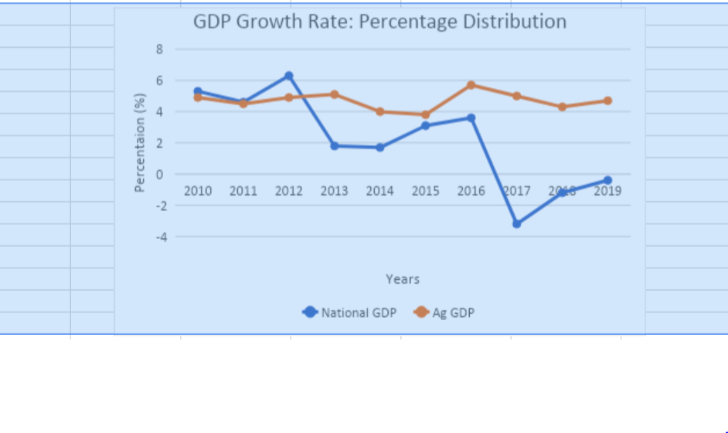

Figure 1: National GDP patterns
Agriculture is a relatively small sector, contributing less than 10 percent of Lesotho’s gross domestic product (GDP). However, the majority of people in rural areas engage in subsistence agriculture, making it the main sector for livelihoods and food security. Agricultural sector contributes to about 10% of formal employment. (World Bank 2019, forthcoming).
The following chart gives a clear picture of GDP generated by agricultural sector relative to the national GDP generated by other sectors.
Figure 2: contribution of Agriculture to National GDP
Even though the agriculture sector is relatively small in the total economy, it plays a significant role in Lesotho’s economy and for the livelihood of a majority of the population. Agriculture contributes less than 10 percent of Lesotho’s GDP (5.2 percent in 2014 with slight increase to 6.9 in 2016US$160 million). The Central Role of Lesotho’s Agriculture Sector in the Economy70 population live in rural areas and depend, directly or indirectly, on agriculture for livelihood, which also accounts for 10 percent of formal employment.
The majority of those engaged in agriculture are smallholders with less than one hectare per family making the growth in the sector crucial for poverty reduction in Lesotho. Also central to the growth in agriculture is productivity which remains low with value addition activities in the sector limited. The sector consists mainly of rain-fed crop production which accounts for 30 percent, of cereals grown on 85 percent of arable land) and 70% of livestock production.

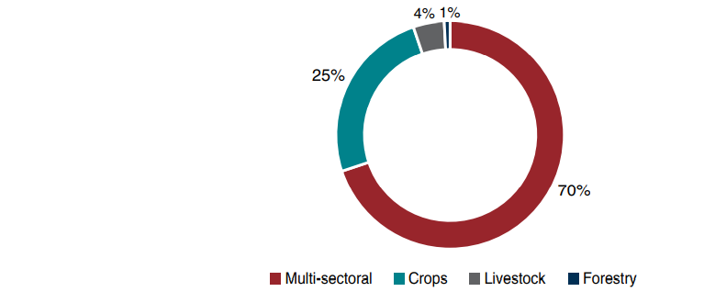
Figure 3: Breakdown of PEA by subsector in percentage
Crops make up 83 percent of sector-specific expenditures, with livestock and forestry accounting for 14 percent and 3 percent, respectively. A major cause for this is that the MAFS’s ICP aims at improving crop productivity.
In addition, based on evidence from interviews conducted with the MAFS and the MFRSC, it is safe to assume that the internal orientation of multi-sectoral expenditures follows the same pattern. For instance, all of the Department of research’s significant active projects are about crops.
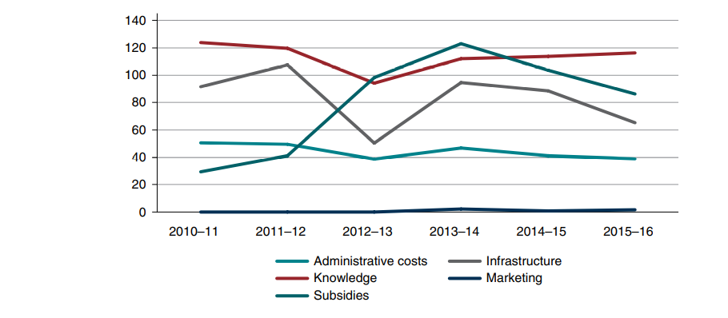
Figure 4: Trend of PEA in support of aggregate functional categories, in millions for a period between 2010/11 to 2015/16

Agricultural expenditures, on the other hand, are almost devoid of infrastructure support, although these are vital to improve the sector’s enabling environment. Irrigation in particular has received only 0.5 percent of PEA, although rainfall dependency and risk of drought represent a major impediment to the sector’s growth. This was illustrated in 2015/16, when a severe episode of drought caused by the El Niño phenomenon left around 709,000 people food-insecure (Lesotho Vulnerability Assessment Committee 2016). The gravity of this episode led to the implementation of a 155 million Maloti for a response plan.

Public expenditure agricultural support of processing and marketing activities have been extremely minimal, at 0.2 percent. They mostly reflect the contribution of the marketing department of the MSBDCM. The department provides a range of interesting market-oriented services to the agriculture sector but these account for a fraction of the total PEA budget. In addition, a number of marketing department activities involve trade and price-distortive measures, such as import restrictions, recommended producer prices, and the handling of consumer price subsidies, as was the case in 2016/17 when a 162 million Maloti subsidy was provided via the MSBDCM to maize flour millers (DMA 2016; MSBDCM 2018)

Table 1: Deviation between functional share of NSDP intervention count and PEA in percentage points
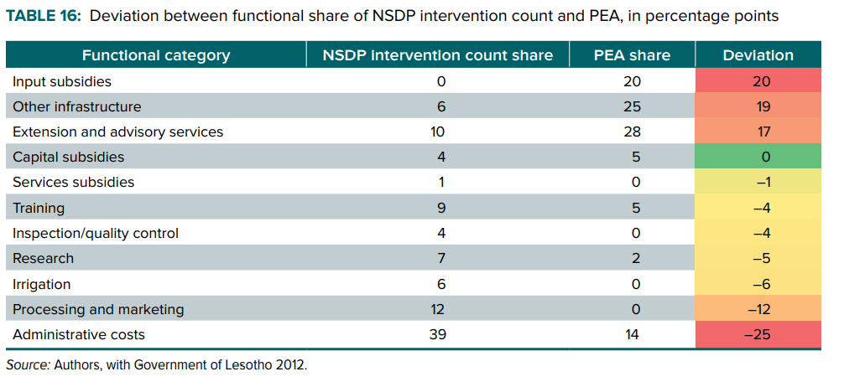
Table 2: functional count of agricultural interventions in the NSDP, count and percent of total
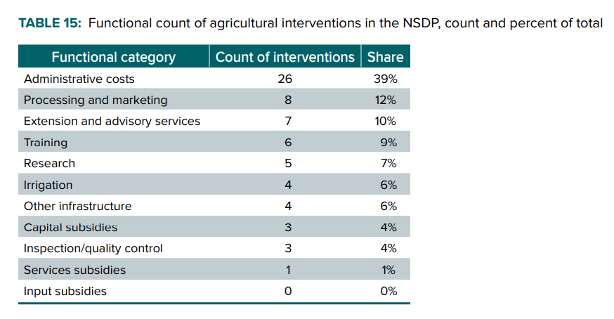

Table 3: Heat table of the share of agricultural functions in PEA (red-low; green-high share) 2010/11 to 2015/16
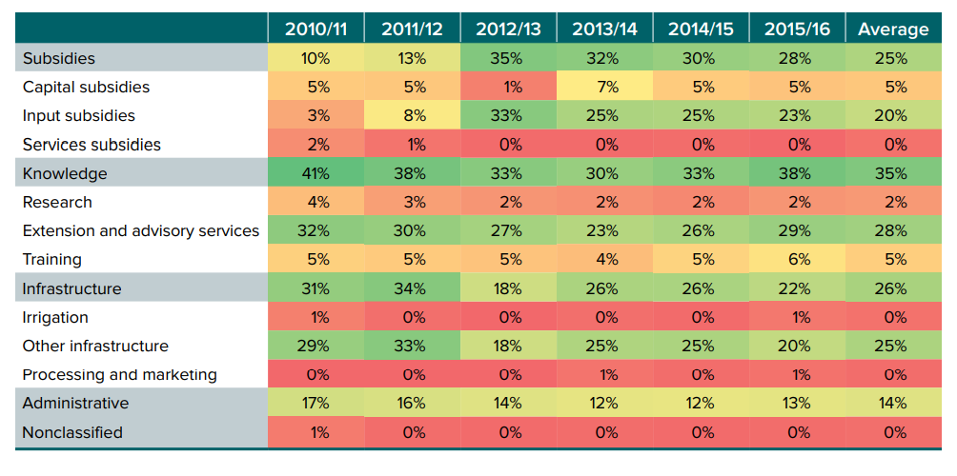
The composition of subsidies is strongly oriented toward inputs rather than capital. Yet input subsidies are less likely to increase productivity in the long run, because the productivity boost effect of the fertilizers and improved seeds will dissipate after one year, as opposed to that of farm equipment, cattle, or other forms of capital. Although input subsidies are meant to be a temporary support measure, they have not abated since 2010/11.
In the current context of narrow fiscal space, the input subsidy program blocks one-third of the GoL’s budget every year—more when considering the salaries of civil servants involved in administrative tasks related to the ICP. This warrants close scrutiny on the rationale for the subsidy program and the results obtained.
Figure 5: cereal production in tonnes

Cereal yields are below 1,000 kilograms (kg) per hectare on average, compared with the Southern African Development Community (SADC) Regional Indicative Strategic Development Plan (RISDP) target of at least 2,000 kg Per hectare; land productivity averages about US$70 per hectare annually, compared to the regional average of about US$120 per hectare (2008–2013 figure). Value addition is low outside the wool and mohair industry, and most agro processing takes place in South Africa.

Low investment in agriculture and adaptation to climate change.
The sector’s low productivity is largely a result of low investment in infrastructure such as irrigation, low uptake of new technologies and inputs, poor quality extension and advisory services, and limited access to credit. Environmental challenges such as land and natural resource degradation, erosion, and low soil fertility exacerbate the situation, leaving the sector vulnerable to risks. High intra-seasonal and inter-annual rainfall variability with frequent droughts, including the El Niño Southern Oscillation (ENSO), have resulted in poor crop harvests and large livestock losses for rural farmers.
According to the Lesotho Vulnerability Assessment Committee, Lesotho experienced an almost 62 percent decline in crop production during the unprecedented El Niño event. On inter-annual timescales, the El Niño Southern Oscillation (ENSO) phenomenon particularly affects climate variation in Lesotho (World Bank 2016a). The Intergovernmental Panel on Climate Change categorizes Lesotho as one of the countries highly vulnerable to the impacts of climate change, with low capacity among the population to adapt to changing weather conditions (Dejene et al. 2011). Low agricultural productivity and poverty are closely linked with food insecurity and malnutrition in Lesotho. Adverse weather impacts on agricultural production left around 709,000 people food-insecure in 2015/16; over 200,000 people in need of humanitarian assistance in 2017; and over 485,000 were reported being at risk of food insecurity in May 2019 (Lesotho Vulnerability Committee 2017; Lesotho Disaster Risk Management.

It is estimated that about one-third of all children under five are stunted in Lesotho, with approximately one-half of all children under five stunted in the lowest income quintile compared to 10 percent of children in the highest. The burden of malnutrition does not just fall on the individual but also affects the economy as a whole. It is estimated that over 7 percent of gross domestic product (GDP) is foregone annually due to lower education outcomes, decreased productivity, poor health, and high child mortality and premature deaths as a result of malnutrition. Income margins are small for Lesotho’s poor, as 41 percent of all families spend more than one-half of their income on food, and recent extreme weather events in Lesotho have exposed the population’s vulnerability to food insecurity.
Low agricultural output and productivity, poverty, and heavy reliance on food imports are closely intertwined with food and nutrition insecurity in Lesotho, which impose high costs on the country. An estimated 80 percent of the food consumed in Lesotho is imported. This applies to staples (e.g., 60 percent of maize is imported) as well as highly nutritious foods such as fruits and vegetables. Forty-one percent of all families spend more than one-half of their income on food, yet diets are still poor and malnutrition is high in Lesotho.
The challenges of malnutrition continue into adulthood; chronic malnutrition costs Lesotho an estimated 7.3 percent of its GDP, and 19.5 percent of child mortality is due to malnutrition (9,272 child deaths in the period 2008–2014).

Key challenges:
- Agriculture contributes less than 10 percent of Lesotho’s GDP (5.2 percent in 2016, at US$160 million). However, over half of the country’s population lived in rural areas and depended, directly or indirectly, on agriculture for their livelihood. Most people in the rural population are engaged in subsistence production, with land coverage below 1 hectare.
- Lesotho’s agriculture sector is dominated by livestock production (52 percent), followed by crops (28 percent) and forestry (20 percent) (contribution to agricultural GDP, 2014 figure). Maize, sorghum, and wheat are planted on 85 percent of the country’s arable land, which comprises about 10 percent of Lesotho’s total land area. Sheep and goats dominate the livestock sector, reared mainly for wool and mohair
- Crop yields are low, with average cereal yields below 1,000 kg per hectare, failing to meet the SADC RISDP target of achieving at least 2,000 kg per hectare (Nhemachena, Matchaya, and Nhlengethwa 2016). For the period 2008–2013, land productivity averaged about US$70 per hectare per year compared to the regional average of about US$120.
- Constraints to improved agricultural productivity include outdated farm technologies and farm management practices, limited technical expertise, low and suboptimal use of inputs, low access to irrigation, land degradation, inadequate rural infrastructure, and limited access to credit. Going forward, limited research and development in the sector along with rudimentary extension and advisory services impede the technological shift necessary for agricultural transformation.
- Climate change is a key challenge for the agriculture sector; weather risks such as droughts, floods, frosts, snow, hailstorms, and strong winds and high intraseasonal and interannual rainfall variability, with frequent droughts, have already resulted in poor crop harvests and large livestock losses.
- The vulnerability of Lesotho’s agriculture sector—characterized by the IPCC as highly vulnerable to climate change impacts— has led to almost one-half of a million people currently facing food insecurity in Lesotho as a result of poor rainfalls in 2018.
- As a result of the low productivity and environmental challenges, the marketable surplus of agricultural products is low; Lesotho imports about 10 times more agro food products than it exports. Exported agro food products largely consist of cereals, milled flower, and wool, while imported Agro food products to a larger extent are processed, like breakfast cereals, meat, and dairy.
- The agro food system does not deliver for nutrition and food security in Lesotho. Weather-related risks regularly put a large share of the agricultural population at risk of food insecurity, and malnutrition is prevalent. Lesotho experiences the double burden of high rates of both child stunting and adult overweight/obesity (stunting in children under five years is 33 percent; adult overweight and obesity are 31 percent, and 45 percent among women). Dietary diversity is low at all income levels, and availability of fruits and vegetables in Lesotho is below the WHO’s recommended intake.
- Recognizing the significant role of agriculture in Lesotho’s overall economic development, poverty reduction, and food security and nutrition, the Government of Lesotho is currently undertaking critical measures to develop the sector. This includes putting agriculture at the center in its new NSDP II for 2018/19–2022/23; developing an Integrated Program for Agriculture and Food System Development (a National Agriculture Investment Plan, NAIP), and a Climate Smart Agriculture Investment Plan (CSAIP) and a Multi-Sector Nutrition Strategy; conducting the Lesotho Zero Hunger Strategic Review (LZHSR); and being an Early Adopter of the World Bank’s Human Capital Project (HCP), launched in 2018

Key issues:

Production and Productivity:
As an agriculture-based economy, over the years Lesotho has allocated considerable resources to increase the production and productivity of crops, livestock, and fisheries. Despite these efforts, production of the main crops, livestock, and fisheries has not increased significantly and is not growing National Agriculture Policy sufficiently to match growing domestic demand and available export opportunities.
The suboptimal performance of the agriculture sector can be attributed to low productivity as measured by output per unit area of land and per unit of labour. Underlying the low productivity is low adoption of agricultural technologies, low access to farm inputs, low mechanisation, low technical labour skills, weak linkages to markets, and limited irrigation, especially among smallholder farmers.
A key constraint for many farmers is access to information to guide their production decision. Improved agricultural extension services from both public and non-state providers that provides farmers with the information that they need to address their challenges and to exploit opportunities with which they are presented is critically important to enable Malawi’s farmers to significantly raise their productivity levels. Production and productivity of crops have generally been below the country’s potential.
Over the years, livestock production in Lesotho, which includes beef, dairy, goat, sheep, pig, chicken and eggs, among others, has steadily increased. Agricultural production estimates show that the cattle population has been steadily increasing at a rate of 3 percent per year in recent years. In 2014 there were just over 584 cattle in the country and slightly over 1.3 million sheep. Both smallholders and estate farmers are involved in animal production, with more intensive production systems found on estate farms. Livestock production faces a number of challenges, including limited pasture due to population pressure, inadequate production and storage technologies in feed and breeding programmes, and insufficient animal health support infrastructure and services such as dip tanks.

Agriculture Marketing, Agro processing and Value Addition Agricultural marketing:

Agriculture Marketing, Agro processing and Value Addition Agricultural marketing entails the services involved in moving an agricultural product from the farm to the consumer. In recent years, Lesotho has made efforts to develop agricultural markets. These include increased liberalisation, development of rural marketing infrastructure and agricultural market information systems, and the establishment of commodity exchanges. Despite these efforts, agricultural marketing systems in Lesotho are still rudimentary, and in some cases, missing markets persist, especially in rural areas. This is partly due to inadequate infrastructure for efficient agricultural marketing; limited access to and poor quality of marketing service provision; and policy incoherencies that negatively affect marketing. These constraints limit the incentives and ability of farmers to increase their participation in agricultural value chains for both domestic and export markets. The inadequate infrastructure is a result of low investments in roads, appropriate agro processing, and packaging and storage facilities. The low investment in public market infrastructure has resulted in high costs for farmers to access markets, especially in rural areas.
Prior to agricultural market liberalisation in Lesotho in the 1980s, co-operatives played an important role in marketing and handling of all agricultural commodities. Since the liberalisation process started, poor market infrastructure has led to more limited than desired participation by traders in agricultural markets. This situation calls for increased investment from both state and non-state actors, both in transportation and in agro-processing, packaging and storage facilities for agricultural commodities in order to improve marketing efficiencies.
Most farmers continue to have limited information on prevailing market prices. They also have limited access to a wide range of services that are essential for profitable agricultural marketing. Limited public and private investments in transport, storage, electricity, financial products, and quality standards inhibits their efficiency and competiveness in both local and international markets. These services are necessary to address agricultural risks and to improve the allocation of agricultural inputs across agricultural outputs in order to profitably commercialise farming. The lack of market information and poor access to commercial services has created asymmetry in agricultural markets, resulting in farmers obtaining relatively low profit margins for their output agricultural commodity markets.
The market asymmetry is exacerbated by weak smallholder farmer organisations. Ineffective agricultural cooperatives limit farmers’ abilities to effectively bargain and negotiate in both input and output markets, resulting in low returns to their commercial farming efforts. For Lesotho, to achieve its strategic objectives of increasing production and expanding agricultural exports, there is a need for policy coherence in the agricultural sector in order to address key policy barriers in agricultural marketing systems. This can be done through the 1) streamlining of burdensome and poorly coordinated policies; 2) modification of restrictive trade policies, and 3) elimination of administrative delays in marketing and trade, including those related to licensing and transit at border crossings. With coordinated efforts, marketing of agricultural commodities in local and international markets is likely to improve.

Agricultural Subsidy

Lesotho’s input subsidy program
The current input subsidy program was launched by the Government of Lesotho in 2010/11. Initially labelled the Summer Cropping Programme, it was renamed the Intensive Crop Production Programme (ICP) due to the fact that inputs are subsidized during both winter and summer cropping seasons. Through the Intensive crop production, the Government of Lesotho buys fertilizer, seed, and pesticide packages (Figure B1) in South Africa and sells them at discounted prices to private traders. The traders then sell the inputs to producers at a subsidized price, factoring in their margin. The inputs are sold by the Ministry of Agriculture food security to the traders against cash. Traders sell exclusively to beneficiaries that appear on a list prepared at the district level, but no transparent or official criteria exists for drawing the list. Since there are no explicit targeting criteria, it can be assumed that the program is regressive, given the unequal structure of land ownership in Lesotho. Indeed, 1.2 percent of households own land above 6 hectares, with some of these landowners holding dozens of hectares, while 45 percent of households own land of less than 1 hectare (Bureau of Statistics 2014).

Table 4: Heat table of the share of agricultural functions in PEA (red-low share; green-high share) 2010/11 to 2015/16
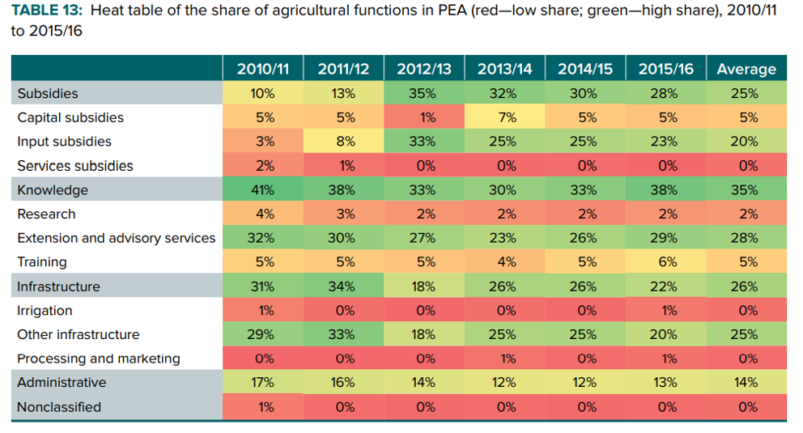

The average subsidy expenditures over the period were 64 million Maloti, and 87 million Maloti since 2012/13. The average Government of Lesotho fertilizer price subsidy rate—that is, the ratio of trader sale price over procurement price—was 62 percent (Annex 5). The rate was higher for highlands (63 percent) than lowlands (56 percent) due to costlier production (MAFS 2018). However, 93 percent of the total input sale value for the period comes from lowland sales (MAFS 2018). Indeed, this is where agricultural production is concentrated. An important point is that since the Government of Lesotho does not give away the inputs procured, but sells them, there is a recoup on the subsidy. The average annual recoup value is estimated at 24 percent of procurement value.
Thus, the true cost for the GoL of the ICP is about one-quarter less than what appears in the expenditure side of the budget. Furthermore, evidence from the Capital Progress Reports communicated by the MAFS implies that ICP expenditures have not been allocated 100 percent to input procurement. An estimated 6 percent went to capital subsidies (equipment procurement), 4 percent to irrigation, 2 percent to research (Geographic Information System), and 2 percent to inspection/quality control (plant protection). However, this breakdown is not reported in the official budget. Finally, it is worth assessing the ICP project with the SMART criteria.
The literature refers to a “SMART” benchmark—Specific targeting, Measurable impacts, Achievable objectives, Result-oriented, Time-bound—to estimate whether input subsidy programs (ISP) are likely to be efficient (Minde et al. 2008; Dorward 2009; Wanzala-Mlobela, Fuentes, and Mkumbwa 2013). Wanzala Mlobela, Fuentes, and Mkumbwa (2013) summarize these objectives as such: smart ISPs (i) target a specific socioeconomic group, (ii) contribute to a competitive and open market, and (iii) come with an exit strategy.
The Intensive crop production does not appear to match any of the criterion, since there is no clear targeting and no evidence of a private sector crowding-in and/or phasing out strategy given the persistence of the program in PEA over the years. In addition, there is no indication of increased yield or production other than bumper harvests due to favourable rainfall (FAO 2018).

Sector-wide planning, management and coordination in the agriculture sector is fundamental for growth. Making prudent public investments in the agriculture sector and ensure efficient delivery of services in agriculture. Supporting innovative evidence-based modifications to agricultural subsidy programmes that will make them sustainable and efficient. As part of the reforms, farm input subsidies will be leveraged to increase the commercial provision of farm inputs in a sustainable way; improve land, labour and water productivity; increase diversification in agricultural production; and will increase commercialisation of crops, livestock, and fisheries.
As part of the envisioned pathways to agricultural subsidies, the Ministry will support efforts to encourage smallholder farmers to use improved seeds, irrigation, integrated soil fertility management techniques, and other modern farm technologies. It is envisaged that policy frame work will Provide platforms for healthy agriculture policy dialogue and actively engage in consultative policy processes in the formulation, planning, and implementation of sub-sectoral policies and strategies.

Transformation of Agricultural sector through policy
The development ambition for the national agriculture policy is agricultural transformation. Such a transformation is necessary to enable all households to better meet their desires for prosperity and economic security, whether by continuing to pursue agriculture-based livelihoods or through engaging in other sectors of the economy. For the moment, food production primarily for the dietary needs of one’s own household dominates the agricultural activities of most Basotho. Agricultural policy to ensure that such production is done as efficiently as possible. However, the longer-term ambition for the transformation of the sector into one in which Lesotho’s farmers engage in considerably more specialized and more productive agricultural production according to the comparative advantage of each, but within the context of an overall more diversified agricultural sector, involving a much broader range of food and non-food crops and other agricultural products, with increased reliance on markets by both farming and non-farming households to earn incomes and to meet the food needs of their members.
A key consideration to realizing this ambition of agricultural transformation is the place of smallholder farming in such a development pathway. That smallholder farming will need to be the principal focus of public investments within the agriculture sector for the foreseeable future is not in question in order to optimise resources under smallholder subsector. However, despite its predominance today, the development objectives of the National agriculture Policy will not be achieved if the policy is oriented towards smallholders and their food needs alone and sustaining smallholder farming in the long-term.
A more heterogeneous perspective of the farming sector is adopted here, including support to medium-scale and large-scale commercial farmers. Public investments in the sector made under the National agriculture policy will be designed, insofar as possible, to be beneficial for all farmers – for smallholders operating primarily at a subsistence level, medium-scale farmers who are consistently able to produce marketable surpluses, and larger, commercial producers. While bearing in mind considerations of equity, activities under the National agricultural policy will operate in a manner to enable entrepreneurial farmers to confidently increase the scale and profitability of their production and thereby boost their incomes.

Technology development and deployment
The use of digital technologies, innovations, and data can transform food systems in Lesotho. Digital technologies, services, and tools now offer numerous opportunities to agriculture value chain actors to make more informed decisions, increase productivity and incomes and achieve improved nutrition and health outcomes. For many farmers, access to output and input markets has increased as a digital revolution allows markets to connect faster. Data from digitalization efforts offer opportunities to design better-informed policies for the transformation of food systems. The digitalization of food systems across Africa presents new opportunities for the use of digital and data-driven technologies at each segment of agriculture value chains, which can guide and support decisions on production methods, value chain optimization and storage methods to avoid food waste and loss.
Access and delivery of holistic digital agriculture technologies, innovations, and data to transform business models and practices across agricultural value chains is critical. Digital innovations can help enhance access to e–extension services and markets by smallholder farmers and support access to mechanization services among farmers. Today’s digital technologies can, for example, help to overcome the complete lack of information about growing conditions.
Remotely sensed data enables tracking changes in vegetation cover, weather data, and other parameters related to cropping activities in real-time. Recent developments in machine learning and computer modelling make it possible to track and predict crop production using such data. Digital technologies can also help overcome challenges hampering access to good quality agricultural data, from measuring arable land, planted areas, crop yields to the spatial distribution of harvested quantities. For these to work for all including women, there is a dire need to invest in closing the gender digital gap.

Youth and women
Youth and women comprise the majority of Lesotho employed in the agriculture sector, yet statistics show that they continue to be disadvantaged in multiple ways. Youth, women and vulnerable groups, including people living with disabilities, have limited access to, ownership and control of finances and productive assets in the sector. As such, women, youth and vulnerable groups are unable to effectively contribute to agricultural growth, food security and nutrition. Closing the gender gap and addressing the socio-economic barriers faced by the youth has the potential to boost annual agriculture GDP by more than 1.4 percentage points. Moreover, in the next five years the share of employable youth will significantly increase, presenting a challenge if remunerative jobs cannot be created to harness the increased available labour.

Invest in nutrition-oriented food systems
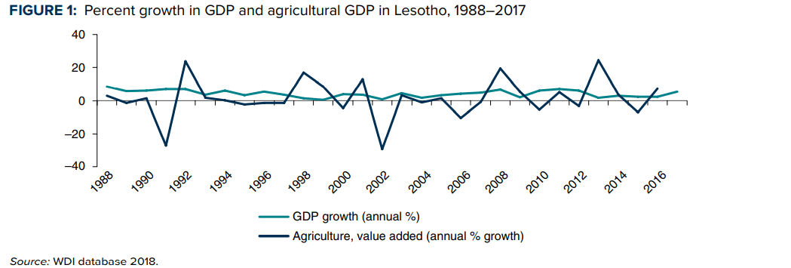
Figure 6: Percent growth in GDP and agricultural GDP in Lesotho, 1988-2017

Low agricultural output and productivity, poverty, and heavy reliance on food imports are closely intertwined with food and nutrition insecurity in Lesotho, which impose high costs on the country. An estimated 80 percent of the food consumed in Lesotho is imported. This applies to staples (e.g., 60 percent of maize is imported) as well as highly nutritious foods such as fruits and vegetables. Forty-one percent of all families spend more than one-half of their income on food, yet diets are still poor and malnutrition is high in Lesotho. One-third of children under five in Lesotho are stunted, with almost one-half of all children under five being stunted in the lowest income quintile. The challenges of malnutrition continue into adulthood; chronic malnutrition costs Lesotho an estimated 7.3 percent of its GDP, and 19.5 percent of child mortality is due to malnutrition (9,272 child deaths in the period 2008–2014).

Nutrition pathways
There is a need to identify, renew and implement longer-term actions across multiple systems –food, health, water and sanitation, education and social protection-- in the food system to facilitate sustained access to affordable and nutritious foods, essential nutrition services and positive nutrition practices in all contexts. Address affordability of nutritious foods.

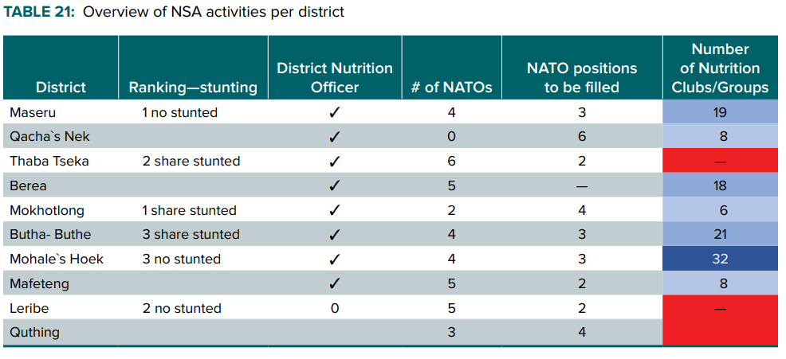
Figure 7: Overview of NSA activities per district
The table above depicts that the deployment of staff in respective districts assist in the formation of nutrition clubs or groups which play a pivotal role of knowledge gap hence the improvement in nutrition and reduction of stunting.
Nutritious and safe foods are critical determining factors of healthy growth and development in children and youth. While unaffordability of nutritious foods is a major barrier to diet quality, the increased cost of sustainably-produced foods further reinforces economic barriers to achieving healthy and sustainable diets, particularly in the context of Africa with the majority of countries are low- and middle-income. Supporting policy and fiscal measures across ministries should be identified to support food affordability (i.e. subsidies for healthy and sustainable foods; taxation for unhealthy foods; procurement policies for healthy school meals) and should be elevated in the discussions at the summit. The Summit and follow up actions should pay equal food security and agriculture dimensions, and better food and nutrition.
The table overleaf reflects the average stunting in children per district with Mokhotlong ranking highest with 48.4% followed by Thaba-Tseka at 39.8% while the lowest is Mafeteng at 24.6%. This is a true reflection of a serious problem that needs immediate attention.
4
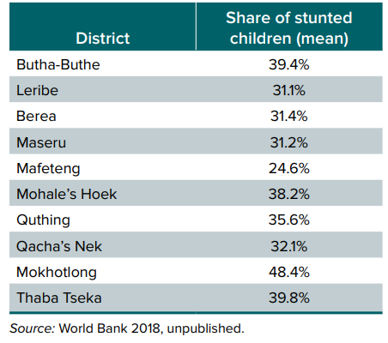
Figure 8: mean percentages of stunted growth in children per district

Land Management, a prerequisite for food system transformation
To align itself with the Declaration on land issues and challenges in Africa as identified by the Heads of state in the African Union, Lesotho has to take into consideration the land tenure system improvement which is vital in the food systems transformation.
Land management is a prerequisite for food system transformation and peace and security. The importance of good management of land for food systems transformation, and peace and security is recognized by African Heads of State in the African Union’s ‘Declaration on Land Issues and Challenges in Africa, which urges member states to “take note of the steps outlined in the Framework and Guidelines on Land Policy in Africa for their land policy development and implementation strategies.” The Framework and Guidelines reflect a consensus on land issues and serve as a basis for African governments' commitment in land policy formulation and implementation and a foundation for popular participation in improved land governance.
Empowering women, including through greater access and control over land and productive resources, is essential step towards closing the gender gap in agriculture, leading to considerable gains in productivity and production. Enhancing women’s income opportunities would also improve the welfare of children and improve food security and nutrition, in addition to attaining enhanced health and education outcomes.

Necessary game changing actions for transforming Lesotho’s food systems:
Based on the voices of the people, the following are the necessary pathways for transforming Lesotho’s food systems as raised in the national and district dialogues:

Policy priority Area 1: National Agriculture Policy
Given the potential for irrigation in Lesotho, a major shift in policy direction to promote profitable irrigated crop production, within the context of sustainable, farmer-led catchment or water management, including water harvesting, would make an important contribution to the transformation of the agriculture sector. Increased use of irrigation would also reduce volatility in agriculture production, while also contributing to greater dietary diversity throughout the year. Therefore, this policy will:
- Fast-track infrastructure investments for smallholder and large-scale irrigation schemes in line with the objectives of the National Irrigation Master Plan and Investment Framework.
- Facilitate the mobilisation of financial resources and technical expertise for the expansion of sustainable irrigation schemes and practices.
- Support private investments and the development of Public-Private Partnerships in establishing irrigation enterprises
- Facilitate the sharing of lessons in the southern Africa region on sustainable approaches to investing and managing irrigation systems.
- Ensure that irrigation infrastructure designs accommodate food and profitable cash crops.
- Promote efficient and sustainable use of water in all irrigation schemes.
- Support integration of irrigation in power generation and sustainable water management investments where feasible.
- Support innovation in irrigation systems through research, technology generation, and dissemination.

Policy priority area 2: production and productivity
- Increased market oriented production
- Promote innovative and high quality agricultural extension and advisory services involving both public and non-state extension service providers.
- Establish effective, demand-driven agricultural innovation systems for research and technology generation, and dissemination.
- Facilitate timely and equitable access for farmers to high quality farm inputs, including inorganic and organic fertilizer, improved seed and livestock breeds, and fish fingerlings.
- Promote investments in climate-smart agriculture and sustainable land and water management.
- Stimulate significant private sector investments in high-productivity agricultural production.
- Promote improved access to financial services, including agricultural credit and insurance
- Provide incentives to farmers to diversify their crop, livestock, and fisheries production and utilisation
- Contract farming model to upscale production

Policy Priority Area 3: Sustainable Irrigation Development
Given the potential for irrigation in Lesotho, a major shift in policy direction to promote profitable irrigated crop production, within the context of sustainable, farmer-led catchment or water management, including water harvesting, would make an important contribution to the transformation of the agriculture sector. Increased use of irrigation would also reduce volatility in agriculture production, while also contributing to greater dietary diversity throughout the year
Only limited percent of about 2 % crop land is currently irrigated yet land and water resources are sufficient to more than double this amount. The total area of irrigated land stood at 104,000 ha in 2014 of which about 46 percent smallholder.
Some of the current challenges in implementing irrigation programmes include slow implementation of infrastructure development, poor management and maintenance of existing irrigation schemes, high energy costs, low profitability from the crops grown, poor catchment management, inefficient water use, and difficulty in accessing financial services for irrigation investment and operations

Pathways for irrigation:
As a way of improving irrigation for increased agricultural production in Lesotho, fast-track infrastructure investments for smallholder and large-scale irrigation schemes in line with the objectives of the National Irrigation Master Plan and Investment Framework is necessary. This can be achieved through the implementation of the following initiatives:
- Facilitate the mobilisation of financial resources and technical expertise for the expansion of sustainable irrigation schemes and practices.
- Support private investments and the development of Public-Private (Partnerships in establishing irrigation enterprises).
- Facilitate the sharing of lessons in the southern Africa region on sustainable approaches to investing and managing irrigation systems.
- Ensure that irrigation infrastructure designs accommodate food and profitable cash crops.
- Promote efficient and sustainable use of water in all irrigation schemes.
- Support integration of irrigation in power generation and sustainable water management investments where feasible.
- Support innovation in irrigation systems through research, technology generation, and dissemination.

Policy Priority Area 4: Agriculture Marketing, agro-processing and Value Added Agricultural marketing

In order to achieve enhanced agricultural production that will boost the country’s economy, there is need to formulate policy instruments in agricultural marketing, agro-processing and added agricultural marketing. Policy should cover areas such as planning production, growing and harvesting of commodities, grading, packaging, transportation, storage, processing, distribution, advertising and sales. Marketing functions and services include:
- Exchange – buying and selling;
- Physical infrastructure – storage, transportation and processing; and
- Facilitation – standardization, regulation, financing, risk bearing and market intelligence.
Agricultural marketing systems in Lesotho have suffered several challenges emanating from deficient infrastructure, policy and regulatory incoherence and low investment in both public and private sectors. These constraints have rendered Lesotho’s agricultural value chains uncompetitive both nationally and regionally.

Pathways for Agriculture Marketing, Agro-processing and value addition
- Promote the growth and development of efficient and inclusive agricultural value chains that ensure competitive and fair pricing of agricultural commodities.
- Facilitate the creation of new structured markets, especially in legumes, oilseeds, and horticulture, livestock, and fisheries products.

Policy Priority Area 5: Food Security and Nutrition
The government recognises the duty it bears to assure adequate access to food for all Basotho. Over the years, there has been emphasis on the need to increase maize production in order to achieve food security for Basotho. The government has promoted programs that intensify fertilizer use and encourage adoption of improved seed varieties for increased maize production. This approach has resulted in increased maize outputs available for consumption in the country.
However, these efforts have not resulted in improved nutrition, as diets have remained undiversified. Child malnutrition has remained particularly high with 47.1 percent of children under-five years of age being found to be stunted in 2010. Addressing this imbalance between agricultural production and nutritional outcomes requires a concerted and multi-pronged approach that increases and diversifies food production and consumption, particularly for the nutritionally vulnerable – young children, pregnant and lactating women, adolescent girls, the elderly, and the chronically ill. Food safety has also been an issue, particularly with regard to high levels of aflatoxins in maize and groundnuts that negatively affect health and nutrition status of Basotho.

Pathways for nutrition:
Promote production and utilisation of diverse nutritious foods in line with the National Nutrition Policy and Strategic Plan.
- Foster adequate market supply and access of diverse and nutritious foods and
- Ensure food safety for all.
- Promote private sector investments in production, processing and marketing of high quality nutritious foods, including complementary foods.
- Coordinate investments and sub-sectoral policies and strategies that help improve the nation’s nutritional status and promote healthy diets.
- Promote bio-fortification and fortification of major food staples.
- Promote food and nutrition education for all

Policy Priority Area 6: Mechanisation of Agriculture

The majority of Lesotho farmers continue to use rudimentary farm equipment such as hoes, while much of the harvesting and processing of farm output is done by hand. In this modern day and age, this state of affairs in the agriculture sector is unacceptable. It is highly inefficient and burdens millions of households, making agriculture unattractive, particularly to the youth.

Pathways for Mechanisation of agriculture
- Promote mechanisation of farming, agro-processing and value addition.
- Facilitate market-based imports of new and used agricultural machinery that are appropriate for Malawi and meet established standards.
- Facilitate market-based imports and production of quality spare parts of agricultural machinery.
- Facilitate the growth of entrepreneurs in the agricultural mechanisation and services industry.
- Promote home-grown inventions and innovations in agricultural mechanisation and service provision.
- Promote the development and growth of farmer-managed agricultural mechanisation groups

Policy Priority Area 7: Investment in agriculture

Table 5 investment in agriculture policy instrument
INVESTMENT AREAS | IMPLEMENTATION TOOLS
ENHANCING THE EFFICIENCY AND ACCOUNTABILITY OF THE PUBLIC SECTOR IN DELIVERING CRITICAL ENABLING RESULTS | Strengthening the public sector’s organizational and institutional capacity.  Enhancing the agricultural sector’s accountability system.  Setting-up and operating the National Agricultural Geo-referenced Information System (AGIS).  Assessing and enhancing sector policies.  Transfer of property ownership or management from Government to private sector.
MOBILIZING PUBLIC RESOURCES TO FINANCE THE DEVELOPMENT OF THE NATIONAL AGRI-FOOD-SYSTEMS | Setting-up, financing, and steering the implementation of the Agricultural Development Funds (ADF).  Setting-up, financing, and steering the implementation of the Rural Infrastructure Development Funds (RIDF).  Making the National Securities Market (NSM) work for agri-food-systems investments.  Institutional enforcement of producer organizations and industry associations.

Key solution | Investment Areas
PROMOTION OF FOOD SAFETY AND QUALITY MEASURES | - Promoting SPS measures  Strengthening quality assurance (certification) process in food production, processing, and distribution.  Strengthening official food control capacities including extension services at primary production level
ENHANCING IMPORT AND EXPORT POLICIES | Establishing a range of import/export policies as trade remedies when necessary.  Establishing import/export subsidies where necessary.
ENHANCING OTHER TRADE AND TRADE RELATED POLICIES | - Establishing pro-competition market regulations and regulating anti-competitive behaviour.  - Implementing trade facilitation agreements with neighbouring countries and trading partners.

Conclusion
In evolving agricultural policy framework that will take the agricultural sector to the next level at the local and national levels for a more relevant global crop and animal economy, it is important that both the smallholder family and large-scale commercial systems are giving full attention for a symbiotic relationship to achieve agriculture transformation in Lesotho. The demand for raw materials by the commercial systems will be a necessary stimulant for enhanced production in the smallholder family units. The expected investment interventions in the areas of suitable technologies and agricultural policies can transform household farm units from traditional to improved systems that are market-oriented. Hence, investments in both the small holder family and large-scale systems are important to achieve the Sustainable Development Goals by enhancement of national income, poverty reduction, food and nutritional security, exports, environmental sustainability, and climate change adaption and mitigation.
The government must divest from the burden of financial investments in avoidable projects, therefore, it is important to create investment policy environment with encapsulated incentives to attract and encourage investors in composite post-production transformation and processing for a successful end of the food value chain. Since in most business environments, the small holders are often more disadvantaged, these encapsulated incentives (reduced taxes, innovation grants, loans below market interest rates, subsidized insurance schemes) must majorly target the smallholder farm units and small-scale post-harvest agro-allied industries.

Recommendations: The Way Forward
- A gender-sensitive value chain approach can help reduce food insecurity as the State of Food and Agriculture 2010-2011 determined that women’s yields could grow by 20–30 percent if the gender gap in accessing agricultural inputs were closed. It can strength value chain efficiency as value chains are highly dependent on strong linkages and positive collaboration among actors, and women are important stakeholders all along value chains, though they are often invisible or overlooked. It can shift gender relations, increase, or decrease women’s access to and control over income (Rubin and Manfre, 2014) and/or lead to shifts in the balance of decision-making power at household and community levels given changes in men’s productive roles and earning capacity.
- Commercial horticulture offers opportunities to transform the rural economy by increasing incomes and creating jobs. Crop farming in Lesotho is based on subsistence cultivation of cereal crops, which contributes to low incomes and widespread poverty in rural areas. Transitioning to commercial cultivation of fruits and vegetables can significantly increase farm incomes. However, unlocking the full potential of horticulture sector requires significant public and private investment.
- Improving the functioning of the land market and availability of serviced land (with access to irrigation and road infrastructure) will encourage foreign and large-scale domestic investment in commercial farming. To increase the productivity of smallholders, who constitute the majority of farmers in Lesotho, the government may consider incentivizing private investment in aggregators, supporting productive alliances between farmer groups and potential buyers, and establishing an SMS-based market information system, possibly through a partnership with the international service provider. Given the capital and skill intensity of fruit farming as well as lack of such experience in Lesotho, targeted FDI attraction from South Africa could facilitate knowledge transfer and support development of the industry.
The sector has the highest potential to increase food security, reduce rural poverty, and generate both on- and off-farm employment opportunities.
Through the NSDP II, the Government of Lesotho prioritized agriculture and technology as part of the four sectors for driving economic growth in the country. As part of its recovery agenda, the Government has developed a two-year policy framework that is aligned to the NSDP II Key Priority Areas to select the areas of focus and strategies for implementation over the two-year period, from 2020. This framework will also respond to the myriad of challenges that Lesotho faces, including COVID–19, climate change, unemployment and inequalities, and macroeconomic and fiscal risks. The Strategy prioritizes agriculture and nature-based interventions, focusing on promoting conducive policy and legal environment and improved capacities for increasing quality and volume of production. The strategy also encourages adoption of innovative technologies to unlock economic opportunities and drive youth inclusivity in the recovery agenda.

