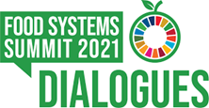

World Food Systems Summit 2021

CAMEROON'S ROADMAP FOR SUSTAINABLE FOOD SYSTEMS

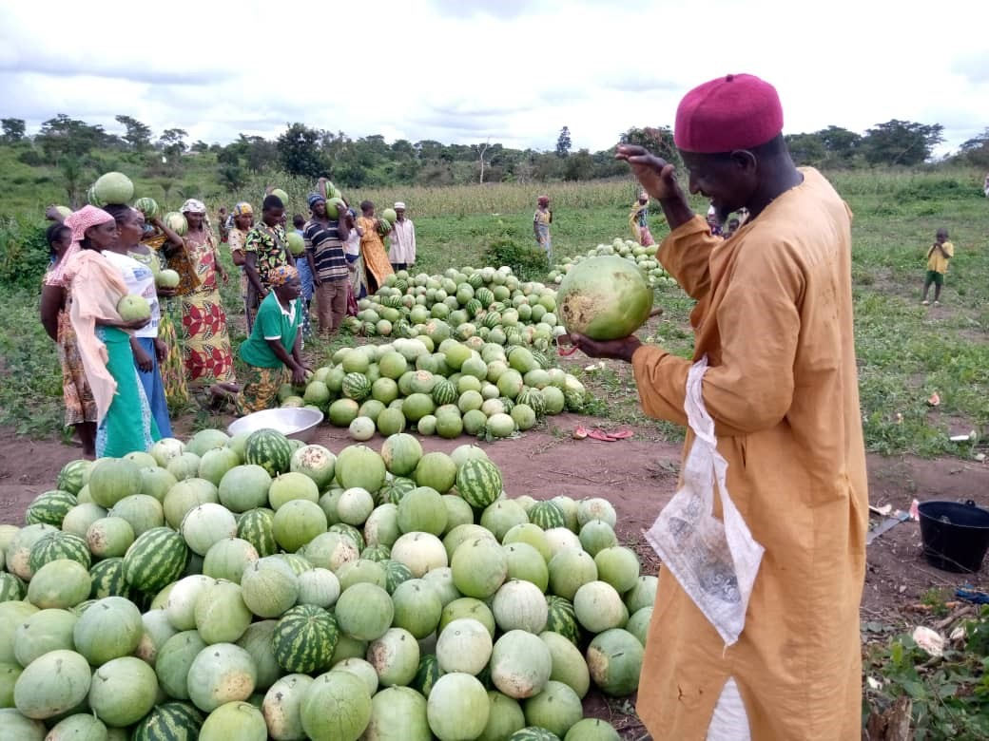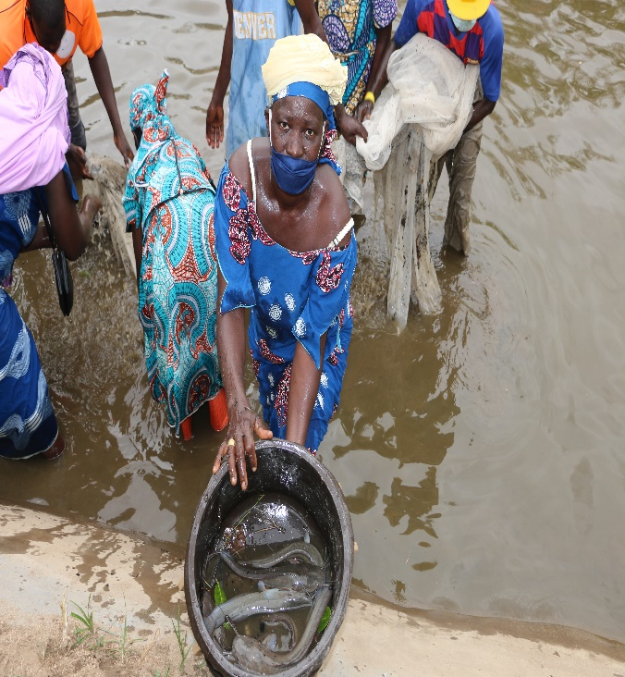

CONTENTS

contents ii
Acronyms and abbreviations iii
Context 4
Overview of the process 5
Inclusion of the national route in the Rural Sector Development Strategy / National Agricultural Investment Plan (SDSR / PNIA 2020-2030) and the National Development Strategy (SND30) 5
Diagnosis of food systems 6
Proposed activities 7
Distribution of roles between the different actors 8
Sources of funding for activities 8
Provisional implementation schedule 9
Monitoring and evaluation mechanism 11
Annex 1: Roadmap matrix 12
Annex 2: Letter of designation of the National Coordinator 19

Acronyms and abbreviations
AFD | French Development Agency
ANOR | National Standards Agency
ADB | African Development Bank
WB | World Bank
MTEF | Medium-Term Expenditure Framework
ECCAS | Economic Community of Central African States
CTA | Decentralized Territorial Authorities
ECAM | Cameroonian Household Survey
FAO | Food and Agriculture Organisation
IFAD | International Fund for Agricultural Development
NIS | National Institute of Statistics
IRAD | Agricultural Research Institute for Development
MINADER | Ministry of Agriculture Rural Development
MINAS | Ministry of Social Affairs
MINAT | Ministry of Territorial Administration
MINCOMMERCE | Ministry of Commerce
MINDCAF | Ministry of State Property, Survey and Land Tenure
MINDDEVEL | Ministry of Decentralization and Local Development
MINEE | Ministry of Water and Energy
MINEPAT | Ministry of the Economy, Planning and Territorial Development
MINEPDED | Ministry of the Environment, Nature Protection and Sustainable Development
MINEPIA | Ministry of Livestock, Fisheries and Animal Industries
MINFOF | Ministry of Forestry and Wildlife
MINIMIDT | Ministry of Industry, Mines and Technological Development
MINPOSTEL | Ministry of Posts and Telecommunications
MINPROFF | Ministry for the Promotion of Women and the Family
MINRESI | Ministry of Scientific Research and Innovation
MINSANTE | Ministry of Public Health
MINTP | Ministry of Public Works
MINTRANS | Ministry of Transport
MINTSS | Ministry of Labour and Social Security
PO | Producers Organisations
WFP | World Food Programme
CDP | Communal Development Plan
NWFP | Non-Wood Forest Products
NAIP | National Agricultural Investment Plan
UNEP | United Nations Environment Programme
RSDS | Rural Sector Development Strategy
NLUPSDP | National Land Use Planning and Sustainable Development Plan
NDS | National Development Strategy
NARS | National Agricultural Research System
SPM | Services of the Prime Minister
AU | African Union
EU | European Union

Context
Cameroon, a country in Central Africa located at the bottom of the Gulf of Guinea, is populated by around 24 million people over an area of 475,442 km². It benefits on its territory from almost all natural tropical ecosystems and for this reason has often been rightly called Africa in miniature. In the year 2030, this flagship country of the CEMAC zone would be populated by around 35 million inhabitants. The young and relatively skilled population is made up of a mosaic of over 240 ethnic groups and is growing at a relatively high rate. Half of it lives in rural areas and half in urban areas. The young fringe is, however, more attracted to large agglomerations where socio-economic opportunities appear more attractive. Moreover, this position prepares the country to be a land of welcome for the population’s victims of various crises in the sub-region.
Because of its location and its biophysical potential, agriculture is considered there as one of the engines of the national economy and the country as the breadbasket of Central Africa. The areas usable for crop and animal production represent respectively 7.2 million hectares of arable land and 2 million hectares of pasture, or about 20% of the territory. Forests, for their part, cover an area of approximately 22 million ha (46% of the territory) and the country abounds in a rich and abundant biodiversity which ranks it, in this respect, in second place in the Basin of Congo. Cameroon also has an important hydrographic network and more than 4 million ha of inland water bodies, potential sites for fishing and aquaculture activities, and 400 km of seafront with 13,000 km² of continental shelf.

Cameroonian agriculture which has two sub-branches - industrial and export agriculture on the one hand and subsistence agriculture on the other. Animal and fishery productions integrate a similar paradigm, with, in recent years, increasingly intensive systems alongside traditional extensive and semi-intensive approaches. Numerous Non-Wood Forest Products (NTFPs) contribute to food security, to the supply of energy to populations and constitute raw materials for the traditional pharmacopoeia, the pharmaceutical industry, construction and decoration.

Despite the relative good performance of the agrosylvo-pastoral and fishery sectors, the impact of the agricultural sector on improving the living conditions of the rural population remains insufficient, the poverty rate in rural areas (56.8%) remaining significantly higher. the national average (37.5%). About 22% of rural households suffer from food insecurity compared to 10.5% of urban households.
The main causes of this situation are in particular: (i) limited access and / or insufficient availability of improved plant and animal seeds, (ii) difficult and insecure access to land, (iii) an insufficient supervision rate of producers, (iv) high post-harvest losses, (v) the isolation of production basins, (vi) the insufficient level and unsuitable procedures of public financing in favour of the sector, (vii) the effects of climate change, (viii) insufficient private investment due to an insufficiently favourable business climate for the development of rural enterprises, (ix) poor coordination of structures intervening in the sector, (x) sub-optimal management of forest resources and wildlife, (xi) difficulties in accessing inputs, equipment and agricultural mechanization, (xii) poor structuring of actors and (xiii) occurrence of plagues such as armyworm, swine fever Africa, avian influenza and the COVID-19 pandemic.
This observation shows that it is essential to put in place a more ambitious strategy to improve the national food system (s).
The historic Summit of September 2021 was an opportunity to involve all citizens of Cameroon as stakeholders in the food system and to develop Cameroon's path towards sustainable food systems. The roadmap constitutes the operationalization of this national path by 2030.

Overview of the process
In line with the approach prescribed by the United Nations Secretariat for the conduct of consultations between Member States, the development of the Cameroon path resulted from a process carried out between March and June 2021. Following the appointment of a Coordinator At the national level, an information and sensitization phase for stakeholders preceded the consultations. These were launched during a national dialogue held on May 08, 2021 in order to generate buy-in and involvement of stakeholders in the development of national food systems. Then, consultations took place simultaneously in the ten regions of Cameroon between May 18 and 21, 2021 and each mobilized around fifty participants representing different categories of food system actors, in particular: parliamentarians; decentralized territorial communities; administrations; organizations of producers, processors and consumers; Civil society ; universities, training and research centres; economic operators and Technical and Financial Partners. Finally, the synthesis of national and regional consultations took place during the technical consolidation workshop held on May 25, 2021. The resulting national road project was subsequently endorsed by the government.

At the national and regional level, the consultations were conducted in an inclusive and participatory manner, with free, consensual and non-discriminatory debates in order to best reflect the points of view of the stakeholders. During these workshops, the work focused on the pillars and avenues of action of the summit, namely (i) access for all to healthy and nutritious food, (ii) sustainable consumption models, (iii) stimulation of a production that respects nature, (iv) the promotion of equitable livelihoods and (v) the strengthening of resilience in the face of vulnerabilities, shocks and stress.

In addition to formal consultations, additional initiatives have also been used. These include the common position of the ministers of ECCAS, the socio-economic impact study of the effects of COVID 19 on peasant strategies and the adaptation of agricultural and food sectors in Cameroon, the study on the analysis of food systems in Cameroon, the independent consultations of the Regional Platform of Farmers' Organizations of Central Africa (PROPAC), and the high-level inclusion dialogue on young people, women, people with disabilities and others vulnerable groups facilitated by the Climate Smart Agriculture Youth Network Global (GCSAYN).

Inclusion of the National Route in the Rural Sector Development Strategy / National Agricultural Investment Plan (SDSR / PNIA 2020-2030) and the National Development Strategy (SND30)
Convinced of the importance of achieving the Sustainable Development Goals (SDGs) by 2030, Cameroon has developed a National Development Strategy (SND30). SND 30 is the compilation of all sectoral strategies and therefore constitutes the centre of national priorities.
Cameroon's approach in including the national route in the Rural Sector Development Strategy / National Agricultural Investment Plan (SDSR / PNIA 2020-2030) is a justified choice because the rural sector is the area where resides near. 43.7% of the total population and which concentrates 90% of people living below the poverty line (less than 931FCFA per day to cover the basic priority needs of an adult). Rural producers constitute the socio-economic group most exposed to precariousness and contribute 66.1% to national poverty (ECAM 4, INS). Agriculture, the main activity in this sector, is an essential lever for economic development.
The vision of the rural sector by 2035 is that of a sector "important engine of the national economy which creates decent jobs, wealth for domestic demand and for exporting, which ensures food and nutritional security in a context of sustainable development.” Thus, agriculture can be seen as the entry point to food systems. It can be used to strengthen the connection between different sectors (education, health, infrastructure, etc.) and unite the many actors around food systems; all this through the implementation of specific actions well defined in time and space.
Diagnosis of Food Systems
The diagnosis of Cameroon's food systems resulting from the consultations revealed that:
- Access to factors of production (animal and plant seeds, land, credit) remains low, and particularly for certain disadvantaged groups such as women, young people and other vulnerable people.
- The weak collaboration between research institutions, universities, ministries and Decentralized Territorial Authorities does not facilitate the development and transfer of innovations.
- The lack of zoning leads to poor management of the agrosylvo-pastoral space and is very often a source of conflicts between users;
- Funding for agrosylvo-pastoral and fishery activities remains weak;
- The agricultural workforce is aging due to the disinterest of young people in agro-pastoral and fishing activities;
- The production basins remain insufficiently opened up, under-equipped with socio-economic infrastructure;
- Climate change exacerbates the occurrence of natural disasters (flood, drought, landslide); which negatively impacts food production;
- Poor agricultural practices contribute to accelerating the degradation of natural resources (soil, water and biodiversity);
- Food insecurity results in a high rate of malnutrition, difficulties in accessing healthy foods with high nutritional values;
- The socio-political crises affecting certain regions lead to the abandonment of production areas and the insecurity of goods and people and result in increased pressure on the resources available in the areas receiving refugees and refugees. internally displaced persons;
- Defective information systems on prices and agro-meteorological data negatively impact the supply of food products and access to the market.
Proposed Activities
In view of the observations noted above, four (04) recommendations were formulated, namely: (i) sustainably increase production, (ii) improve the collective infrastructural environment and access to factors of production and markets, (iii) strengthen the resilience of production systems, sustainable management of natural resources, and food and nutritional security of populations vulnerable to climate change and other shocks, (iv) improve governance of food systems.
- With regard to the sustainable increase in production, the following main activities have been identified:

- Provide funding research structures to boost the production of breeds and seeds of pre-bases and bases;
- Establish a framework for collaboration between research institutions, universities, ministries and Decentralized Territorial Authories;
- Set up an incentive framework for the private sector in the creation of varieties and the strengthening of the control system to test the quality of available seeds;
- Capacity building of seed multipliers;
- Accelerate land reform;
- Operationalize the policy of subsidizing agricultural inputs;
- Involve vulnerable groups in the decision-making process to promote their access to factors of production;
- Develop partnerships and promote the financing of the agro-pastoral sector by microfinance institutions;
- Develop / popularize production standards.
- Regarding the improvement of the collective infrastructural environment and access to factors of production and markets, activities will consist of:
- Open up production basins (Opening / rehabilitation / maintenance of municipal roads);
- Build / Rehabilitate community infrastructure;
- Build the capacities of producers and consumers on conservation techniques;
- Strengthen processing, packaging and storage micro-infrastructures;
- Promote the use of renewable energies.
- Regarding the strengthening of the resilience of production systems, the sustainable management of natural resources, and the food and nutritional security of populations vulnerable to climate change and other shocks, it is a question of:

- Build the capacities of producers on agro-ecological practices, sustainable management of soil and water;
- Develop and distribute species and varieties adapted to climate change;
- Develop / strengthen early warning mechanisms on agro-meteorological risks;
- Develop / strengthen early warning and risk and disaster management mechanisms;
- Promote and strengthen capacities for the production of foods with high nutritional value;
- Strengthen the social protection system for poor households and other vulnerable groups;
- Develop and popularize minimum food standards and scale up initiatives to improve access to nutritious food;
- Train stakeholders in the reasoned use of phytosanitary and veterinary products;
- Establish a binding mechanism to hold companies accountable for the social and environmental impacts of their activities;
- Facilitate the integration of refugees and internally displaced persons into food value chains;
- Develop human-wildlife conflict mitigation tools;
- Provide multi-sector assistance to people affected by conflict and insecurity;
- Set up Action Plans for the Management of the Bush meat Sector in the target communities.
- In terms of improving governance in food systems, it will be a question of:

Structure the actors and strengthen their capacities around food value chains;

Strengthen initiatives for the integration of young people into food value chains and intensify related communication;

Establish a Food Market Information System;

Promote innovative financing mechanisms and adapted and accessible agricultural insurance systems;

Promote synergies between actors in food value chains.

Distribution of roles between the different actors

The implementation of the proposed activities will be made by different actors: administrations, decentralized territorial communities, Civil Society Organizations (CSOs), Producers Organizations (POs), Technical and Financial Partners (PTF), the sector private and research.

Sources of funding for activities
The total budget is about one thousand and nine hundred billions (1 900 000 000 000) francs CFA. Several sources will be used to mobilize funding for roadmap activities. It is:
- The state budget;
- Support from PTFs;
- The private sector.

Provisional implementation schedule
Areas of intervention | Activities | Execution period
 |  | Short term:  2022-2024 | Middle term:  2024-2028 | Long term:  2028-2030
AXIS 01. Sustainable increase in production | 1.1 Provide funding research structures to boost the production of breeds and seeds of pre-bases and bases
 | 1.2 Establish a framework for collaboration between research institutions, universities, ministries and Decentralized Territorial Authorities
 | 1.3 Set up an incentive framework for the private sector in the creation of varieties and strengthen the control system to test the quality of available seeds
 | 1.4 Build the capacities of seed multipliers
 | 1.5 Accelerate land reform
 | 1.6 Operationalize the agricultural input subsidy policy
 | 1.7 Involve vulnerable groups in the decision-making process to promote their access to factors of production
 | 1.8 Develop / popularize production standards
AXIS 02Improvement of the collective infrastructural environment and access to factors of production and marchés | 2.1 Opening up production basins (opening / rehabilitation / maintenance of municipal roads)
 | 2.2 Build / Rehabilitate community infrastructure
 | 2.3 Build the capacities of producers and consumers on conservation techniques
 | 2.4 Strengthen processing, packaging and storage micro-infrastructures
 | 2.5 Promote the use of renewable energies
AXIS 03. Strengthening the resilience of production systems, sustainable management of natural resources, and food and nutritional security of populations vulnerable to climate change and other shocks | 3.1 Strengthen the capacities of producers on agro-ecological practices, sustainable management of soil and water
 | 3.2 Develop and disseminate species and varieties adapted to climate change
 | 3.3 Develop / strengthen early warning mechanisms on agro-meteorological risks
 | 3.4 Develop / strengthen early warning and risk and disaster management mechanisms
 | 3.5 Promote and strengthen capacities for the production of foods with high nutritional value
 | 3.6 Strengthen the social protection system for poor households and other vulnerable groups
 | 3.7 Develop and popularize minimum food standards and scale up initiatives to improve access to nutritious food
 | 3.8 Train stakeholders in the reasoned use of phytosanitary and veterinary products
 | 3.9 Facilitate the integration of refugees and internally displaced persons into food value chains
 | 3.10 Develop human-wildlife conflict mitigation tools
 | 3.11 Provide multi-sector assistance to people affected by conflict and insecurity
 | 3.12 Set up Action Plans for the Management of the Bush meat Sector in the target communities.
AXIS 4. Improving governance in food systems | 4.1 Structure the actors and strengthen their capacities around Food Value Chains
 | 4.2 Strengthen initiatives for the integration of young people into food value chains and intensify related communication
 | 4.3 Set up a Food Market Information System
 | 4.4 Promote innovative / alternative financing mechanisms and adapted and accessible agricultural insurance systems
 | 4.5 Promote synergies between actors in food value chains

Monitoring and evaluation mechanism
The monitoring of the implementation of the food systems roadmap will be backed up by the SND30 monitoring and evaluation system. This will be completed by the team of the National Food Systems Coordinator.
The National Food Systems Coordinator team is made up of a National Coordinator and Regional Coordinators. The Coordinator recruits animators and facilitators. The SND30 monitoring and evaluation system is as follows:
- The National Committee in charge of Monitoring and Evaluation of the implementation of the National Development Strategy 2020-2030 (CNSE / SND30) chaired by the Minister in charge of Planning. The Secretaries General of the administrations are members, as well as the representatives of the CTDs, the private sector and the Civil Society. PTFs may be invited to participate in the work as observers.
This committee ensures the monitoring and technical and operational supervision of all work relating to the implementation of SND30.
For the accomplishment of its missions, the Committee has a Technical Coordination Unit and sectoral technical secretariats.
- The sectoral sub-committees are aligned with the sectoral distribution of public administrations and their main mission is to ensure the supervision, orientation, coordination, harmonization and supervision of work relating to the implementation of the strategy of the sector concerned. The Coordinator of each sub-committee is appointed by the Chairman of the Committee. Representatives of the private sector and civil society are members of the sub-committee. PTFs may be invited to participate in the work as observers.
Each sector sub-committee has a sector technical secretariat.

Annex 1: Roadmap matrix
Activities | Implementing partners | Expected results | Result indicators | Cost (Million FCFA) | Link with the SDGs
AXIS 01. Sustainable increase in production
1.1 Provide funding research structures to boost the production of breeds and seeds of pre-bases and bases | MINADER, MINEPIA, PTF, MINRESI (SNRA)* private sector, RUFORUM | Research structures have adequate funding | Volume of financial resources of research structures | 195 000 | SDG 1: Poverty eradication
1.2 Establish a framework for collaboration between research institutions, universities, ministries and Decentralized Territorial Authorities | Universities, CTA, private sector, MINRESI (SNRA)*, RUFORUM | a framework for collaboration between the NARS, ministries and CTA is put in place | Number of text signed by PM | 9 000 | SDG 1: Poverty eradication
1.3 Set up an incentive framework for the private sector in varietal creation and strengthen the control system to test the quality of available seeds | MINADER* private sector, MINCOMMERCE  MINEPDED | an incentive framework for the private sector in varietal creation is put in place | Number of text signed by PM | 9 000 | SDG 17: Partnerships for the goals
1.4 Build the capacities of seed multipliers | MINADER*IRAD, PTF, EMF, private sector, OPA | The capacities of seed multipliers are strengthened | Number of seed multipliers trained | 1 000 | SDG 1: Poverty eradication
1.5 Accelerate land reform | MINDCAF*, MINEPAT, MINAT, MINADER, PTF  MINEPIA, MINFOF  Association of Traditional Leaders | Land reform law promulgated | land reform law | 1 300 | SDG 10: Reducing inequalities
1.6 Operationalize the agricultural input subsidy policy | MINADER*, MINEPIA  EMF, OP, PTF,  private sector | The bodies of the agricultural input subsidy policy are functional | Recommendations follow-up report | 2 400 | SDG 1: Poverty eradication
1.7 Involve vulnerable groups in the decision-making process to promote their access to factors of production | MINPROFF, MINAS*  MINADER*, MINEPIA, CTA, PTF (ONUFEMMES, …) | The opinions of vulnerable groups in the decision-making process to promote their access to factors of production are taken into account | Minutes of the proceedings | 132 000 | SDG 10: Reducing inequalities
1.8 Develop / popularize production standards | ANOR, SNRA, OPA*, private sector, MINADER*, MINEPIA*, BMN MINCOMMERCE, | Production standards are available | Number of standards disseminated | 17 900 | SDG 9: Innovation and infrastructure
AXIS 02. Improvement of the collective infrastructural environment and access to factors of production and markets
2.1 Opening up production basins (opening / rehabilitation / maintenance of municipal roads) | CTD*, MINTP*, MINADER*, MINEPAT, OPA, PTF MINDEVEL, MINEPIA, | production areas are opened up | Number of km of rural road opened / rehabilitated / maintained | 631 700 | SDG 11: Sustainable cities and communities
2.2 Build / Rehabilitate community infrastructure | CTD*, MINADER* MINEPIA*, MINEE MINEPAT,MINDEVEL OPA, PTF, private sector, MINPMEESA, MINCOMMERCE | Community infrastructure is built / rehabilitated | The number of community infrastructures built / Rehabilitated | 147 900 | SDG 11: Sustainable cities and communities
2.3 Build the capacities of producers and consumers on conservation techniques | OPA*, CTA*, IRAD, MINADER, MINEPIA, OSC, PTF | The capacities of producers and consumers on conservation techniques are strengthened | The number of producers and consumers trained | 100 000 | SDG 9: Innovation and infrastructure
2.4 Strengthen processing, packaging and storage micro-infrastructures | MINADER*, MINEPIA*, CTA*, Private sector, OPA, PTF (PAM, HCR, FAO,…), SNRA, MINCOMMERCE | micro-infrastructures for processing, packaging and storage are strengthened and operational | The number of new micro-infrastructures for processing, packaging and storage | 132 000 | SDG 9: Innovation and infrastructure
2.5 Promote the use of renewable energies | MINEE*, PTF, PNUE, MINEPDED*, ONUDI MINFI, CTA, OSC, private sector, SNRA, MINPMEESA | the use of renewable energies has increased | The number of people using renewable energies | 19 700 | SDG 7: Use renewable energies
AXIS 03. Strengthening the resilience of production systems, sustainable management of natural resources, and food and nutritional security of populations vulnerable to climate change and other shocks
3.1 Build the capacities of producers on agro-ecological practices, sustainable management of soil and water ^{(a)} | MINADER*, OPA*, MINEPIA*, SNRA, OSC, PTF (FAO, PNUE, PNUD, CGIAR…), MINFOF, MINEE, CTA, OCP, MINEPDED | the capacities of producers are strengthened on agro-ecological practices, sustainable management of soil and water | The number of producers using agro-ecological, sustainable soil and water management practices | 25 000 | SDG 13: Fight against climate change;
3.2 Develop and disseminate species and varieties adapted to climate change | SNRA*, MINADER*, MINEPIA*, CTD, OPA*, OSC, PTF, MINEPDED, MINFOF | new species and varieties adapted to climate change available | The number of species and varieties adapted to climate change | 24 000 | SDG 6: Access to safe water and sanitation
3.3 Develop / strengthen early warning mechanisms on agro-meteorological risks ^{(b)} | MINADER*, ONACC* MINTRANS, SNRA, MINPOSTEL, PTF (BAD, PAM, FAO, BM,…) | early warning mechanisms on agro-meteorological risks developed / strengthened | The number of early warning mechanisms on agro-meteorological risks | 1 500 | SDG 13: Fight against climate change
3.4 Develop / strengthen early warning and risk and disaster management mechanisms (b) | MINAT*, MINEPIA*, MINADER*, OPA*, MINCOMMERCE, MINSANTE, private sector, MINTRANS,  PTF (BM, FIDA, AFD, FAO, PAM, FEWSNET, ACF, OCHA,…), ARC (African Risk Capacity) | early warning and risk and disaster management mechanisms developed / strengthened | The number of early warning and risk and disaster management mechanisms | 5 400 | SDG 13: Fight against climate change
3.5 Promote and strengthen capacities for the production of foods with high nutritional value (c) | MINADER*, MINEPIA*, SNRA, MINSANTE*, PTF (PAM, FAO, UNICEF, OMS, BM, …) | Actions are carried out and capacities are strengthened for the production of foods with high nutritional value | Actions carried out for the production of foods with high nutritional value | 22 800 | SDG 2: Fight against hunger
3.6 Strengthen the social protection system for poor households and other vulnerable groups (d) (e) | MINTSS*, MINAS *, MINEPAT, MINTP, MINADER, MINEPIA, PTF (FIDA, BIT, BM, CARE, PAM, HCR,…), MINPROFF, OSC, MINPOSTEL | the social protection system for poor households and other vulnerable groups is strengthened | the number of people trained in the production of foods with high nutritional value | 24 000 | SDG 2: Fight against hunger
3.7 Develop and popularize minimum food standards and scale up initiatives to improve access to nutritious food (c) | MINSANTE*, SNRA, MINMIDT*, OSC, MINEPIA, MINADER, PTF (PAM, UNICEF, OMS, Initiative SUN,…), private sector, , PACA-UA (Partnership for Aflatoxin Control in Africa) | minimum food standards are developed and popularized | Number of minimum food standards developed and popularized  Number of initiatives to improve access to nutritious foods scaled up | 17 900 | SDG 2: Fight against hunger;
3.8 Train stakeholders in the reasoned use of phytosanitary and veterinary products ^{(c)} | MINADER, MINEPIA, OPA, OSC MINCOMMERCE | initiatives to improve access to nutritious foods are scaled up | Number of stakeholders trained in the rational use of phytosanitary and veterinary products | 100 000 | SDG 12: Responsible consumption
3.9 Facilitate the integration of refugees and internally displaced persons into food value chains | MINAT*, MINADER, MINEPIA, MINAS, PTF (HCR, PAM, FAO, …) | stakeholders are trained in the reasoned use of phytosanitary and veterinary products | Number of refugees and internally displaced persons inserted in food value chains | 115 100
3.10 Develop human-wildlife conflict mitigation tools | MINFOF*, MINADER, MINEPIA, PTF (WWF, IUCN, GEF,…), ECOFAC, COMIFAC | refugees and internally displaced people are included in food value chains | Number of human-wildlife conflict mitigation tools available | 1 500 | SDG 10: Reducing inequalities
3.11 Provide multisectoral assistance to people affected by conflict and insecurity ^{(f)} | MINAT*, MINADER MINSANTE, MINAS, MINEPIA, PTF (FAO, WFP and others), MINPROFF, MINEPAT | Human-Wildlife conflict mitigation tools are developed | Number of people affected by conflict and insecurity receiving multi-sectorial assistance | 15 400 | SDG 14: Protection of aquatic flora and fauna
3.12 Set up Action Plans for the Management of the Bushmeat Sector in the target communities | MINFOF*, MINSANTE, MINCOMMERCE, MINEPIA, CTA, OSC, PTF, private sector | the Action Plans for the Management of the Bush meat Sector are put in place in the target communities | Number of action plans for the management of the bush meat value chain implemented in target communities | 5 400 | SDG 15: Protection of terrestrial flora and fauna
AXIS 04. Improving governance in food systems
4.1 Structure the actors and strengthen their capacities around Food Value Chains | MINADER*, MINEPIA, MINPMEESA, OPA, Secteur privé, PTF (WFP, FAO, ACF, …), PCC (Pan-African Cooperative Conference) | the actors are structured around Food Value Chains and their capacities strengthened | Number of actors structured around Food Value Chains whose capacities are strengthened | 21 900 | SDG 1: Poverty eradication
4.2 Strengthen initiatives for the integration of young people into food value chains and intensify related communication | MINJEC*, MINADER, MINEPIA, MINCOM, PTF (FIDA, AUDA-NEPAD,…) | initiatives to integrate young people into food value chains are strengthened and related communication intensified | Number of initiatives to integrate young people into food value chains; | 7 600 | SDG 8: Access to decent jobs;
4.3 Set up a Food Market Information System | MINADER*, MINEPIA, MINPOSTEL, MINCOMMERCE, INS, OPA, CTD, PTF (WFP, FAO, FEWSNET, …) | a Food Market Information System is set up | The related communication actions put in place | 1 500 | SDG 10: Reducing inequalities
4.4 Promote innovative / alternative financing mechanisms and adapted and accessible agricultural insurance systems (g) | MINEPAT*, MINFI*, MINADER, MINEPIA, MINTSS, MINEPDED, MINFOF, private sector, IFR, PTF (IFAD, FAO, EU, GIZ, KFW, BM, PNUD,…), initiative CAFI, CGIAR… | Innovative / alternative financing mechanisms and adapted and accessible agricultural insurance systems are available | an existing Food Market Information System | 13 040 | SDG 1: Poverty eradication
4.5 Promote synergies between actors in food value chains | SPM*, MINEPIAT, MINADER, MINEPIA, OPA, Private sector | synergies are created between actors in food value chains | Number of actors in food value chains with synergies between them | 63 300 | SDG 17: Partnerships for the goals

Annex 2: Letter of designation of the National Coordinator

Leader Structure (*)

